YYU59EWG9CTFEOMQ0OM8TNG9KR0JH9OV

Xcode Overview

Contents

**About Xcode** 5

At a Glance 5

Single-Window Interface 5

Assisted Source Code Editing 6

Graphical UI Design 8

Integrated Debugging 10

Unit Testing and Continuous Integrations 12

Automatic Saves, Project Snapshots, and Source Control Management 13

Integrated Documentation 14

App Distribution to Testers and the App Store 15

See Also 16

**Develop Your App in the Workspace Window** 17

Navigate Your Workspace 18

Edit Your Project Files 19

Perform Additional Workspace Actions in the Utility Area 23

Manage Common Tasks with the Workspace Toolbar 25

Work in Multiple Tabs or Multiple Windows 26

**Maintain Your Code and Other Resources in Projects or Workspaces** 28

A Project Is a Repository of Files and Resources for Building Apps 29

Apply App-Specific Settings to a Target 31

Add Technology Features to a Target 32

Override Build Settings for a Target 32

Workspaces Extend the Scope of Your Workflow 33

Close and Reopen a Project or a Workspace 33

**Write Code in the Source Editor** 34

Fix Errors as You Type 35

Drop Code Snippets into Your Files 36

Create Source Files from Templates 37

Perform Static Code Analysis 37

Speed Up Typing with Code Completion 38

Split the Editor to Display Related Content 39

**Contents**

Open a File Quickly 42

Use Gestures and Keyboard Shortcuts 42

Automate Extensive Changes in Your Code 43

Display the Definition of a Symbol 45

Examine the Structure of Your Code with Code Folding 47

Match Pairs of Braces, Parentheses, and Brackets Automatically 47

Choose Syntax-Aware Fonts and Text Colors 48

Customize Editing and Indenting Options 48

Look Up Documentation for a Symbol 49

Find Help for Using the Source Editor 53

**Build a User Interface** 55

Add User Interface Elements from the Object Library 57

Lay Out User Interface Objects for Automatic Resizing and Positioning 60

Connect User Interface Objects to Your Code 63

Design the User Interface of Your iOS App with Storyboards 67

Look Up Documentation for an Object 69

Find Help for Using Interface Builder 71

**Add Icons, Images, and Effects** 73

Add App Icons 74

Create and Set iOS Launch Images 75

Add Particle Emitter Effects 76

Add 3D Scenes to Your Mac App 77

**Run Your App** 79

Choose a Scheme to Build Your App 79

Choose a Destination to Run Your App 80

Run Your App 80

Run Your App in iOS Simulator 82

Run Your App on a Connected Device 83

Edit, Create, and Manage Schemes 86

**Debug Your App** 89

Control Execution and View State Information 90

Examine Your App’s Impact on System Resources 93

Measure Your App’s Performance 95

Perform Early Testing in iOS Simulator 96

Customize Your Debugging Workflow 97

**Contents**

**Unit Test Your App** 100

Create and Run Unit Tests 100

Automate Unit Testing as Part of a Continuous Integration Workflow 102

**Save and Revert Changes** 106

Revert to the Last Saved Version of a File 107

Undo File Changes Incrementally 107

Use Snapshots to Restore Projectwide Changes 107

Store and Track Changes with Source Control 109

Compare File Versions to Revert Lines of Code 112

Create a Branch to Isolate Risky Changes 112

**Learn More About Xcode** 113

Get a Hands-On Introduction 113

Find Step-by-Step Instructions 114

Learn from Detailed User Guides 116 Stay Up to Date 120

**Document Revision History** 122

About Xcode

Develop iOS and Mac apps with Xcode, Apple’s integrated development environment (IDE). Xcode provides tools to manage your entire development workflow—from creating your app, to testing, optimizing, and submitting it to the App Store.

At a Glance

Xcode is built to help you build great apps for iPad, iPhone, and Mac.



Use the App Store app on your Mac to download Xcode. It’s free. After you download Xcode, it automatically appears in Launchpad, where you can click the icon for Xcode to launch it.

### Single-Window Interface

The Xcode interface integrates code editing, user interface design, asset management, testing, and debugging within a single workspace window. The window reconfigures its content as you work. For example, select a file in one area, and an appropriate editor opens in another area. Select a symbol or user interface object, and its documentation appears in a nearby pane.

You can focus on a task by displaying only what you need, such as only your source code or only your user interface layout. Or you can work with your code and UI layout side by side. You can further customize your environment by opening multiple windows and multiple tabs per window.

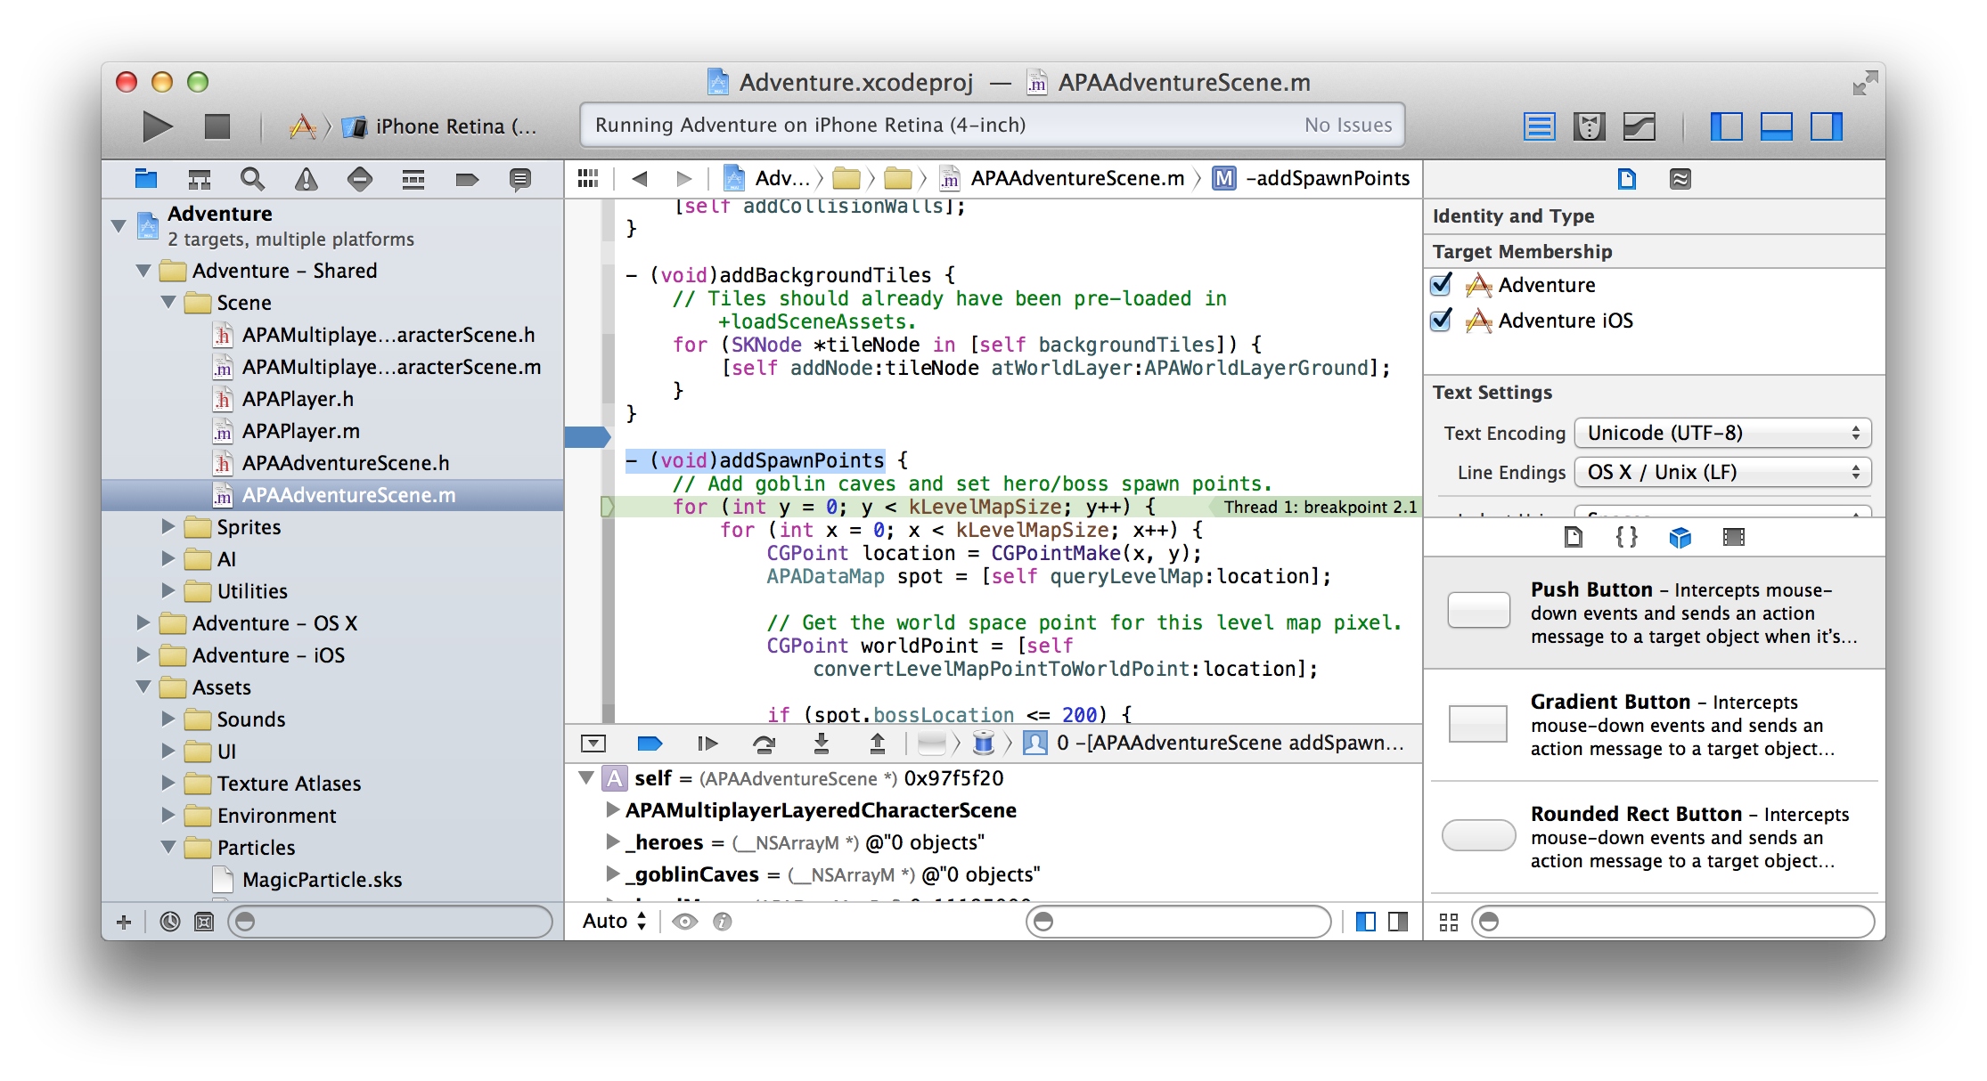

**Relevant Chapters:** “Develop Your App in the Workspace Window” (page 17), “Maintain Your Code and Other Resources in Projects or Workspaces” (page 28).

### Assisted Source Code Editing

Xcode checks your source code as you type it, and when Xcode notices a mistake, the source code editor highlights the error. The source code editor then offers to fix it. Xcode speeds up your typing with intelligent code completion. Xcode reduces your typing by offering ready-to-use code snippets and source file templates. You can easily configure the source editor to display multiple views of the same file or to view multiple related files at once. Search-and-replace and refactoring operations help you make extensive changes to your code quickly and safely. With these and other capabilities, Xcode makes it easier for you to write better code more quickly than you thought possible.

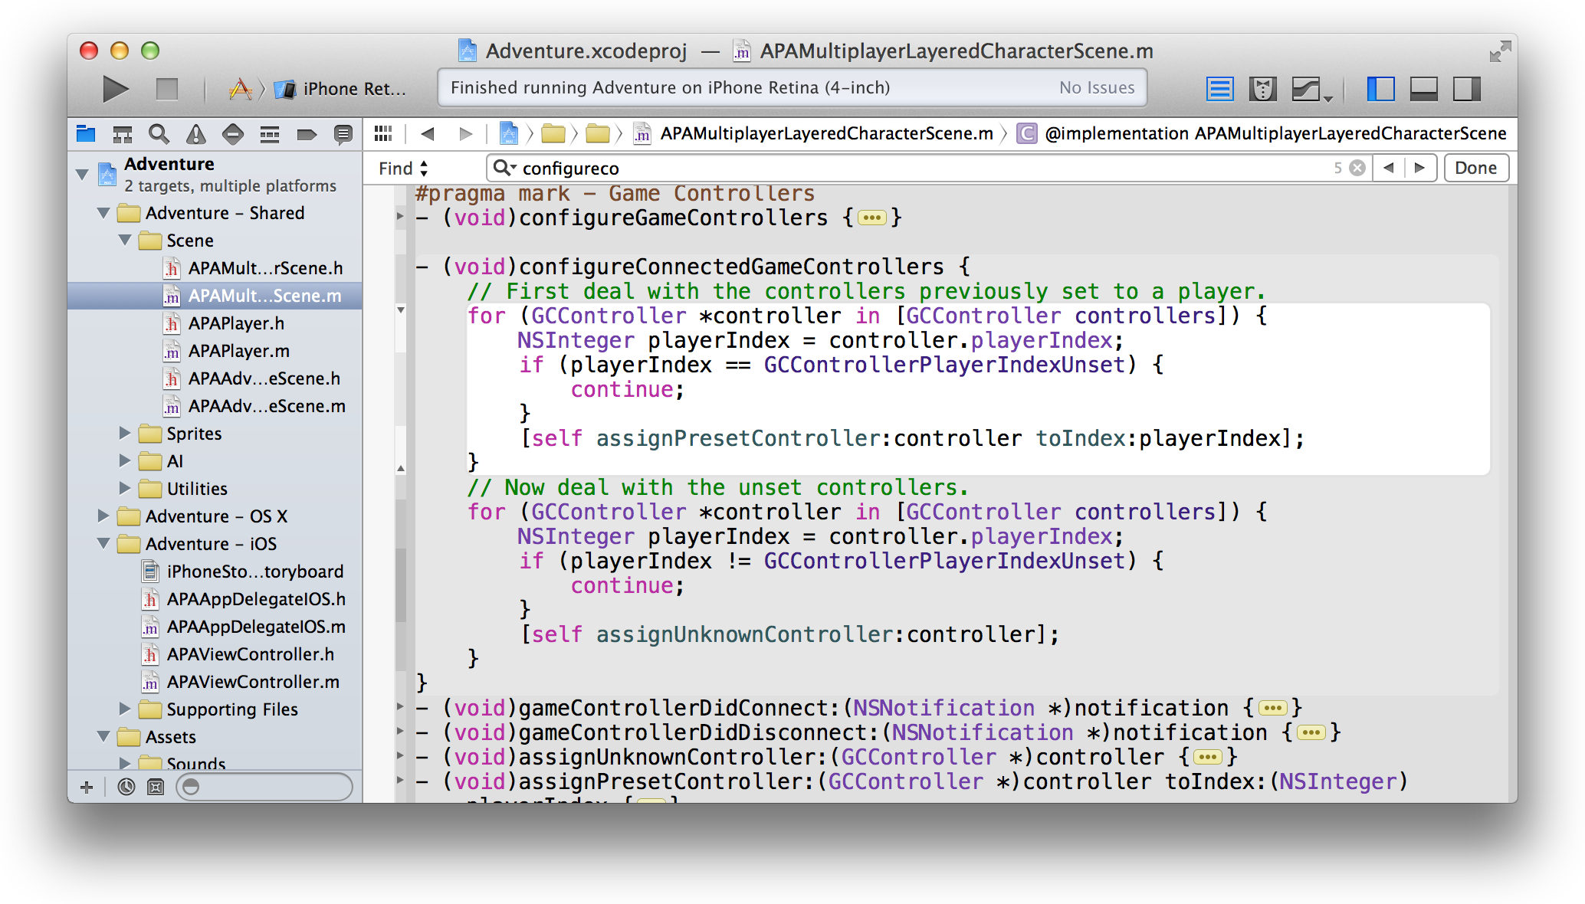

**Relevant Chapter:** “Write Code in the Source Editor” (page 34).

### Graphical UI Design

Interface Builder is a visual design editor that’s integrated into Xcode. Use Interface Builder to create the user interfaces of your apps by assembling windows, views, controls, menus, and other elements from a library of configurable objects. Graphically connect these object to your implementation code. With the Auto Layout feature, define rules for your objects so that they automatically adjust to screen size, device orientation, window size, and localization.

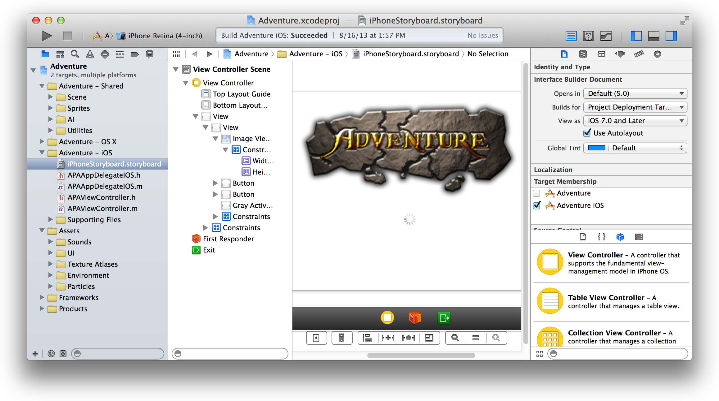

The asset catalog in Xcode helps you manage the many images you’ll use for your app’s user interface—items such as icons, launch images for iOS devices, and custom artwork. With the particle emitter editor in Xcode, you can enhance your iOS or Mac game by adding animation effects involving moving particles such as snow, sparks, and smoke. For Mac apps, the Scene Kit editor helps you work with scenes created in 3D authoring tools and exported as COLLADA Data Asset Exchange (DAE) files.

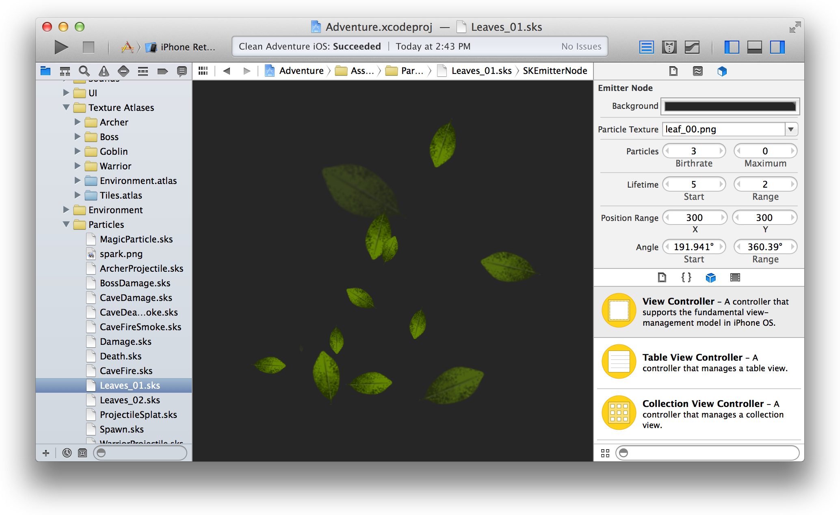

**Relevant Chapters:** “Build a User Interface” (page 55) and “Add Icons, Images, and Effects” (page 73).

### Integrated Debugging

Build your app, and Xcode launches it and immediately starts a debugging session. If you are running an iOS app, Xcode launches it either in iOS Simulator or on an iOS device connected to your Mac. If you are running a Mac app, Xcode launches it directly on your Mac.

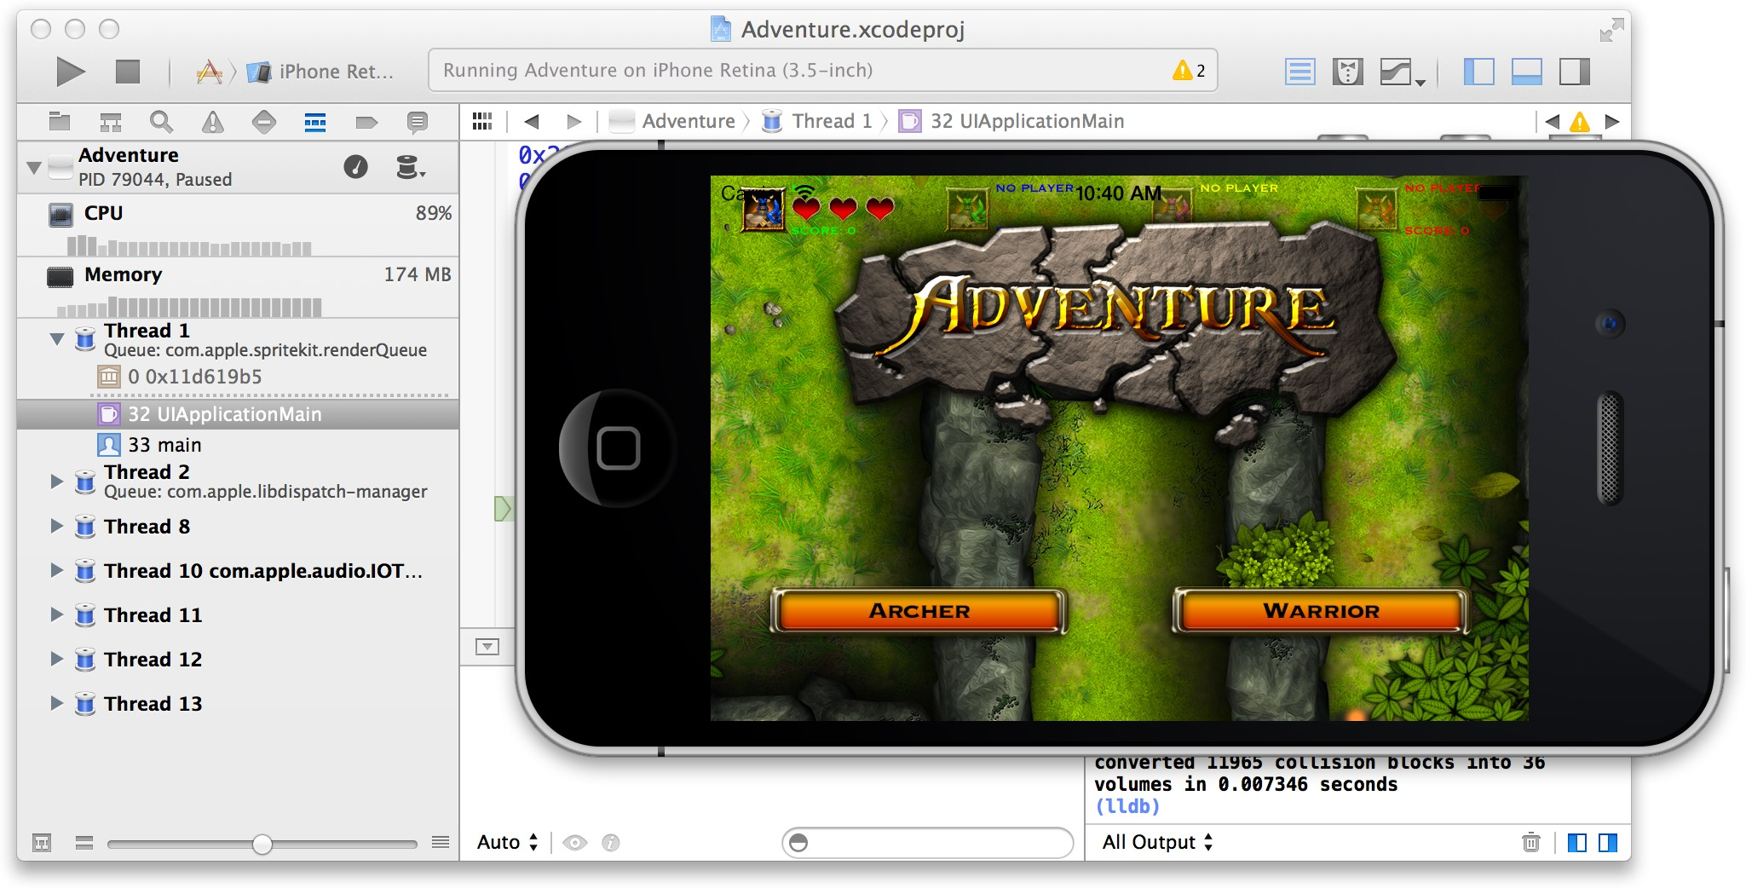

You can debug your app directly within the source editor with graphical tools like data tips and the variables Quick Look. The debug area and the debug navigator let you carefully control the execution of your app while you examine the code.

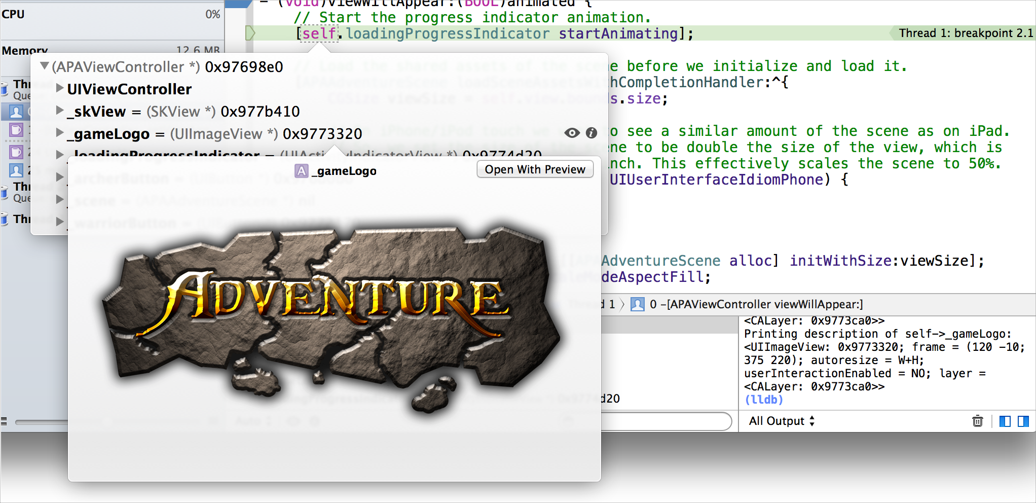

Debug gauges display your app’s resource consumption to help you identify problems before your users do.

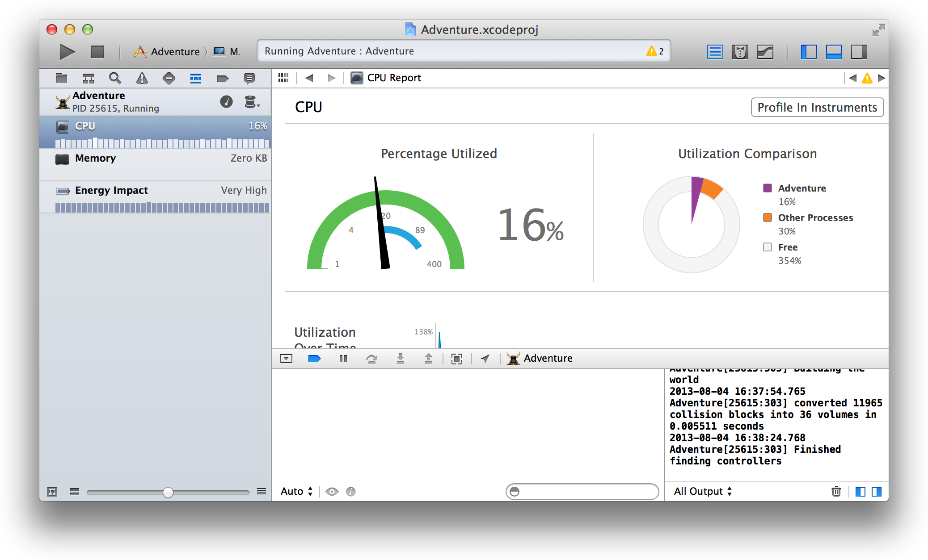

**Relevant Chapters:** “Run Your App” (page 79) and “Debug Your App” (page 89).

### Unit Testing and Continuous Integrations

To help you build a better app, Xcode includes unit testing tools. Unit tests are programs that automatically exercise the features of your application and check the results. You should create unit tests that automatically exercise the features of your application, and then monitor the results of the tests and fix any issues from the Xcode test navigator.

You can use the Xcode service, available in OS X Server, to automate the execution of unit tests. From Xcode on your development Mac, you create **bots** that run on a separate server to execute your unit tests either periodically or on every source code commit.

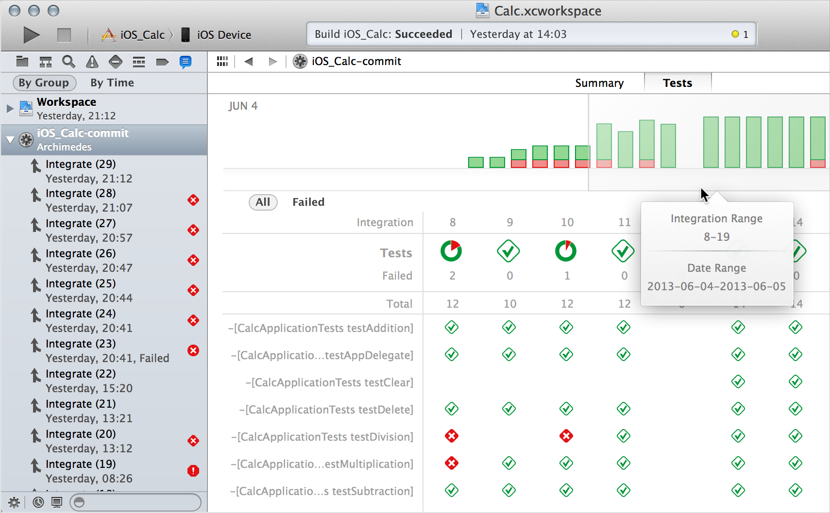

In addition to running unit tests, bots automatically perform static analysis on your code, build your app, and archive it for distribution to testers or the App Store. While performing these continuous integrations of your app, bots report build errors and warnings, static analyzer problems, and unit test failures.

**Relevant Chapter:** “Unit Test Your App” (page 100).

### Automatic Saves, Project Snapshots, and Source Control Management

While you work, Xcode automatically saves changes to source and project files. This feature requires no configuration, because Xcode continuously tracks your changes and saves them. You can revert a file to a previous state with Undo and Revert Document commands.

You can revert an entire project to a previous “snapshot” of a known working version with the Restore Snapshot command. Snapshots provide an easy way to back up the current version of your project. Xcode automatically creates a snapshot before you perform any mass-editing operation, and you can set Xcode to automatically create snapshots in other circumstances. You can also create snapshots manually, such before you add a new feature to your app.

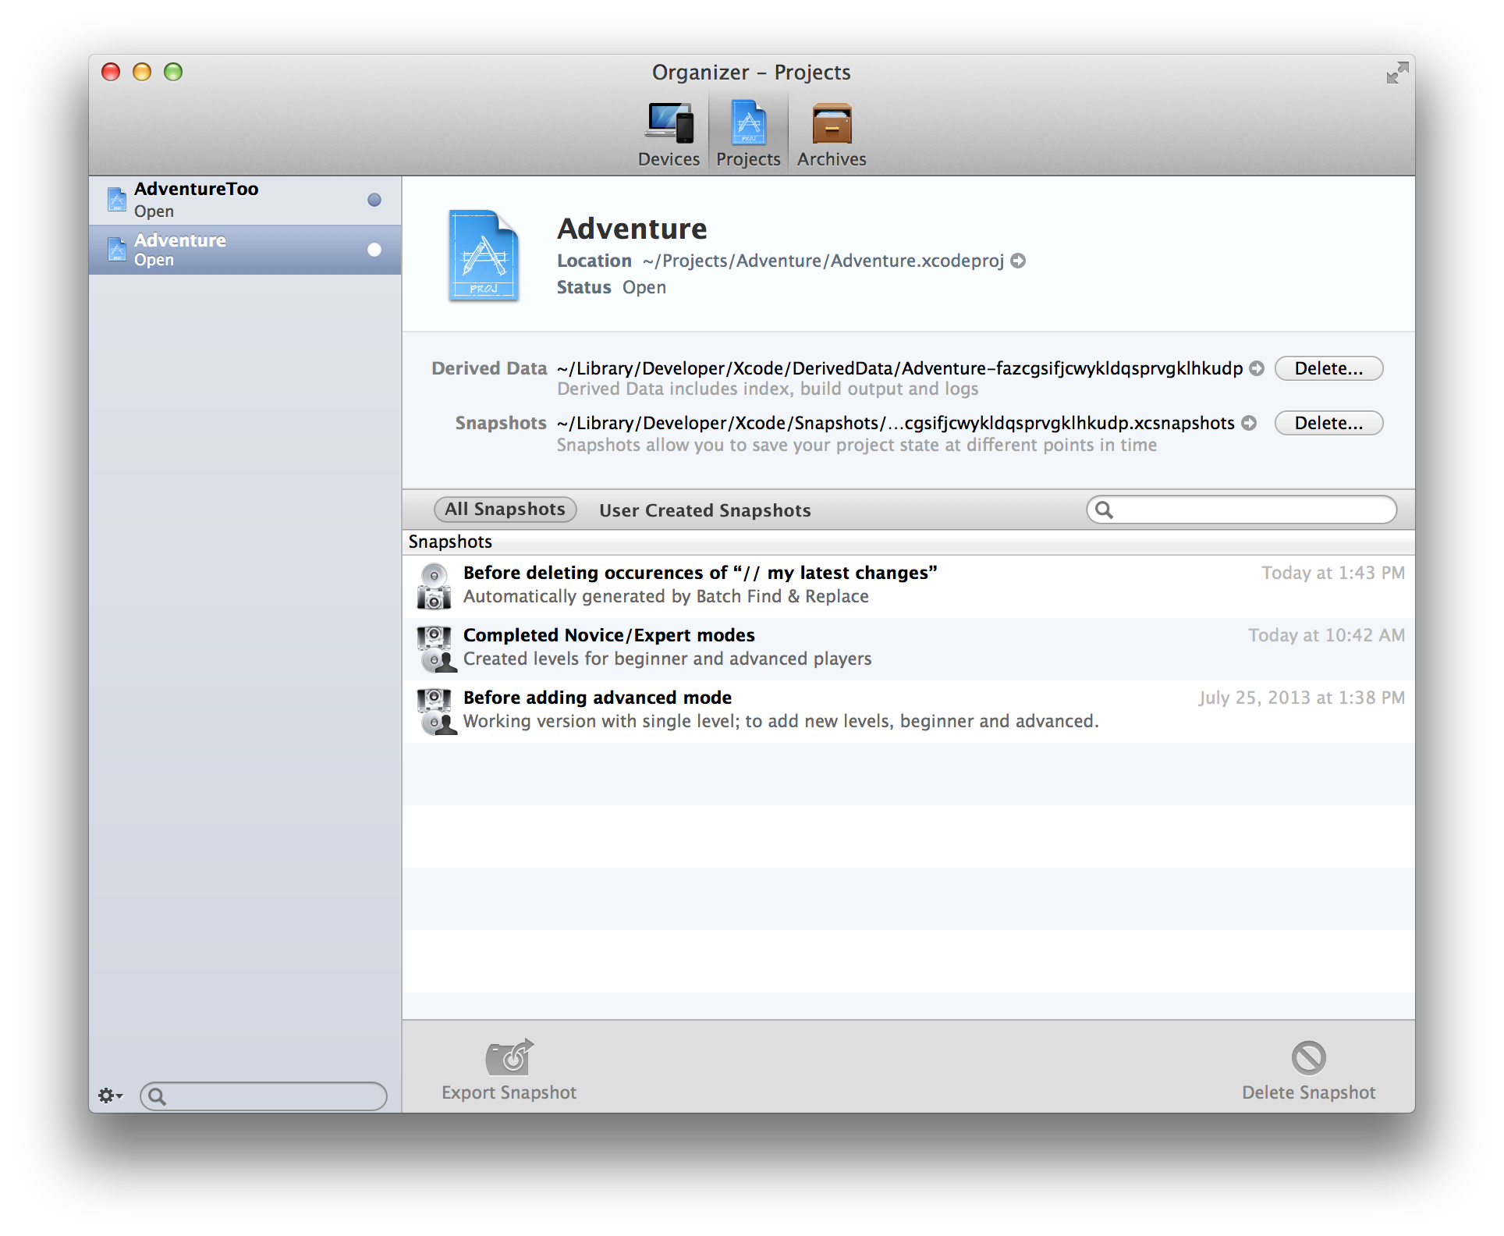

To keep track of changes at a fine-grained level, use the Xcode source control management features. Xcode supports two popular source control systems: Git and Subversion. You can access remote Git and Subversion source code repositories, and you can create local Git repositories. Using the Xcode service, available with OS X Server, you can host Git repositories on your own server.

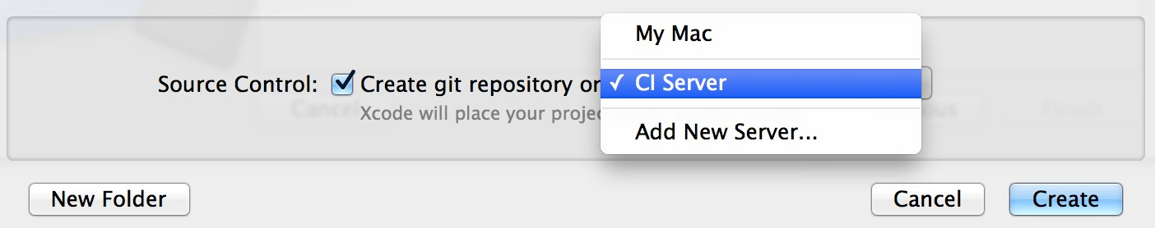

**Relevant Chapter:** “Save and Revert Changes” (page 106).

### Integrated Documentation

While you’re coding, Xcode makes detailed technical information available at your fingertips. When you want it, Quick Help keeps concise API information always in view, and Xcode application help is always close at hand with step-by-step instructions for performing common Xcode tasks. Xcode includes extensive documentation for using Xcode, and it provides comprehensive SDK documentation, including programming guides, tutorials,

sample code, detailed framework API references, and video presentations by Apple engineers, all viewable from the Xcode documentation viewer. As updated documentation becomes available, it downloads automatically in the background.

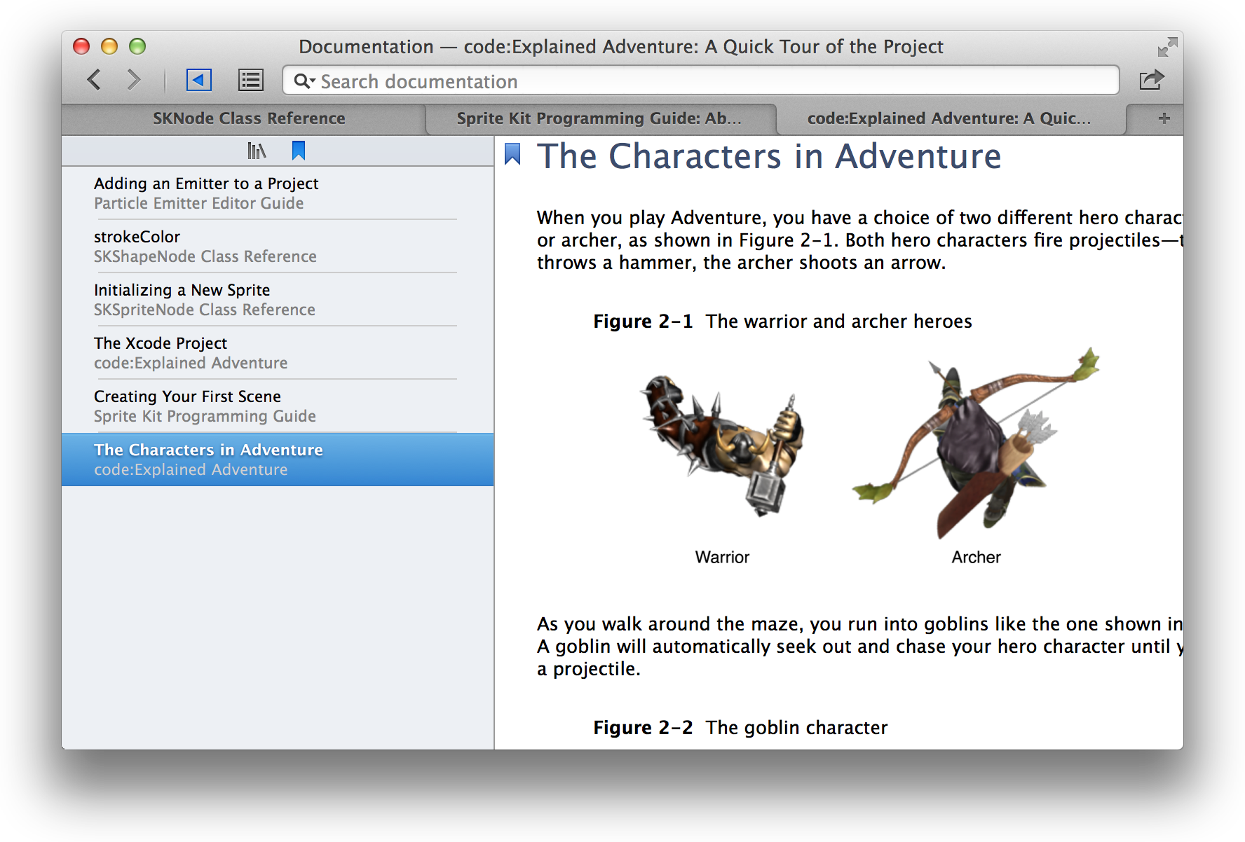

**Relevant Chapter:** “Learn More About Xcode” (page 113).

### App Distribution to Testers and the App Store

Most of your development time is spent on coding tasks, but to develop for the App Store, you need to perform a number of administrative tasks throughout the lifetime of your app. In addition to using Xcode, you’ll use the Member Center web tool to manage developer program accounts and entitlements, and you’ll use the iTunes Connect web tool to check the status of your contracts, set up tax and banking information, obtain sales and finance reports, and manage metadata about the app.

Xcode project configurations help prepare your app for distribution to beta testers and for submission to the App Store. Submitting your app is a multistep process that begins when you sign into iTunes Connect and supply necessary product information. In Xcode, you create an archive of your project and submit it to the store. When your app is approved, you use iTunes Connect to release it by setting the date. (If you are distributing your Mac app outside the store, you follow a slightly different process.)

See Also

**Relevant Guide:** *App Distribution Guide*.

See Also

Manyofthescreenshotsusedtoillustratethisdocumentaretakenfromthe *Adventure* Xcodeprojectdescribed in *code:Explained Adventure*. To explore the Xcode features described in this guide on your Mac, obtain Xcode from the App Store, then download the Adventure project by clicking either link in this paragraph.

This guide introduces you to the major features and capabilities of Xcode. For a hands-on introduction to using Xcode, read either *Start Developing iOS Apps Today* or *Start Developing Mac Apps Today*. In each document, you use Xcode to create a simple app, and you learn the basics of programming with Objective-C.

Develop Your App in the Workspace Window

Perform your core development tasks in the Xcode workspace window. The workspace window is your primary interface for creating and managing projects. The workspace window automatically adapts itself to the task at hand, and you can further configure the window to fit your work style. You can open as many workspace windows as you need.

The

workspace

window

has

five

main

components.



The workspace window always includes the **editor area.** When you select a project file, its contents appear in the editor area, where Xcode opens the file in an appropriate editor.

The workspace window can also display three optional areas. You hide or show these optional areas by using buttons in the view selector in the toolbar:

 Show and hide the **navigator area**. The navigator area is where you view and maneuver through files and other facets of your project.

 Show and hide the **debug area**. The debug area is where you control program execution and debug code.

Navigate Your Workspace

 Show and hide the **utility area**. You use the utility area for several purposes, most commonly to view and modify attributes of a file and to add ready-made resources to your project.

Navigate Your Workspace

Access files, symbols, unit tests, diagnostics, and other facets of your project from the navigator area. In the **navigator selector bar,** you choose the navigator suited to your task. The **content area** of each navigator gives you access to relevant portions of your project, and each navigator’s **filter bar** allows you to restrict the content that is displayed.

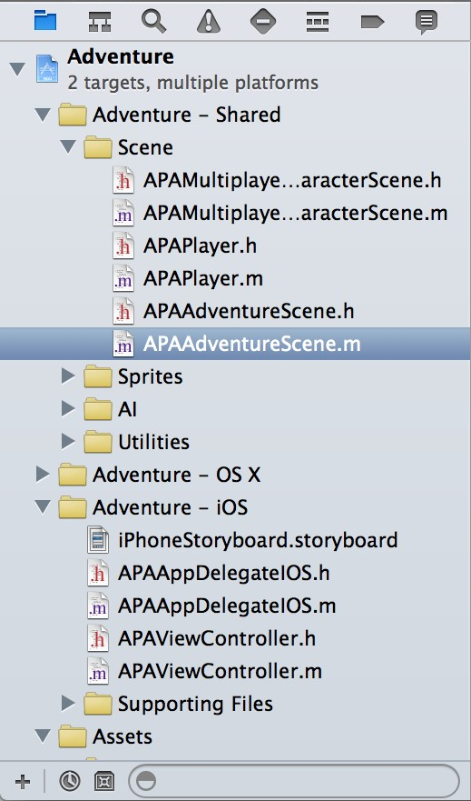

Choose from these options in the navigator selector bar:

*  **Project navigator.** Add, delete, group, and otherwise manage files in your project, or choose a file to view or edit its contents in the editor area.
*  **Symbol navigator.** Browse the class hierarchy of the symbols in your project.
*  **Find navigator.** Use search options and filters to quickly find any string within your project.
*  **Issue navigator.** View issues such as diagnostics, warnings, and errors found when opening, analyzing, and building your project.
*  **Test navigator.** Create, manage, run, and review unit tests.
*  **Debug navigator.** Examine the running threads and associated stack information at a specified point or time during program execution.
*  **Breakpoint navigator.** Fine-tune breakpoints by specifying characteristics such as triggering conditions.
*  **Log navigator.** View the history of your build, run, debug, continuous integration, and source control tasks.

Type text into the filter bar to restrict the items displayed in the content area of the navigator. Click the icons in the filter bar to display only recently changed files ( ) or only files with source control status ( ). You can also add a file to the project by clicking the Add (+) button.

Select files in the content area to view or edit them.

Edit Your Project Files

Most development work in Xcode occurs in the editor area, the main area that is always visible within the workspace window. The editors you use most often are:

* **Source editor.** Write and edit source code.
* **Interface Builder.** Graphically create and edit user interface files.
* **Project editor.** View and edit how your apps should be built, such by specifying build options, target architectures, and app entitlements.

When you select a file from the content area of a navigator, Xcode opens the file in an appropriate editor. In the screenshot, the file iPhoneStoryboard.storyboard is selected in the project navigator, and the file is open in Interface Builder. (The optional utility and debug areas are hidden to maximize space for the navigator and editor.)

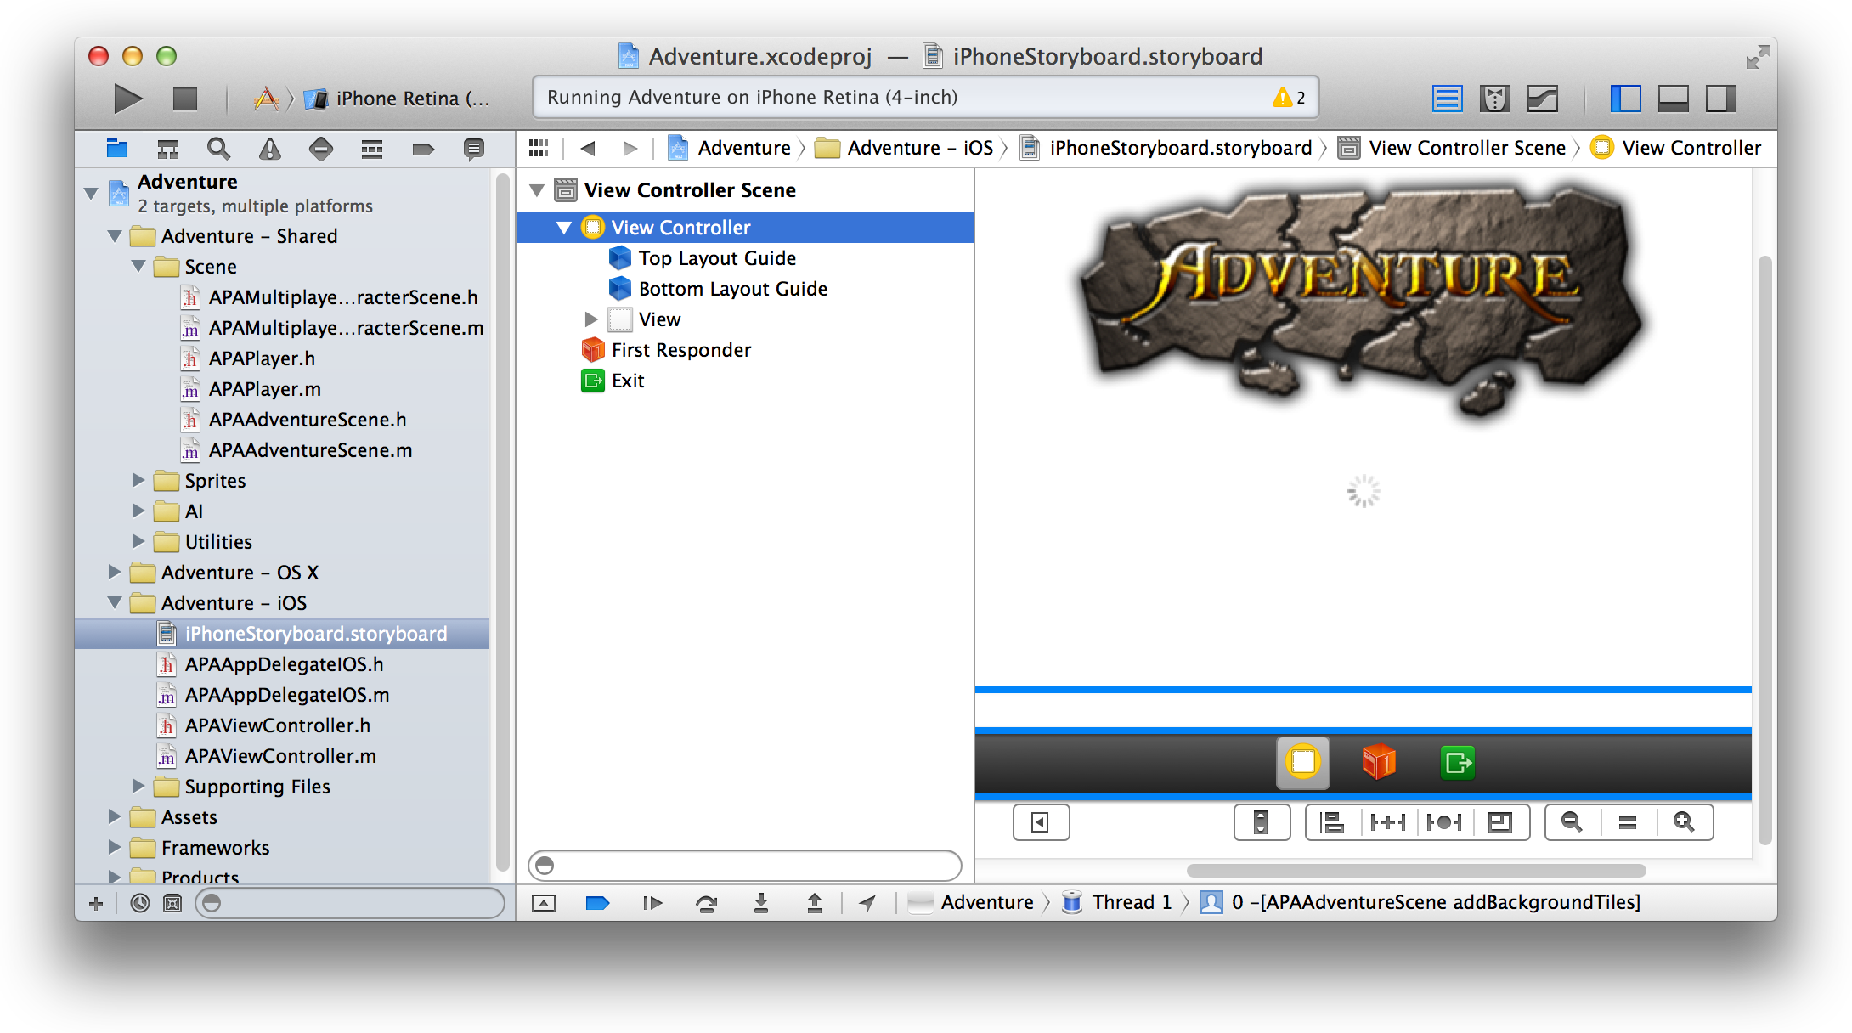

The following screenshot shows a number of search results appearing in the find navigator’s content area.

One of the results is selected, and its text string appears in the source editor.

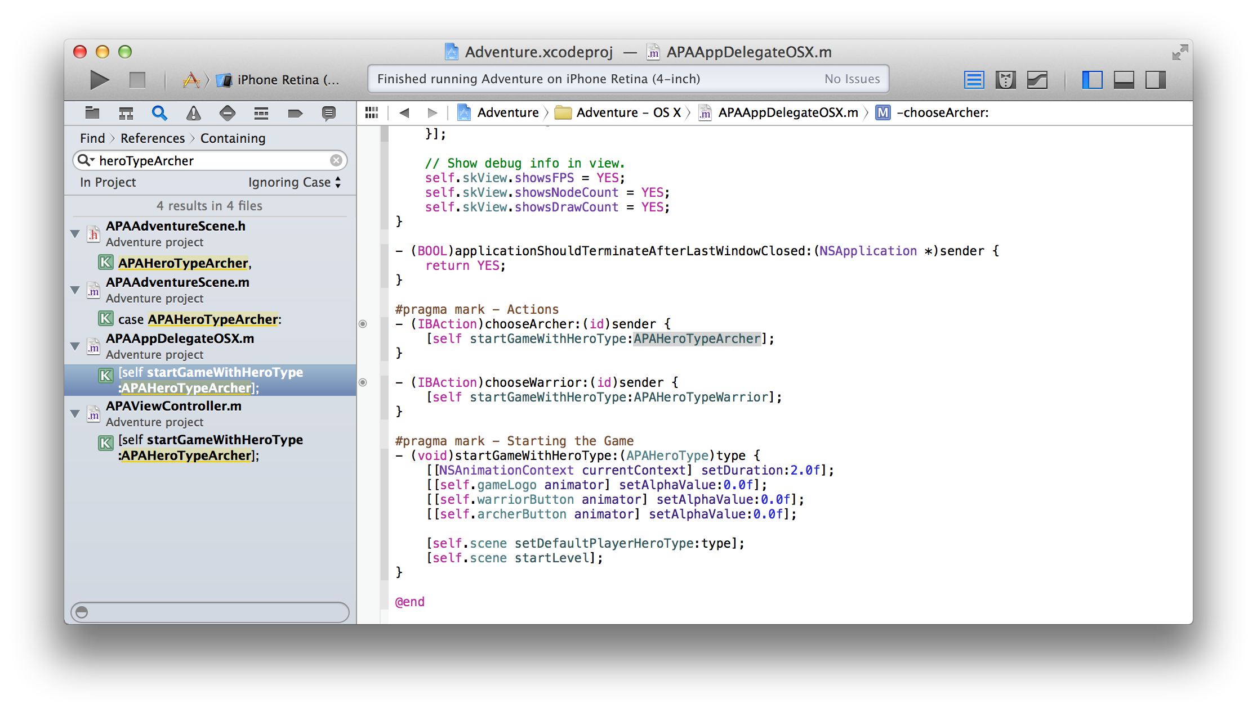

Configure the editor area for a given task with the editor selector, found in the toolbar. The editor selector offers three controls:

*  **Standard editor.** Fills a single editor pane with the contents of the selected file.
*  **Assistant editor.** Presents a separate editor pane with content logically related to that in the standard editor pane.
*  **Version editor.** Shows the differences between the selected file in one pane and another version of that same file in a second pane.

This screenshot shows an implementation file, APAAdventureScene.m, open in the standard editor pane. The three optional workspace areas—navigator, debugger, and utility—are hidden to maximize the editor’s content display. Within the source code editor, the assistant pane displays the implementation file’s associated

header

file,

APAAdventureScene.h

.

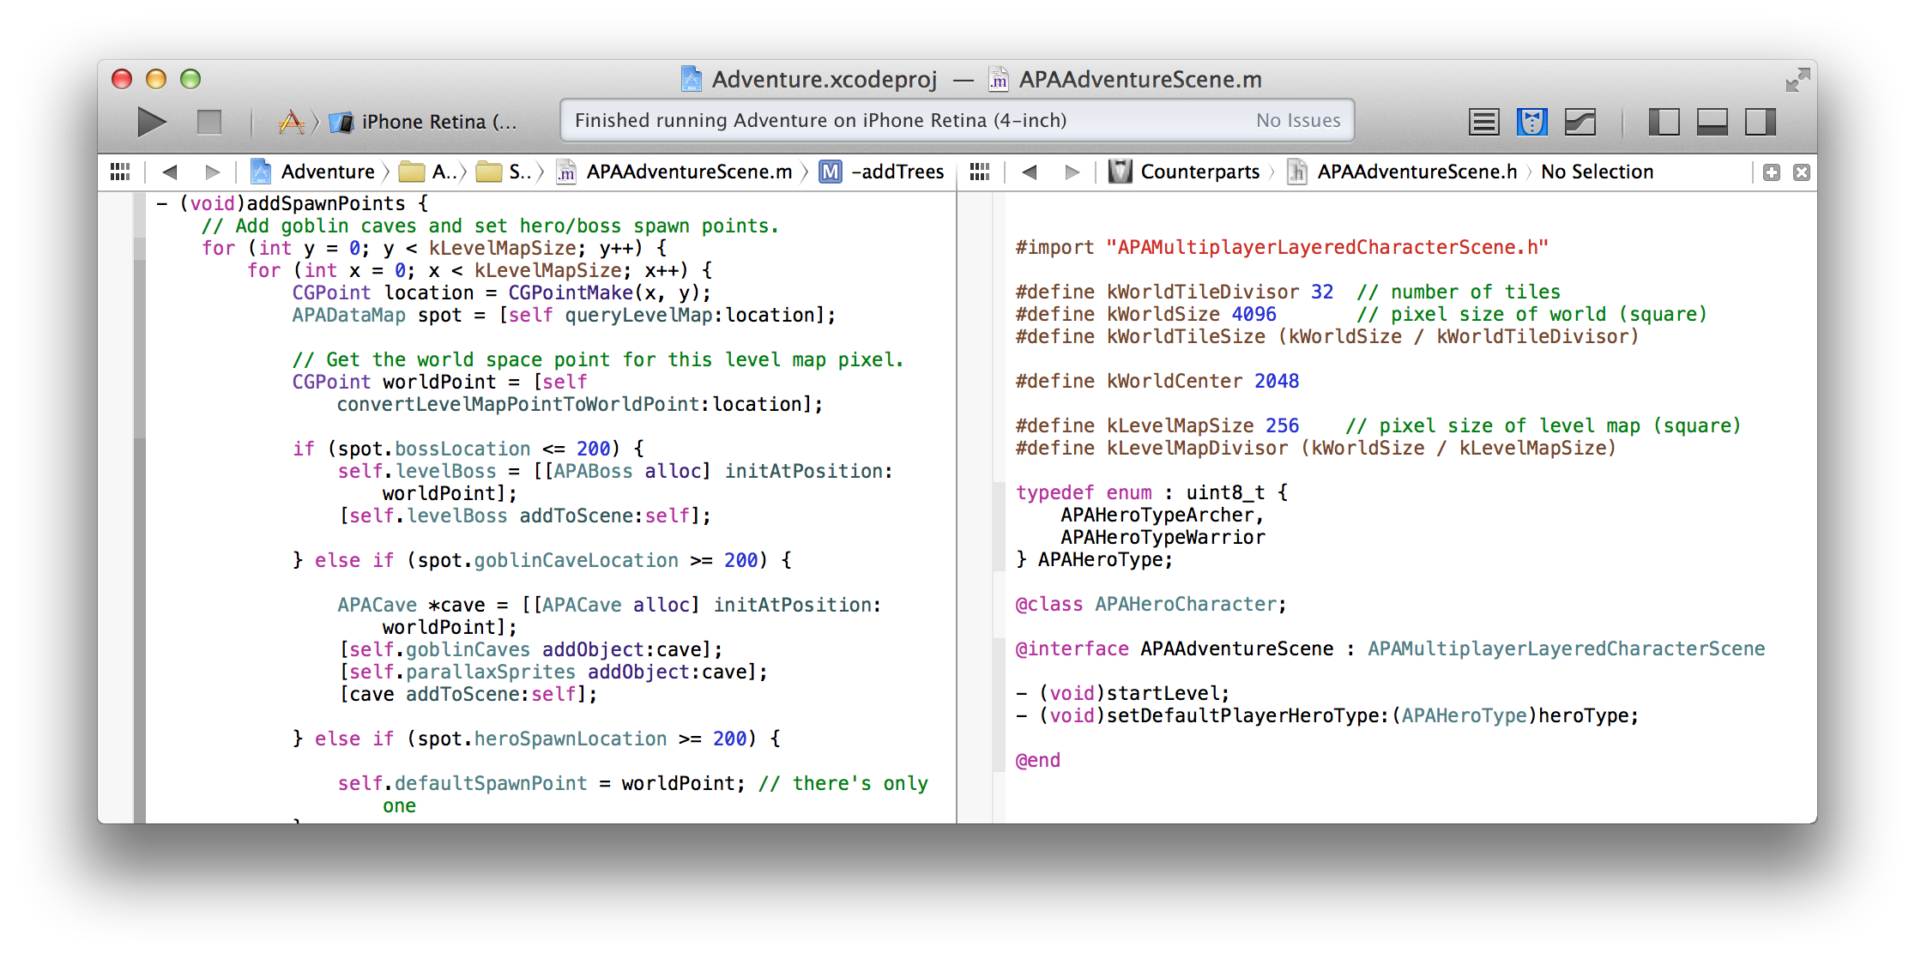

Every editor pane includes a jump bar—an interactive, hierarchical mechanism for navigating directly to items at any level in your project. The configuration and behavior of the jump bar is customized for its context. The basic jump bar configuration includes three components:

* The related items menu ( ) offers additional selections relevant in the current context, such as recently opened files or the interface (.h) file for an implementation (.m) file you are editing.
* Previous/next buttons ( ) allow you to step back and forth through your navigation history.
* The hierarchical path menu is made up of one or more segments.

Perform Additional Workspace Actions in the Utility Area

Click a segment in the hierarchical path menu to see a pop-up menu of related sub items. For example, if the segment identifies the name of the project, you can use the jump bar to find folders within the project. If the segment identifies the name of a folder, you can use the jump bar to find files within the folder. If the segment identifies the name of a source file, you can use the jump bar to find symbols within the file.

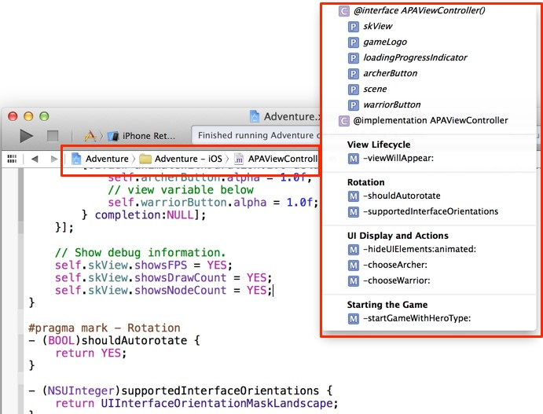

Perform Additional Workspace Actions in the Utility Area

The utility area gives you quick access to these resources:

* Inspectors, for viewing and modifying characteristics of the file open in an editor
* Libraries of ready-made resources for use in your project

Perform Additional Workspace Actions in the Utility Area

The top pane of the utility area displays inspectors. The bottom pane gives you access to libraries.

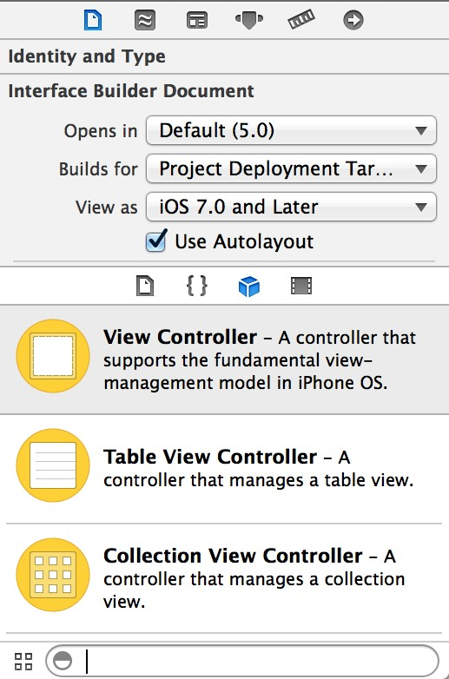

Use the **inspector selector bar** to choose the inspector best suited to your current task. Two inspectors are always visible in the selector bar (additional inspectors are available in some editors):

*  **File inspector.** Manage metadata for a file, such as its name, type, path, location within your project, and so forth.
*  **Quick Help.** View details about a symbol, interface element, or a build setting in the file. For a method, for example, Quick Help displays a concise description, where and how the method is declared, its scope, the parameters it takes, and its platform and architecture availability.

Use the **library selector bar** to access ready-to-use libraries of resources for your project:

*  **File templates.** Model files for common types of files and code constructs.
*  **Code snippets.** Short pieces of source code for use in your software.
*  **Objects.** Items for your app’s user interface.
*  **Media.** Files containing graphics, icons, sound files, and the like.

Manage Common Tasks with the Workspace Toolbar

You can type into the text field in the **filter bar** to restrict the items displayed in the selected library. To use a library, drag it directly to the appropriate area. For example, to use a code snippet, drag it from the library to the source editor; to create a source file from a file template, drag its template to the project navigator.

Manage Common Tasks with the Workspace Toolbar

The toolbar at the top of the workspace window provides quick access to frequently used commands. The **Run button** builds and runs your products. The **Stop button** terminates your running code. The **Scheme menu** lets you configure the products you want to build and run. The **activity viewer** shows the progress of tasks currently executing by displaying status messages, build progress, and other information about your project.

You’ve seen how the **editor selector** lets you configure the editor area, and you’ve seen how the **view selector** hides or shows the optional navigator, debug, and utility areas.



The **View menu** includes commands to hide or show the toolbar.

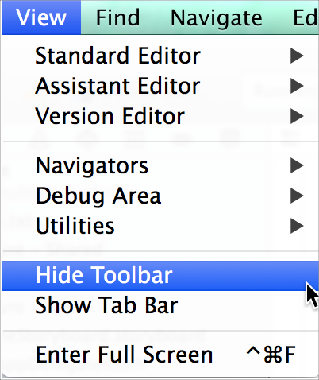

Work in Multiple Tabs or Multiple Windows

Work in Multiple Tabs or Multiple Windows

You can use Safari-style tabs to implement multiple, workflow-specific layouts of the workspace window. For example, you can use one tab to view a header file, another to view an implementation file, and another to view a user interface file.

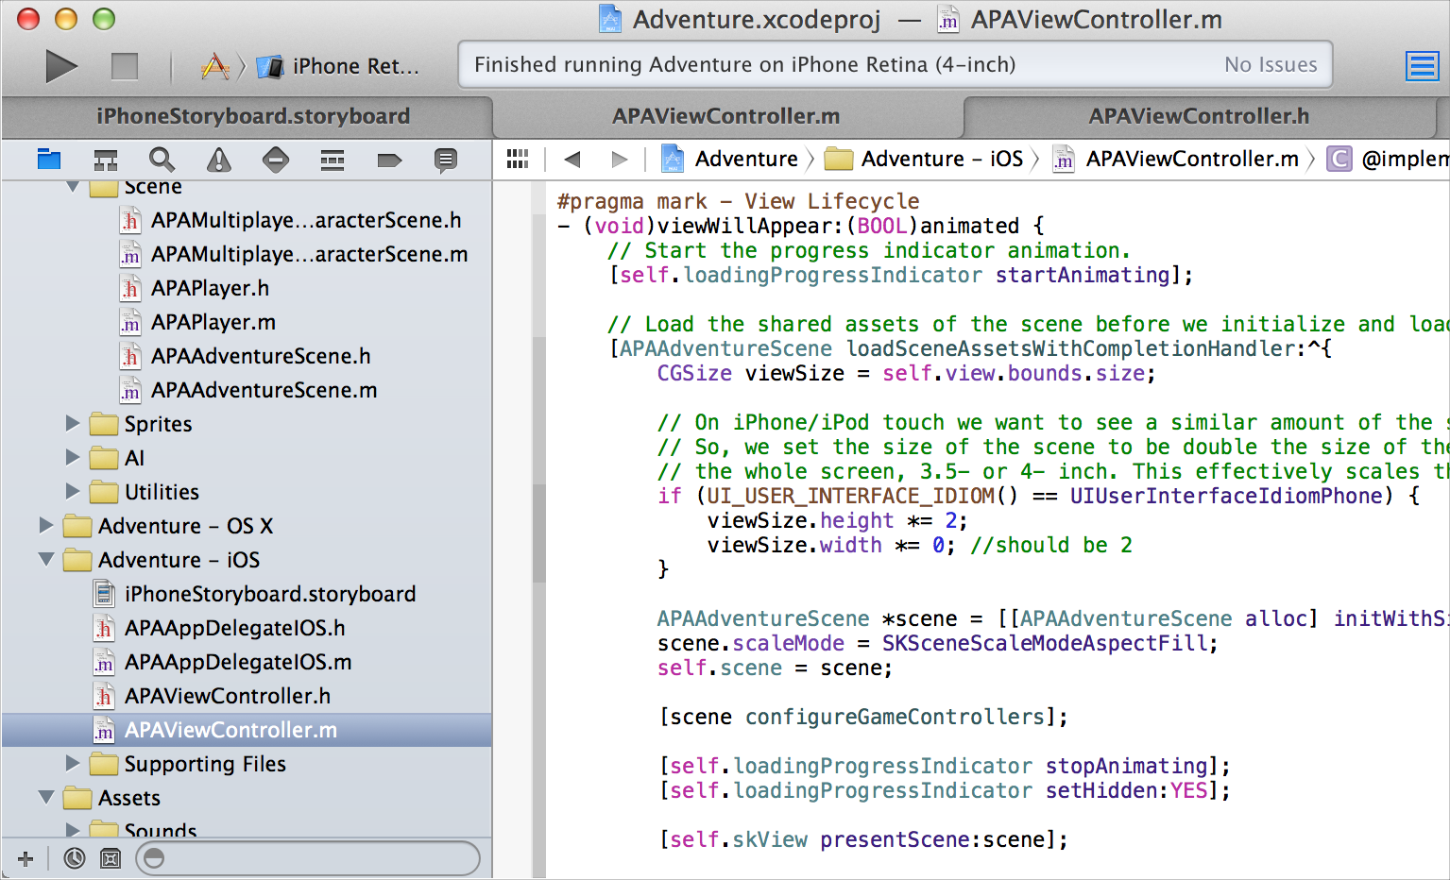

The View menu contains commands to show or hide the tab bar. To create a tab, choose File > New > Tab. To remove a tab, move the pointer to the tab and click its close box.

Work in Multiple Tabs or Multiple Windows

You can also create multiple workspace windows by choosing File > New Window. Each tab or window can be customized independently of the others, for example, by showing and hiding the utility area with the utility area button ( ) in the View selector.

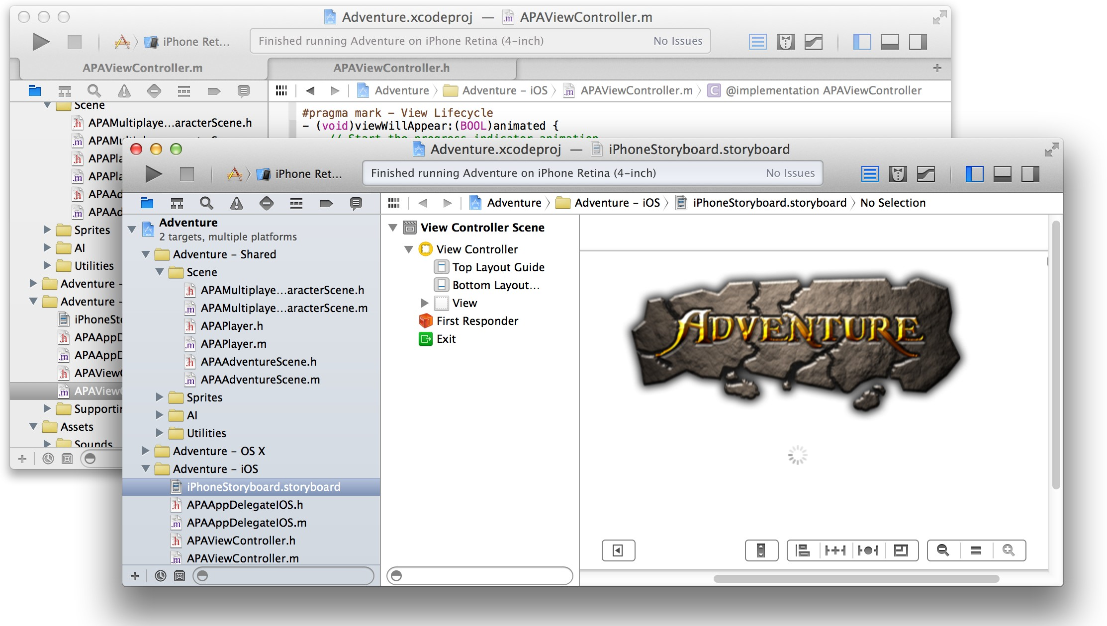

Maintain Your Code and Other Resources in Projects or Workspaces

Apps you create in Xcode require a **project**, which keeps the necessary files and resources organized. You start a project by choosing File > New > New Project. Xcode opens a new workspace window and displays a dialog in which you choose a project template. Xcode provides built-in templates for developing common styles of iOS and Mac apps. These templates include essential project files that help you start your development effort quickly.

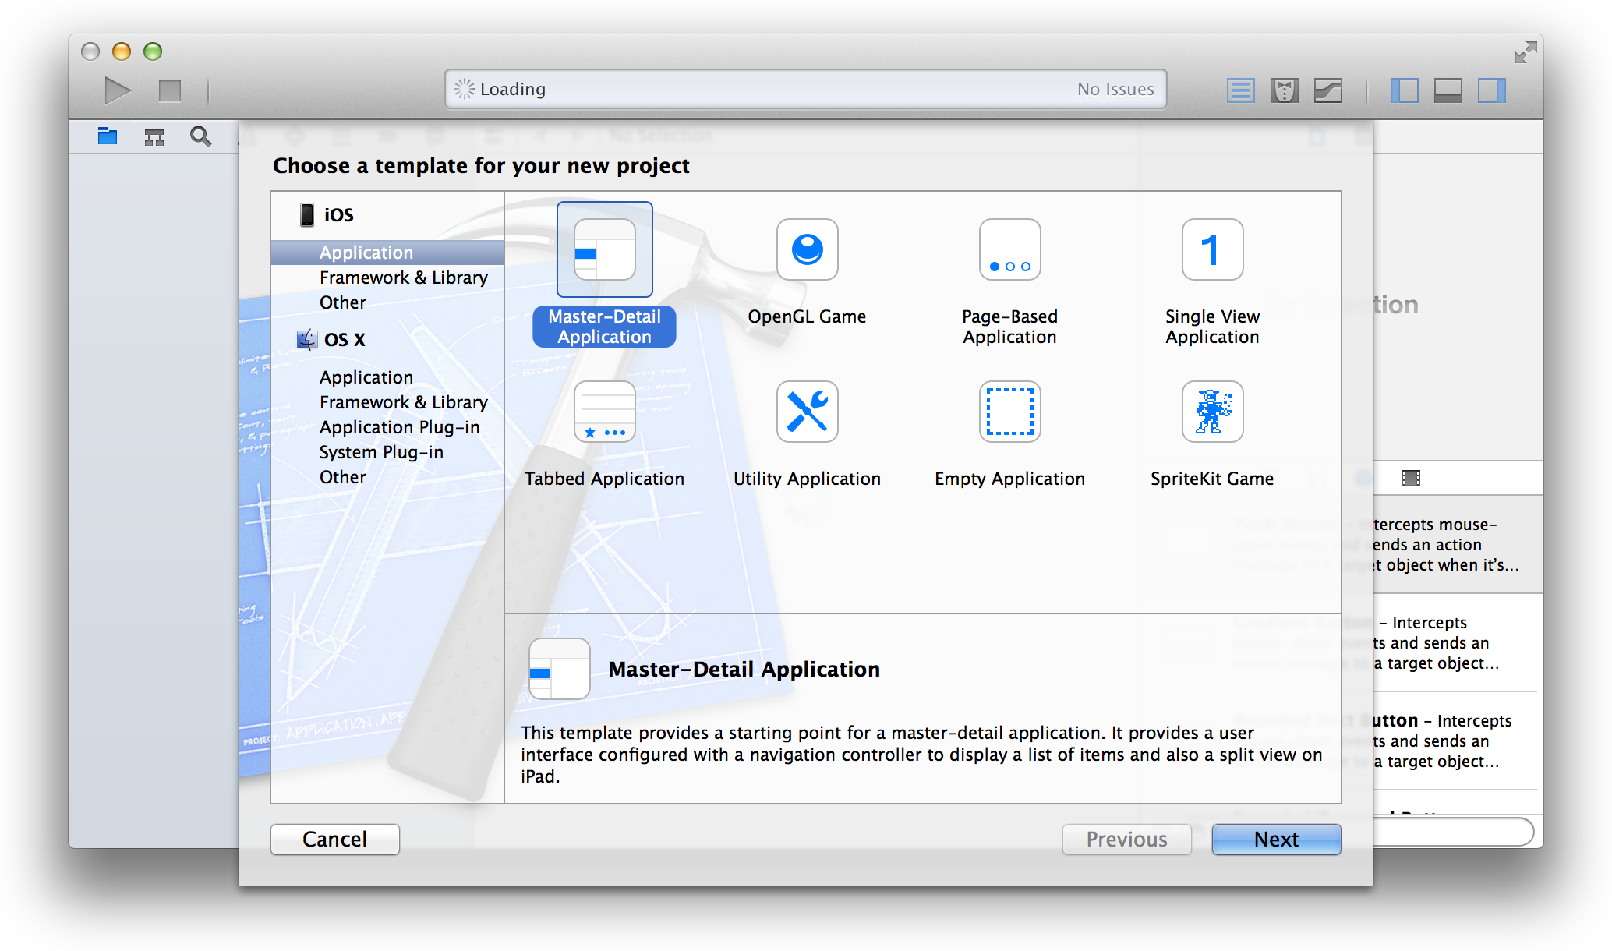

A Project Is a Repository of Files and Resources for Building Apps

You view the names of project files in the project navigator. When you select a file in the project navigator, the file’s contents appear in the appropriate editor or viewer. In this screenshot, an implementation file (APAViewController.m) is selected in the project navigator, and the file’s contents appear in the source editor.

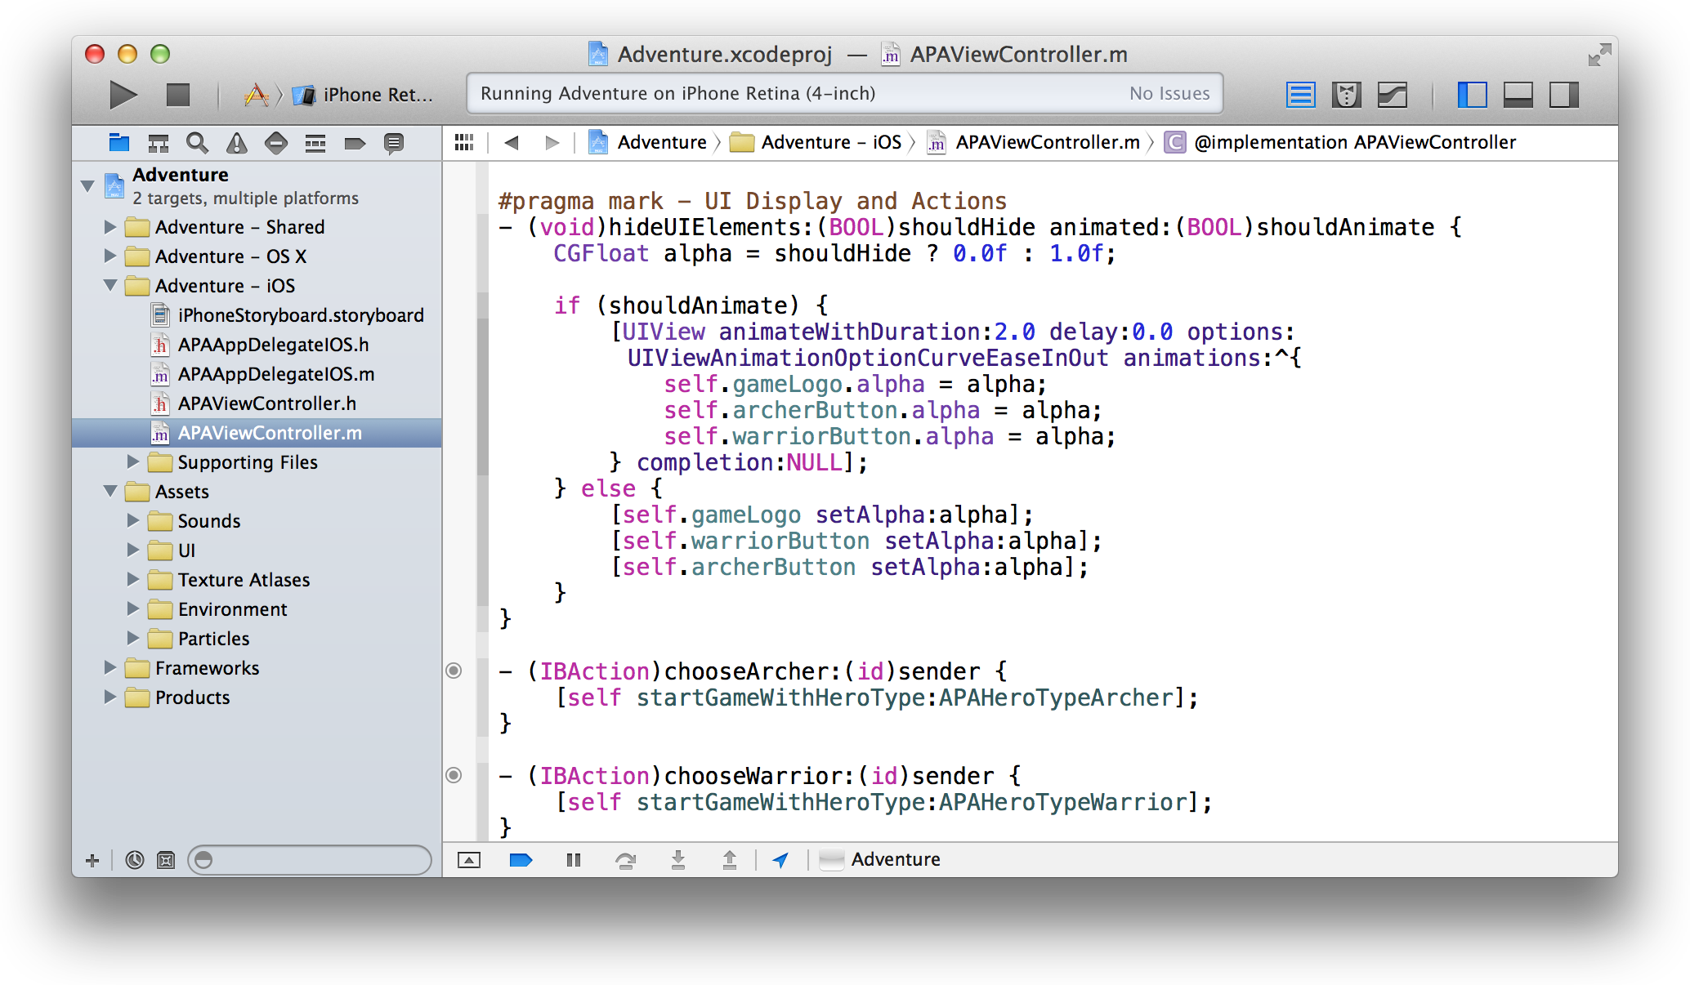

A Project Is a Repository of Files and Resources for Building Apps

A project contains the elements needed to build one or more apps (or other software products, such as command-line tools and plug-ins). The project also maintains the relationships among these elements. These elements include:

* References to source code files (including header files and implementation files), libraries and frameworks, image files, and user interface files
* Groups, for organizing files in the project navigator
* Project-level build configurations
* Targets, each of which produces a single app

A Project Is a Repository of Files and Resources for Building Apps

By selecting the project name in the project navigator, you open the project editor. You can use the project editor to specify every aspect of how your apps should be built, from the version of the software development kit (SDK) to specific compiler options. In this screenshot, the Adventure project is selected in the project navigator *and* in the project editor. The project editor displays the Info pane for the Adventure project.

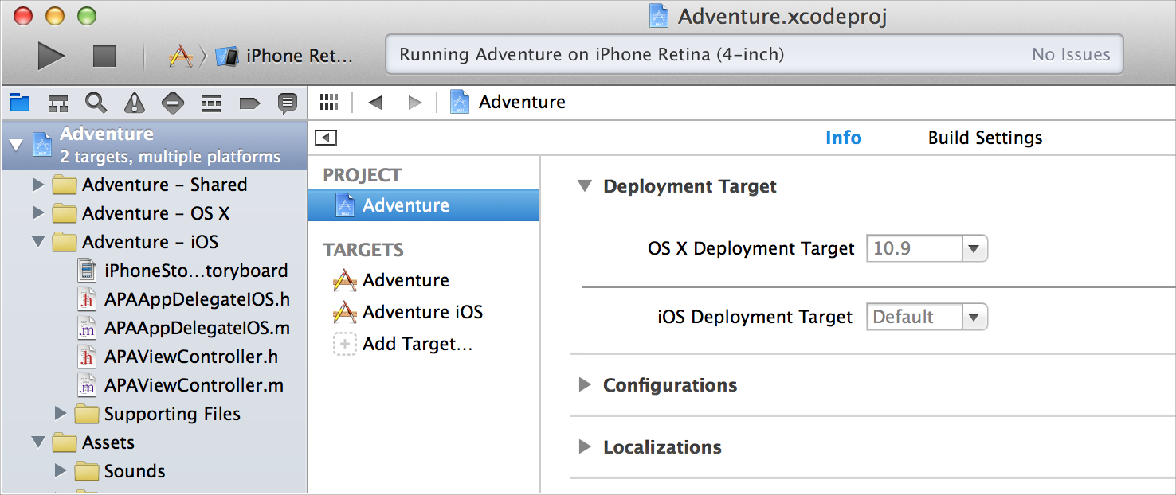

When you create a project, Xcode provides two standard project-level build configurations: debug and release. These configurations differ mostly in whether they include debug information and in the degree to which each build is optimized. These two build configurations are probably sufficient for your product development needs.

Most developers never need to change the values of the vast majority of build settings.

To add more build configurations, open the project editor, duplicate one of the project’s existing configurations, and then modify its settings. For example, you might configure a build that’s fully optimized but that also includes debug information in order to debug your optimized code.

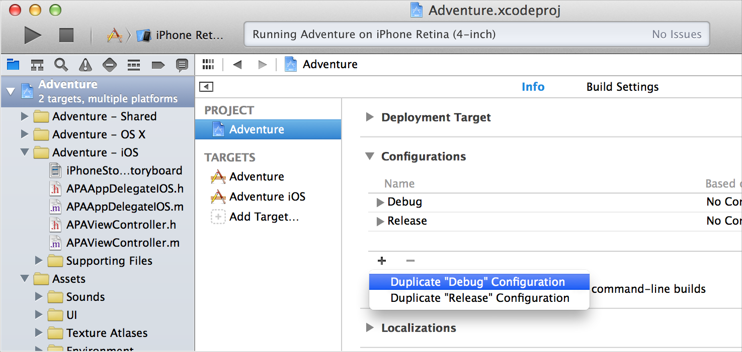

Apply App-Specific Settings to a Target

Apply App-Specific Settings to a Target

Every project contains at least one target. A target specifies a product to build, such as an iOS or Mac app.

Select a target in the project editor to view and modify the target’s settings. In the screenshot below, the *Adventure project* is selected in the *project navigator,* and the *Adventure iOS target* is selected in the *project editor*. The project editor displays the General pane for the target.

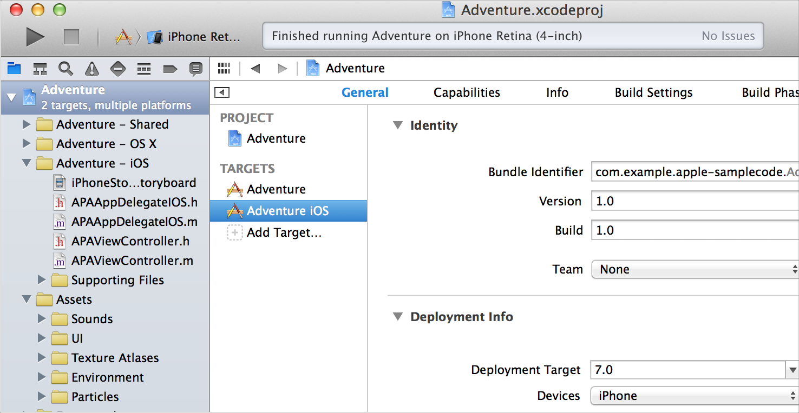

The General pane for a target shows basic settings that you occasionally check and possibly edit. You typically assign values for these settings elsewhere during the app development process, for example, in dialogs that appear when you create a new project.

For an iOS app, the General pane contains these sorts of target settings:

* The bundle identifier, a string that identifies the app to the operating system and to the App Store
* The version number under which to publish the app
* The build number, which identifies a particular build of the app
* The name of your Apple Developer Program development team
* The deployment target, which is the earliest iOS version on which the app runs
* The devices, such as iPhone or iPad, for which to build the app
* The main user interface file to load when the app launches
* The user interface orientations (portrait, upside down, landscape left, landscape right) that the app supports

For a Mac app, the General pane contains these sorts of target settings:

* The application category, for classifying the app on the Mac App Store
* The bundle identifier

Add Technology Features to a Target

* The version number
* The build number
* An option for code signing—whether to code sign the app for the Mac App Store, to code sign the app with a developer ID for distribution outside the Mac App Store, or to leave the code unsigned
* The deployment target, which is the earliest OS X version on which the app will run
* The icon that OS X uses to identify the app to the user

Add Technology Features to a Target

To add various Apple technologies—such as iCloud, Game Center, In-App Purchase, and Maps—to your app, select its target in the project editor and select the Capabilities tab. Click a switch to On to add a capability. Xcode adds the necessary entitlements file to your project and links the target to the necessary frameworks.

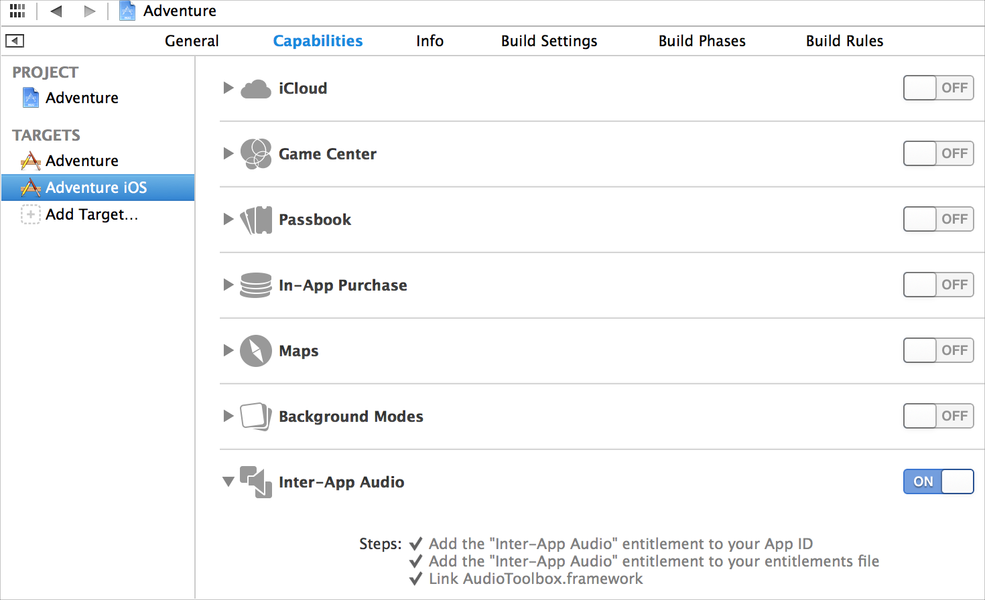

Override Build Settings for a Target

A target also contains instructions—in the form of build settings and build phases—for building a product. A target inherits the project’s build settings. Although most developers seldom need to change these, you can override any of the project’s build settings by specifying different settings at the target level. Select a target in the project editor to modify the target settings in the Info, Build Settings, or Build Phases pane.

Workspaces Extend the Scope of Your Workflow

Workspaces Extend the Scope of Your Workflow

To group Xcode projects and other related files, you can create a workspace. Putting your related projects in the same workspace affords you several benefits. For example:

* One project can use the products of another project while building.
* If one project depends on the products of another in the same workspace, Xcode can detect this fact and automatically build the projects in the correct sequence.
* Because all the files in one project are visible to all the other projects in the workspace, you don’t need to copy shared libraries into each project separately.

You create a workspace by choosing File > New > Workspace. After you create a workspace, you can create new projects within it and you can add existing projects to it.

Close and Reopen a Project or a Workspace

To close a project or workspace, choose File > Close Project or File > Close Workspace. Xcode remembers which windows you had open and how they were configured, and it restores them when you reopen the project or workspace.

Write Code in the Source Editor

You spend most of your development time writing, editing, and debugging code. With features like syntax correction, code completion, and static code analysis, the Xcode source editor helps you enter code quickly and accurately. Customizable features like split windows, keyboard shortcuts, and syntax-aware fonts and text colors allow you to configure the source editor to suit your work style.

To view and edit a source file, select it in the project navigator. The file’s contents appear in the editor area of the workspace window.



Fix Errors as You Type

Fix Errors as You Type

As you type into the source editor, Xcode scans your text. When you make a syntax error, Xcode marks it with a red underline or a caret. Click the error, and Xcode displays a message describing the issue.

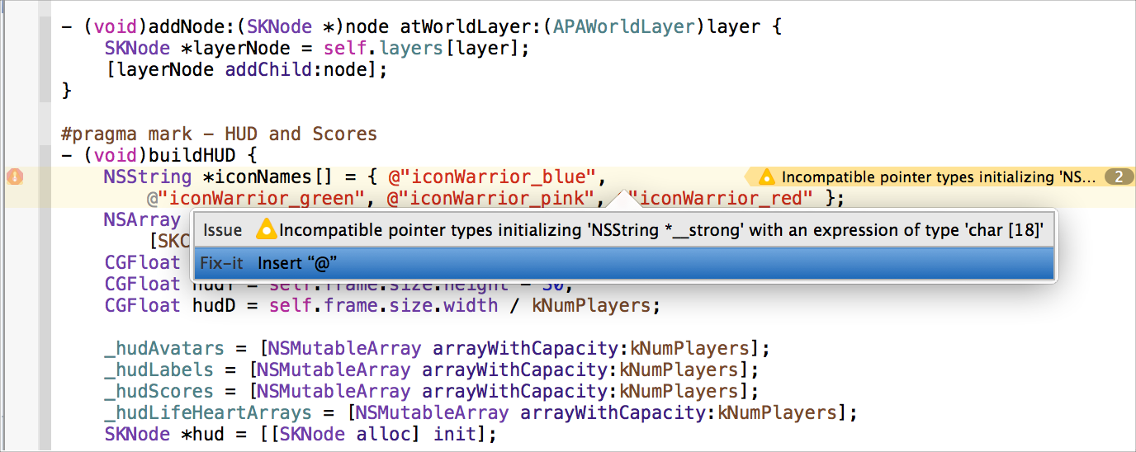

Often, Fix-it offers to repair your error automatically. Select a suggested correction, and press Return to accept it. In the screenshot, Fix-it suggests inserting the “@” character before the text string.

Drop Code Snippets into Your Files

Drop Code Snippets into Your Files

Use code snippets to enter source text with minimum effort. You can drag a code snippet directly from the Code Snippet library into a source file. The Code Snippet library, which is available by clicking the code snippet button ( ) in the utility area of the workspace window, provides a number of useful standard snippets, such as the switch statement snippet shown in the screenshot. You can add your own code snippets to the library.

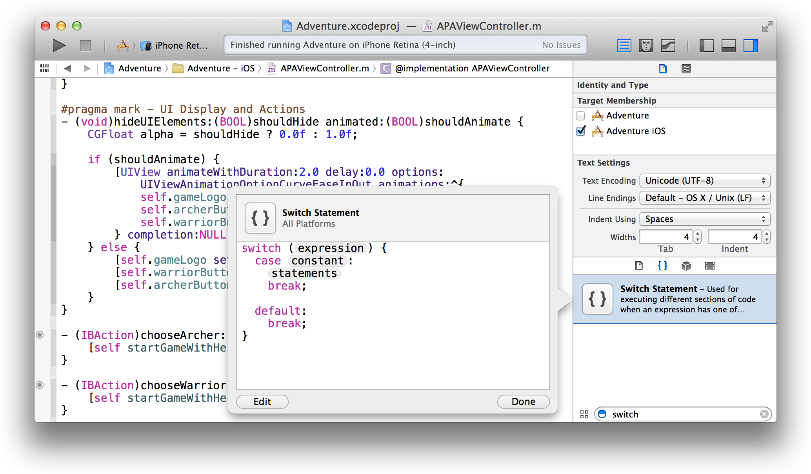

Create Source Files from Templates

Create Source Files from Templates

Use file templates to add files to your project with minimum effort. The File Template library is available by clicking the file template button ( ) in the utility area of the workspace window. Create a source file by dragging its template to the project navigator.

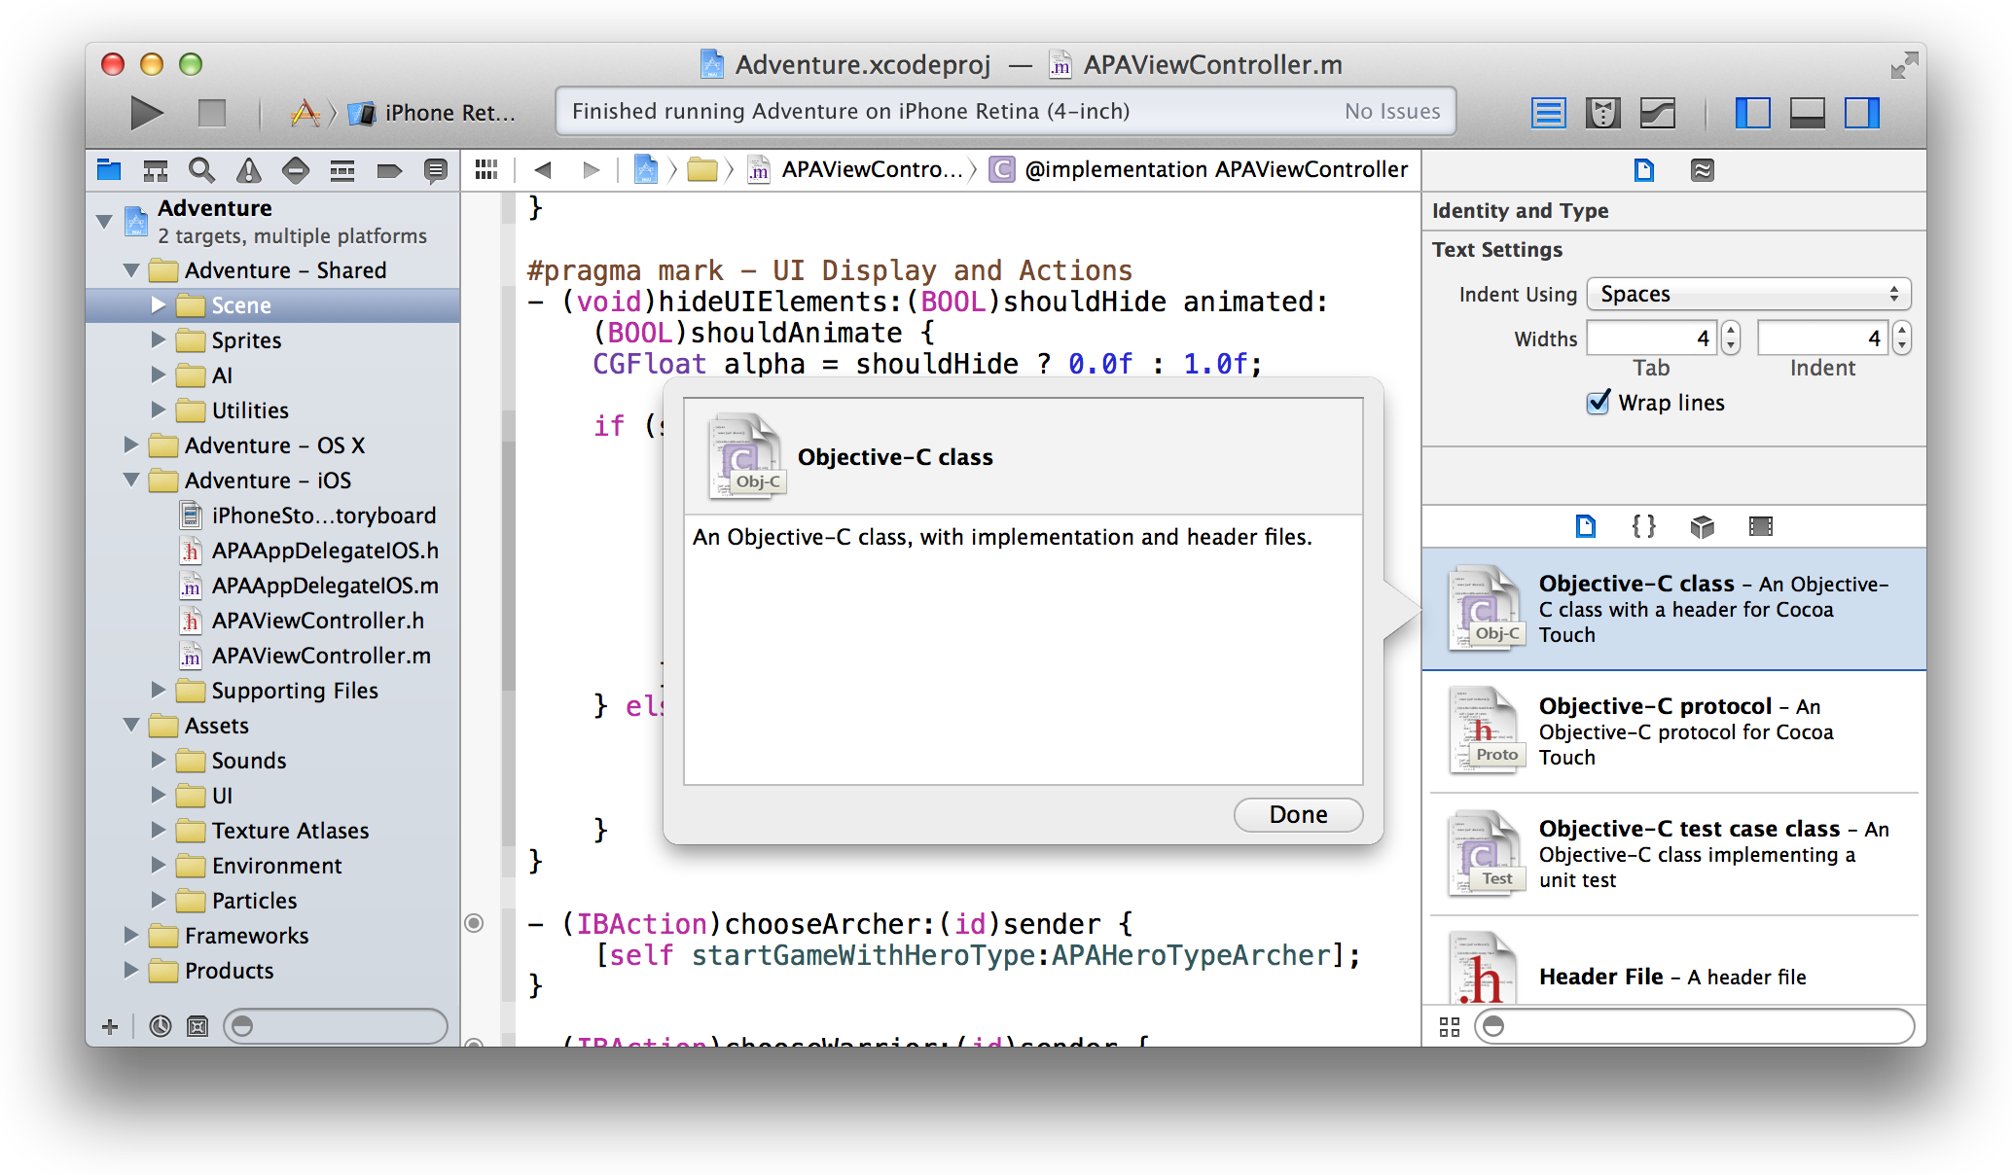

Perform Static Code Analysis

Use the static analyzer to find bugs in your code before you even run your app. The static analyzer tries out thousands of possible code paths in a few seconds, reporting potential bugs that might have remained hidden or bugs that might be nearly impossible to replicate. This process also identifies areas in your code that don’t follow recommended API usage, such as Foundation, UIKit, and AppKit idioms.

To perform static code analysis, choose Product > Analyze. The Xcode static analyzer parses the project source code and identifies these types of problems:

* Logic flaws, such as accessing uninitialized variables and dereferencing null pointers
* Memory management flaws, such as leaking allocated memory
* Dead store (unused variable) flaws
* API usage flaws that result from not following the policies required by the frameworks and libraries the project is using

Speed Up Typing with Code Completion

The static analyzer reports problems in the issue navigator, available by clicking  in the project navigator selector bar. Select an analyzer message in the issue navigator to display the associated code in the source editor. Click the corresponding message in the source editor. Use the pop-up menu in the analysis results bar above the source code editor to study the flow path of the flaw. Then edit the code to fix the flaw.

Speed Up Typing with Code Completion

When you begin typing the name of a symbol, Xcode offers inline suggestions for completing the name. Click an item in the suggestion list to select it. Press Return to accept the suggestion.

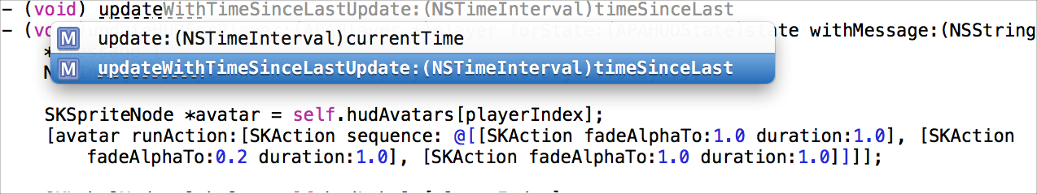

When a method or function contains parameters or arguments, code completion includes a placeholder for each. To move from one placeholder to another, choose Navigate > Jump to Next Placeholder (and Navigate > Jump to Previous Placeholder).

Split the Editor to Display Related Content

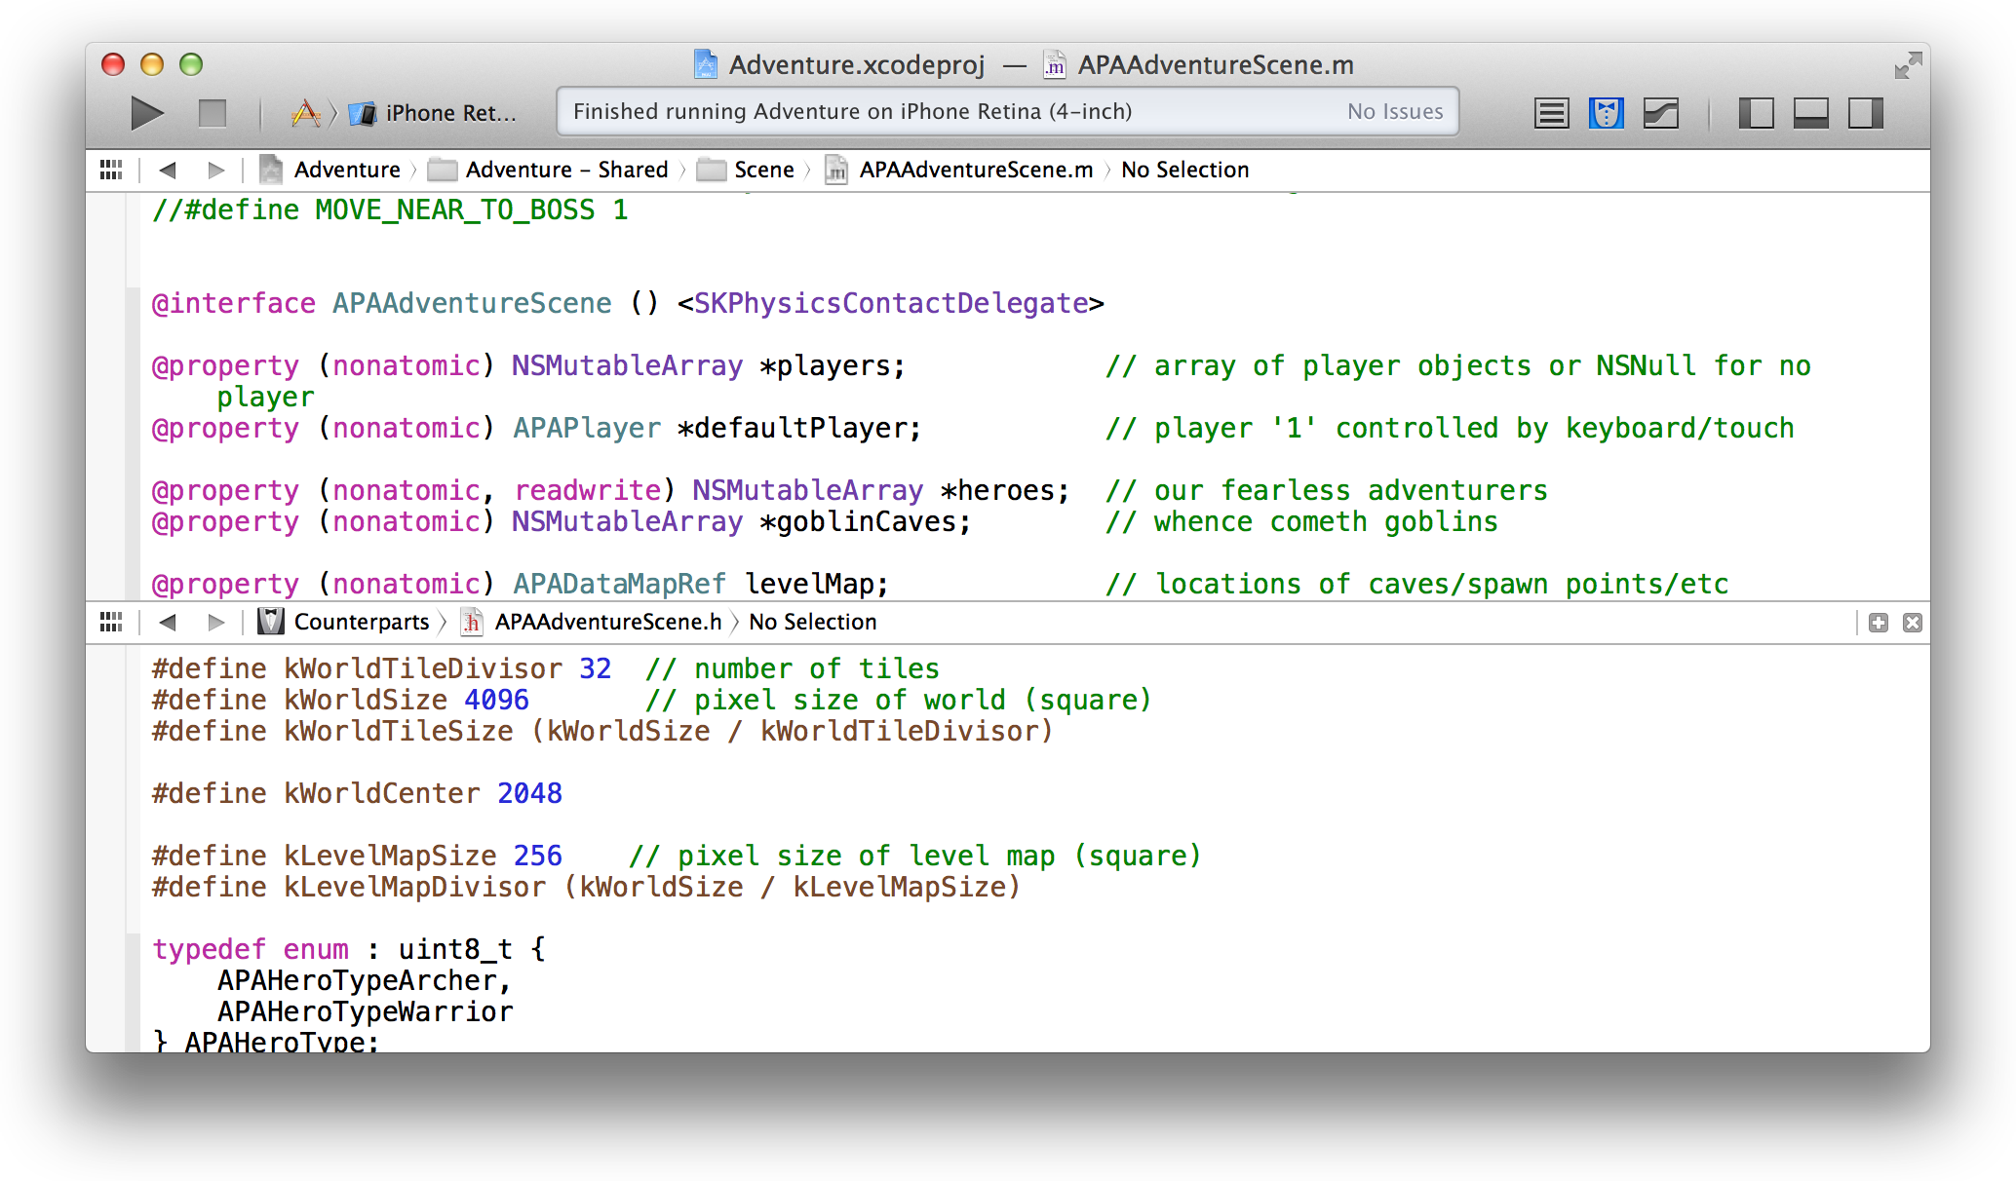Split the editor pane to see multiple views of the same file or to view multiple related files at once. For example, you can simultaneously view an implementation file and its header file counterpart. To split the source editor, open an assistant editor pane by clicking the Assistant Editor button ( ) in the workspace toolbar. The split can be vertical or horizontal.

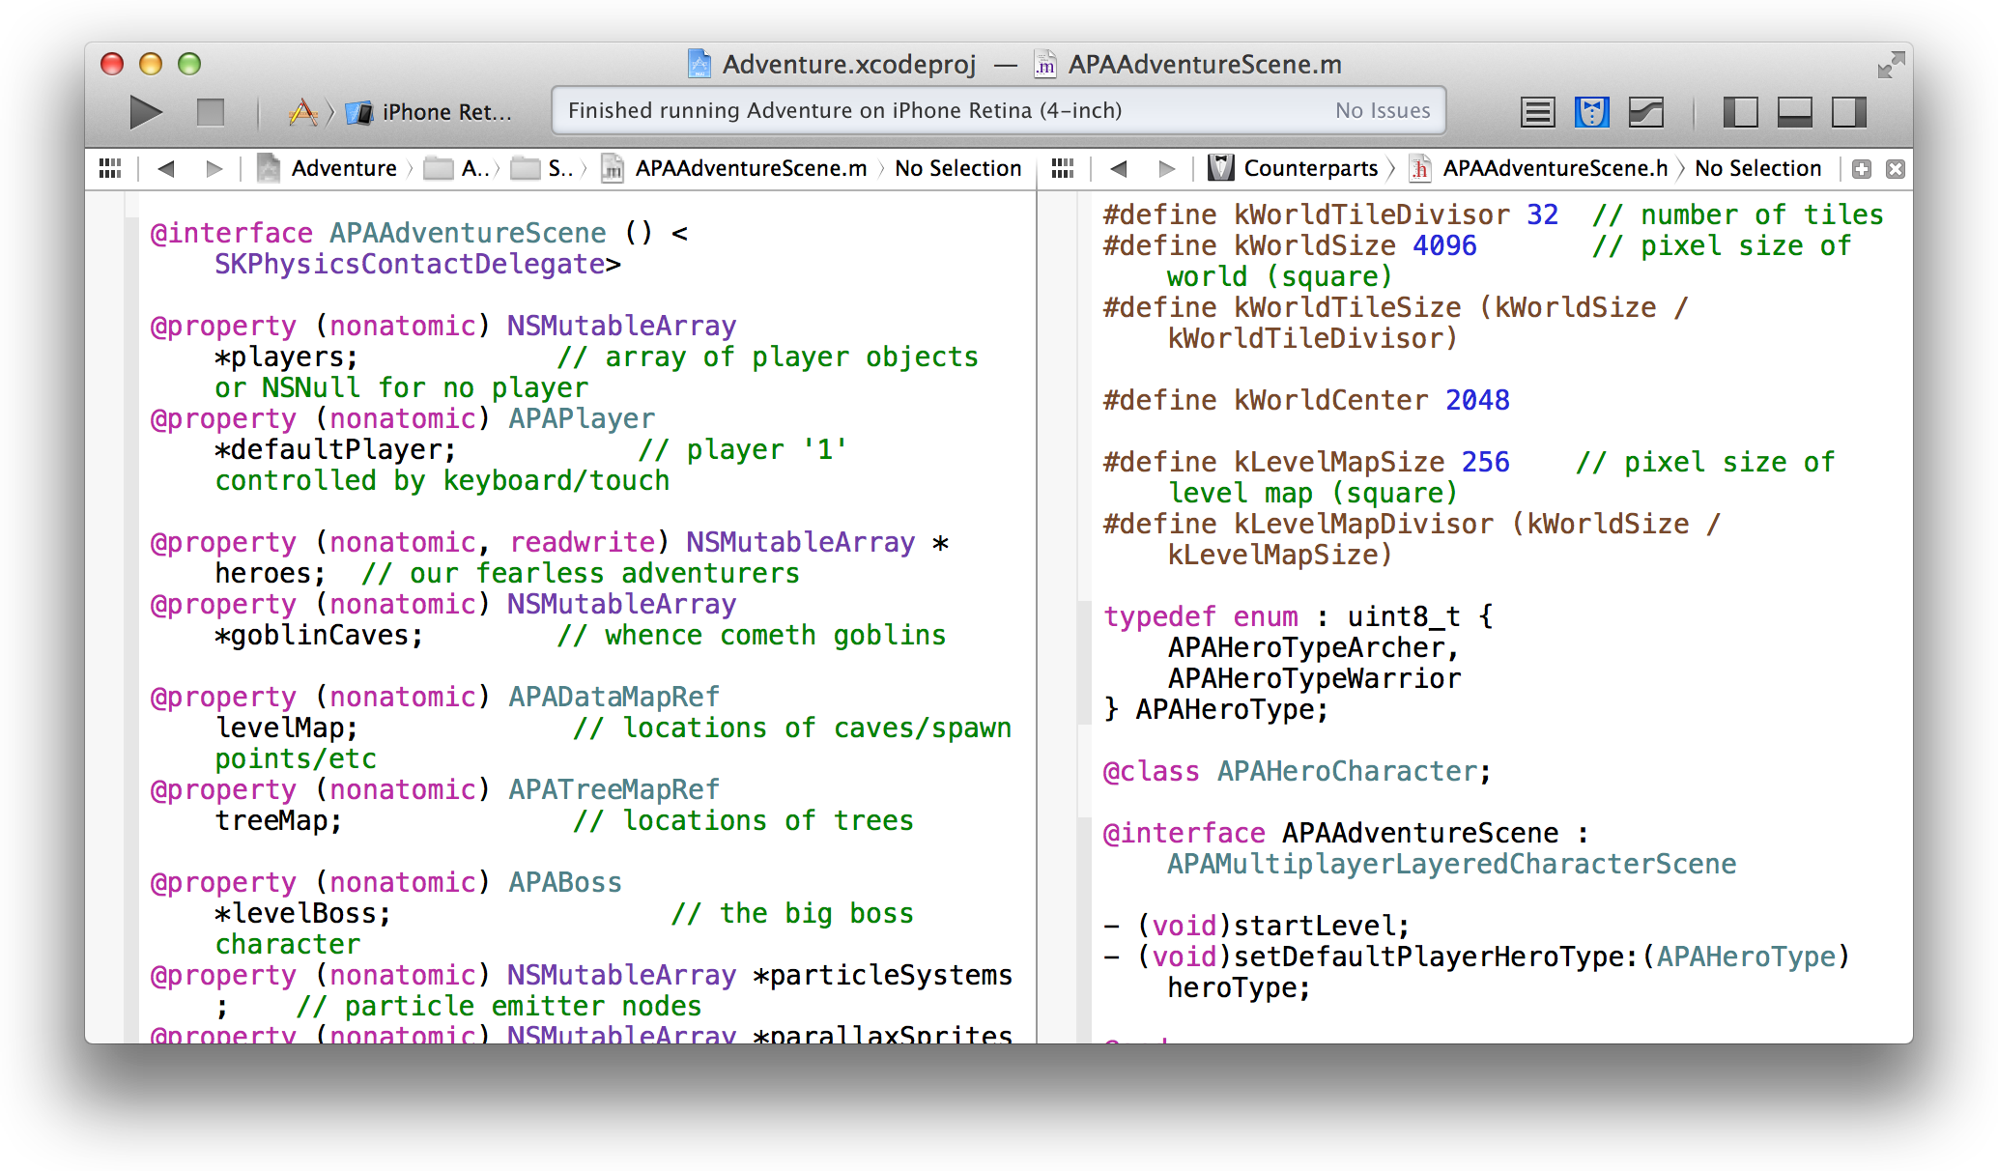

To change the orientation of the split, choose View > Assistant Editor and then choose one of the menu options. In both of the screenshots above, the navigator and utility areas are closed to maximize the viewing area of the source editor.

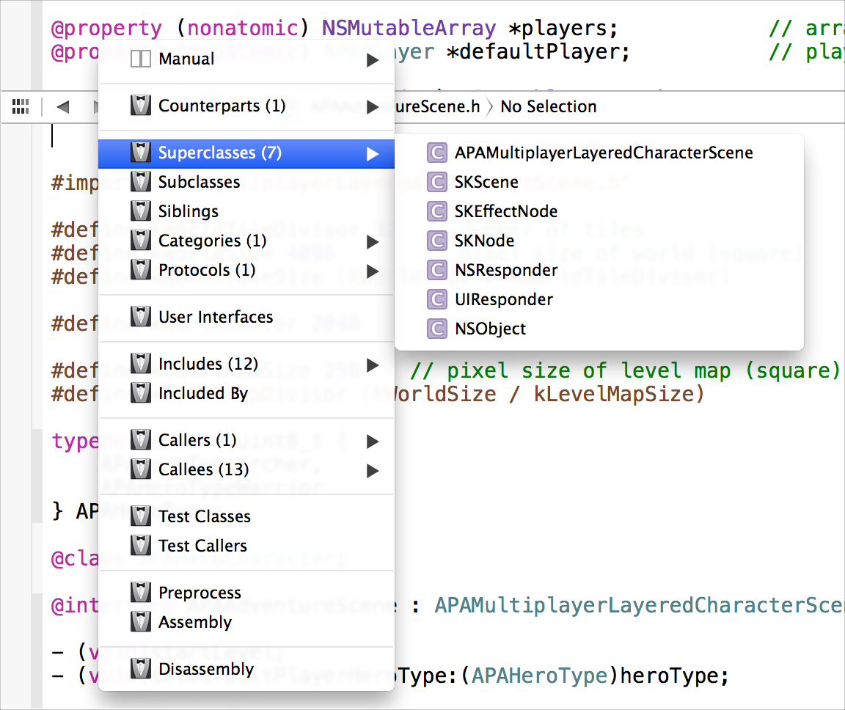When you open an assistant editor pane, you can set it to either of two modes: manual or tracking. In manual mode, you select the file to display by navigating to it in the jump bar. Tracking mode has several criteria to choose from, such as opening counterparts, superclasses, subclasses, and siblings. In tracking mode, Assistant selects the file that best meets your criterion and then displays it.

To change the mode, select one from the Assistant pop-up menu. (The Assistant pop-up menu is the first item to the right of the back and forward arrows in the assistant editor jump bar.)

You can further split the assistant editor pane by clicking the Add button ( ) in the top-right corner of the

assistant editor pane. The nearby Close button ( ) closes it again.

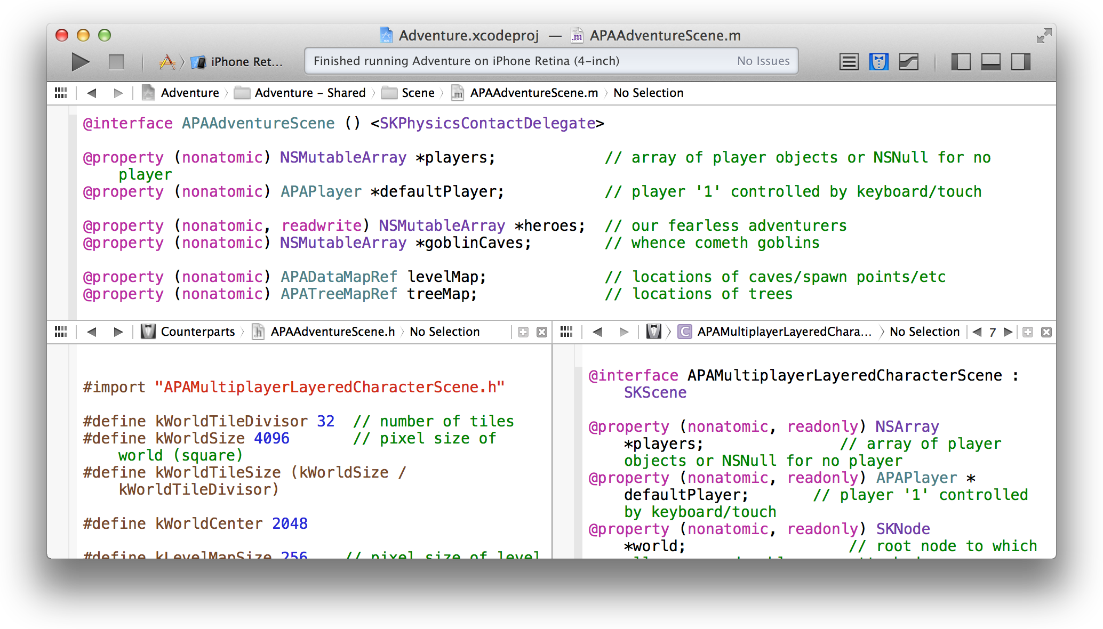

Open a File Quickly

# Open a File Quickly

Choose File > Open Quickly to locate files that define a specified symbol or whose filenames contain a specified string. Open Quickly searches are case insensitive and are limited to the current project and to the active software development kit (SDK). From the search results list, double-click the file you want to open.

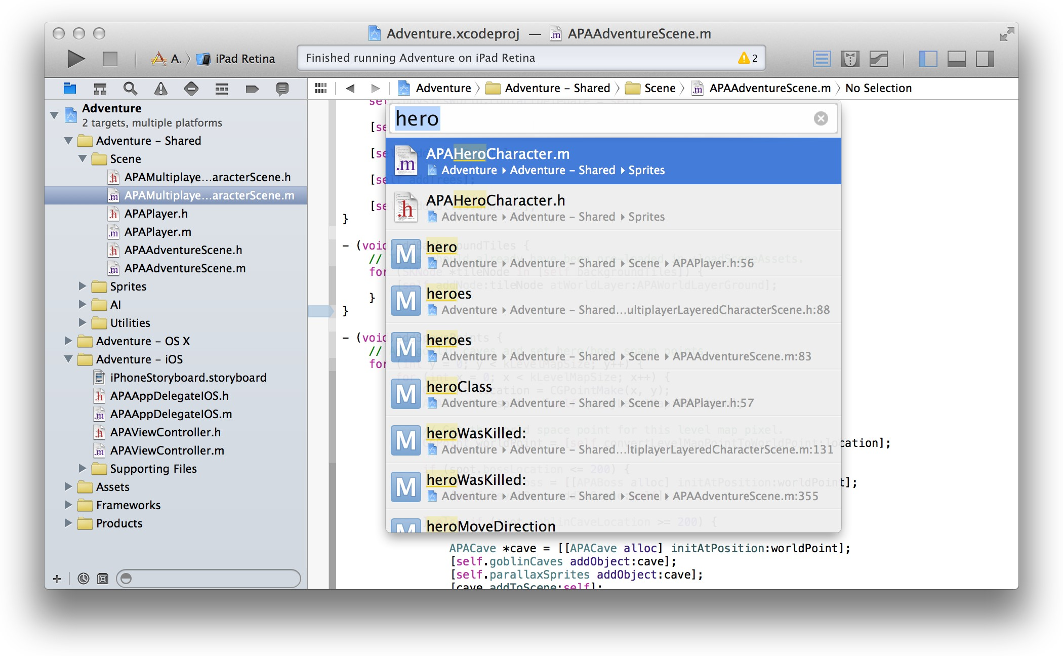

To open the file in the assistant editor pane, hold down the Option key when you double-click. To open the file in a separate window, hold down Option-Shift. To see a dialog letting you specify where the file should open, hold down Option-Shift-Click.

# Use Gestures and Keyboard Shortcuts

Gestures and keyboard shortcuts can simplify and enhance your use of the source editor. Besides the common Multi-Touch gestures in OS X, three are particularly applicable within the source editor:

* A three-finger swipe, to switch between a source file (.m) and the associated header (.h) file
* A two-finger tap, to open a contextual menu for the editor
* A two-finger swipe, either up/down or left/right, to scroll vertically or horizontally

Automate Extensive Changes in Your Code

Keyboard sequences serve as shortcuts for many common menu commands in Xcode. For example, Shift-Command-O invokes the Open Quickly command from the File menu, and Shift-Command-D invokes the Jump to Definition command from the Navigate menu. Other keyboard shortcuts assist with editing operations. For example, Control-K deletes every character from the insertion point to the end of the line.

Keyboard shortcuts are established through key bindings, which you can view and modify by choosing Xcode > Preferences and selecting Key Bindings.

# Automate Extensive Changes in Your Code

When you need to make changes that apply to multiple lines of text, Xcode offers several approaches.

You can simultaneously modify all the occurrences of a symbol, such as the name of a local variable or parameter, within a scope. Place the insertion point in the symbol you want to edit. When the pop-up menu control appears, click the control to display the menu, and select Edit All in Scope. Edit the symbol. As you type new text, all instances of the symbol change simultaneously.

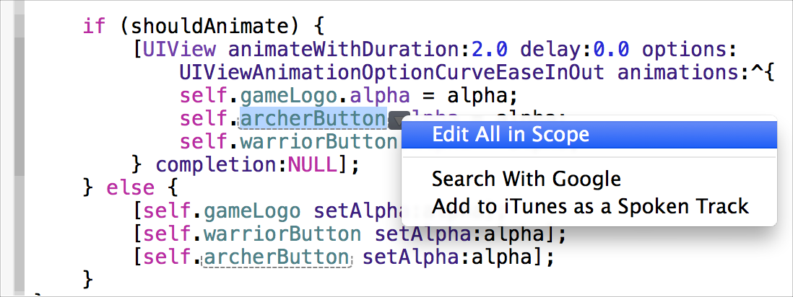

Automate Extensive Changes in Your Code

You can change instances of a text string in a single file by choosing Find > Find and Replace.

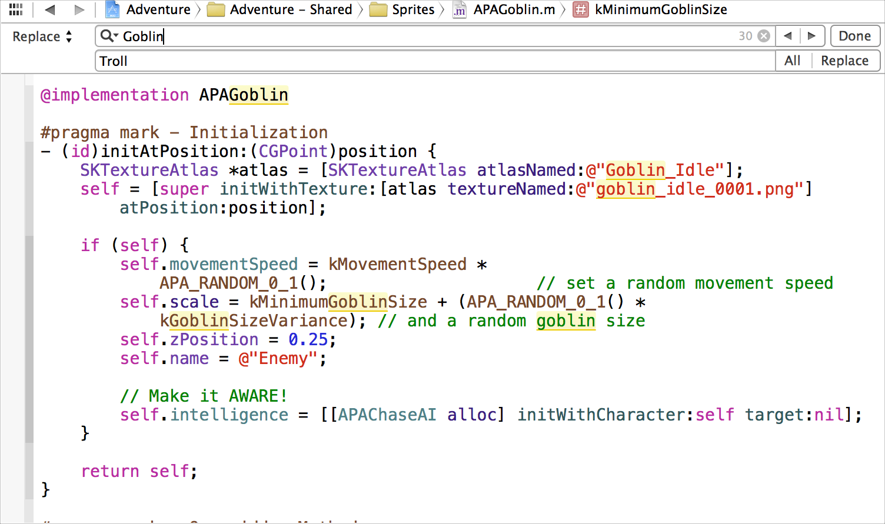

You can change instances of a text string in your project or workspace by choosing Find > Find and Replace in Project. This command displays the find navigator. You can customize the operation—for example, to limit the scope of the search or to match the case of letters in the string. The find navigator provides a preview that allows you replace all instances of the string or to accept or reject individual replacements.

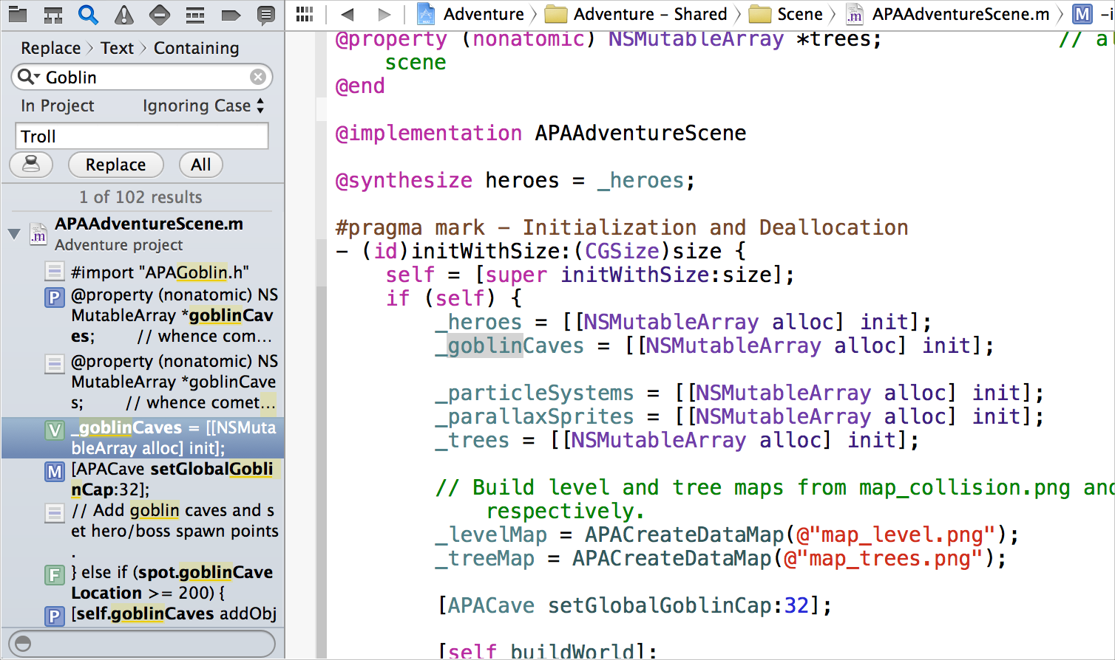

Display the Definition a Symbol

You can refactor your code to improve its structure, readability, and maintainability without changing its behavior. A refactoring operation (also called a *transformation*) is applied to a code fragment or a symbol that you select in the source editor. You can rename symbols, extract code into methods, create superclasses, move items up to the superclasses or down to their subclasses, and encapsulate variables throughout your project files.

After selecting the code fragment or symbol you want to refactor, choose Edit > Refactor and then the appropriate refactoring command. A preview pane shows you how each change will appear when applied. Deselect a file in the leftmost pane of the preview dialog to leave it out of the refactoring operation. You can edit your source code directly in the preview dialog. Any such edits are shown in the preview and are included in the refactoring operation.

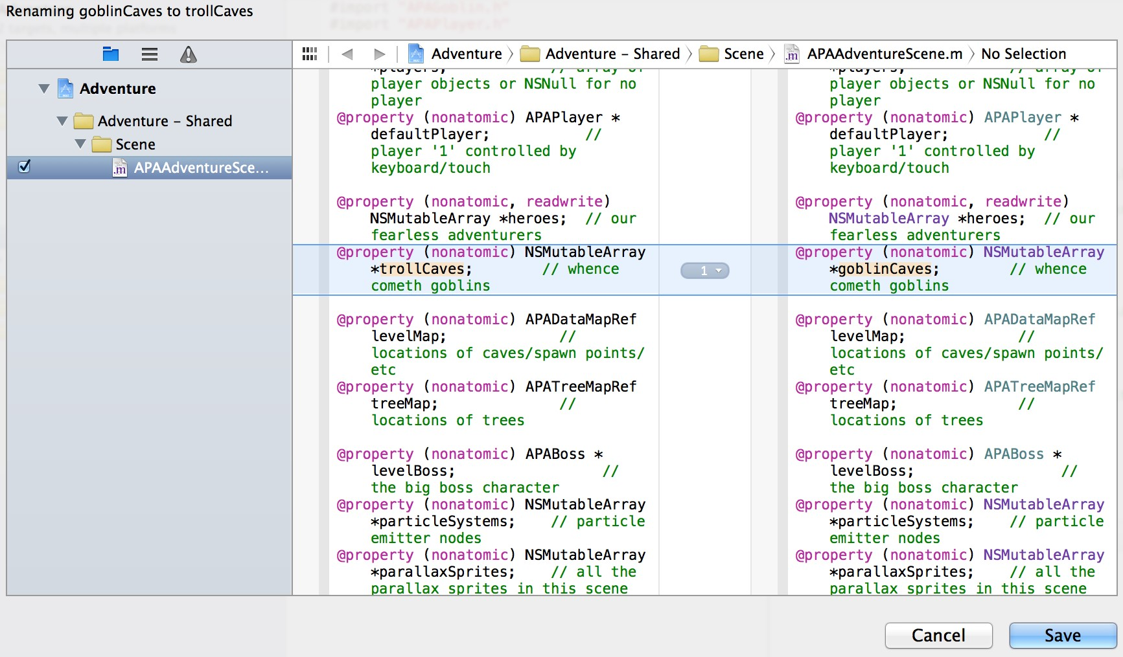

# Display the Definition of a Symbol

Place the pointer over a symbol and Command-click to display the symbol definition. The source editor navigates to the symbol definition and highlights it. If the definition is in a separate file, the source editor displays that file. (Alternatively, you can place the pointer over a symbol and choose Navigate > Jump to Definition.)

Display the Definition a Symbol

Place the pointer over a symbol and Option-Command-click to display its definition in the assistant editor pane, as illustrated for the APALoadFramesFromAtlas function in the screenshot. This approach lets you keep the symbol in view as you inspect its definition.

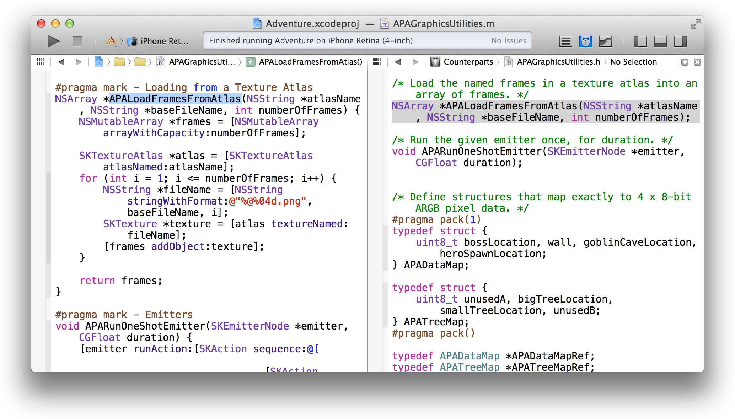

Examine the Structure Your Code with Code Folding

# Examine the Structure of Your Code with Code Folding

You can more easily focus your attention on a particular method or function in source code by hiding the other parts of the source code. Choose Editor > Code Folding > Fold Methods & Functions. Navigate to the method you want to unfold and double-click the ellipsis button to unfold the method. The screenshot shows the configureConnectedGameControllers method unfolded.



Move the pointer into the focus ribbon on the left edge of the editor to display a scope—such as the for statement in the screenshot—in a focus box. Additional scopes are indicated by degrees of shading in the code.

# Match Pairs of Braces, Parentheses, and Brackets Automatically

Xcode helps you balance delimiters automatically. For example:

* Position the pointer over the focus ribbon on the left edge of the source editor. Xcode highlights the scope at that location, as shown in the previous screenshot.
* Type an opening brace. Xcode automatically inserts a closing brace after you enter a line break.
* Type a closing brace or other delimiter. Xcode briefly highlights its counterpart.
* Use the Right Arrow key to move the insertion point past a closing delimiter. Xcode briefly highlights its counterpart.

Choose Syntax-Aware Fonts and Text Colors

* Choose Editor > Structure > Balance Delimiter. Xcode selects the text surrounding the insertion point, including the nearest set of enclosing delimiters.
* Double-click any delimiter. Xcode selects the text enclosed by the delimiter and its counterpart.

# Choose Syntax-Aware Fonts and Text Colors

Xcode parses code based on the language, and it assigns a syntactic label to each token or string—for example, each comment, keyword, class name defined in the project, and other class name. Xcode assigns a color and font to each syntactic type to make it easier for you to read the code. You can select from several font and color themes by choosing Xcode > Preferences and then selecting Fonts & Colors. For example, the Presentation theme increases the font sizes so that the text is easier to read when projected on a screen. You can also create your own custom font and color themes.

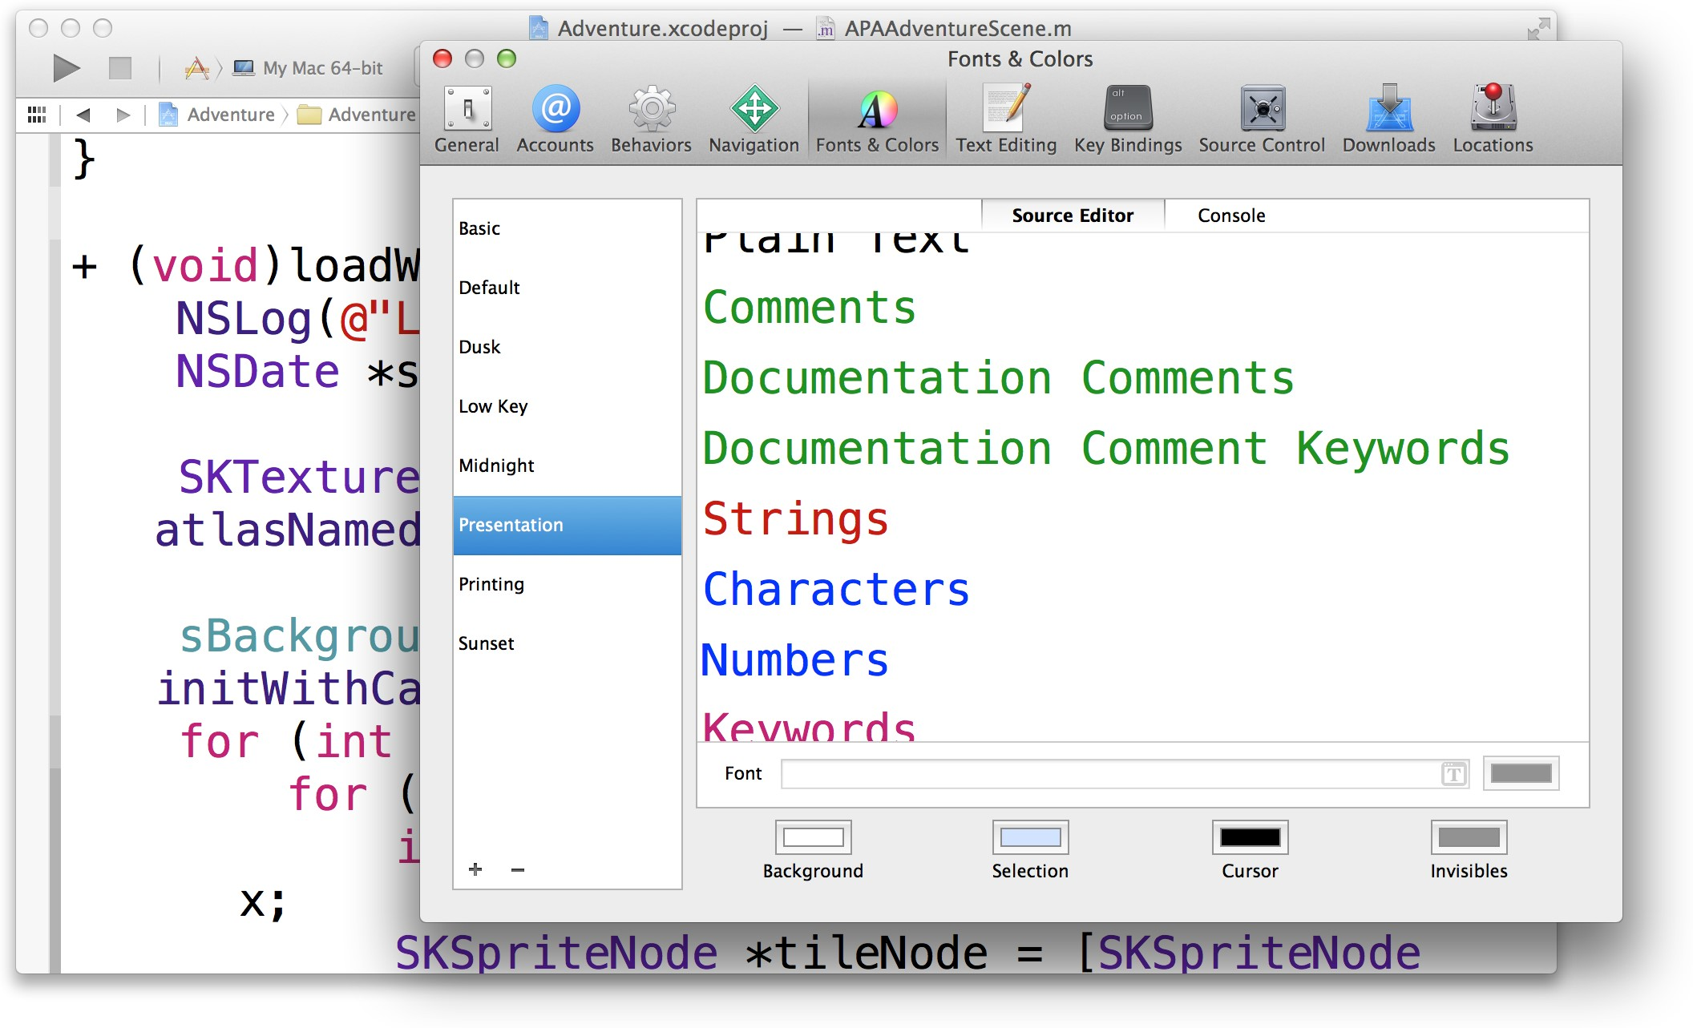

# Customize Editing and Indenting Options

You can change source editing and indenting settings to suit your preferences. Choose Xcode > Preferences, and select Text Editing to modify options such as these:

* Display line numbers in the source editor gutter.
* Automatically insert closing braces as you type.
* Suggest code completions while you enter code.
* Use spaces or tabs for an indent.
* Soft-wrap lines.
* Perform syntax-aware indenting.

# Look Up Documentation for a Symbol

Find concise reference documentation for a symbol by placing the insertion point in the symbol. Click  in the view selector in the toolbar, and select the Quick Help button ( ) in the inspector selector bar. Quick Help for that symbol appears in the utility area.

The information includes links to complete reference documentation for the symbol, the header file where the symbol is declared, related programming guides, and related sample code. (To view in a pop-up window only a description of the symbol, its release availability, its header file, and a link to it’s related reference document,

Option-click the symbol.)

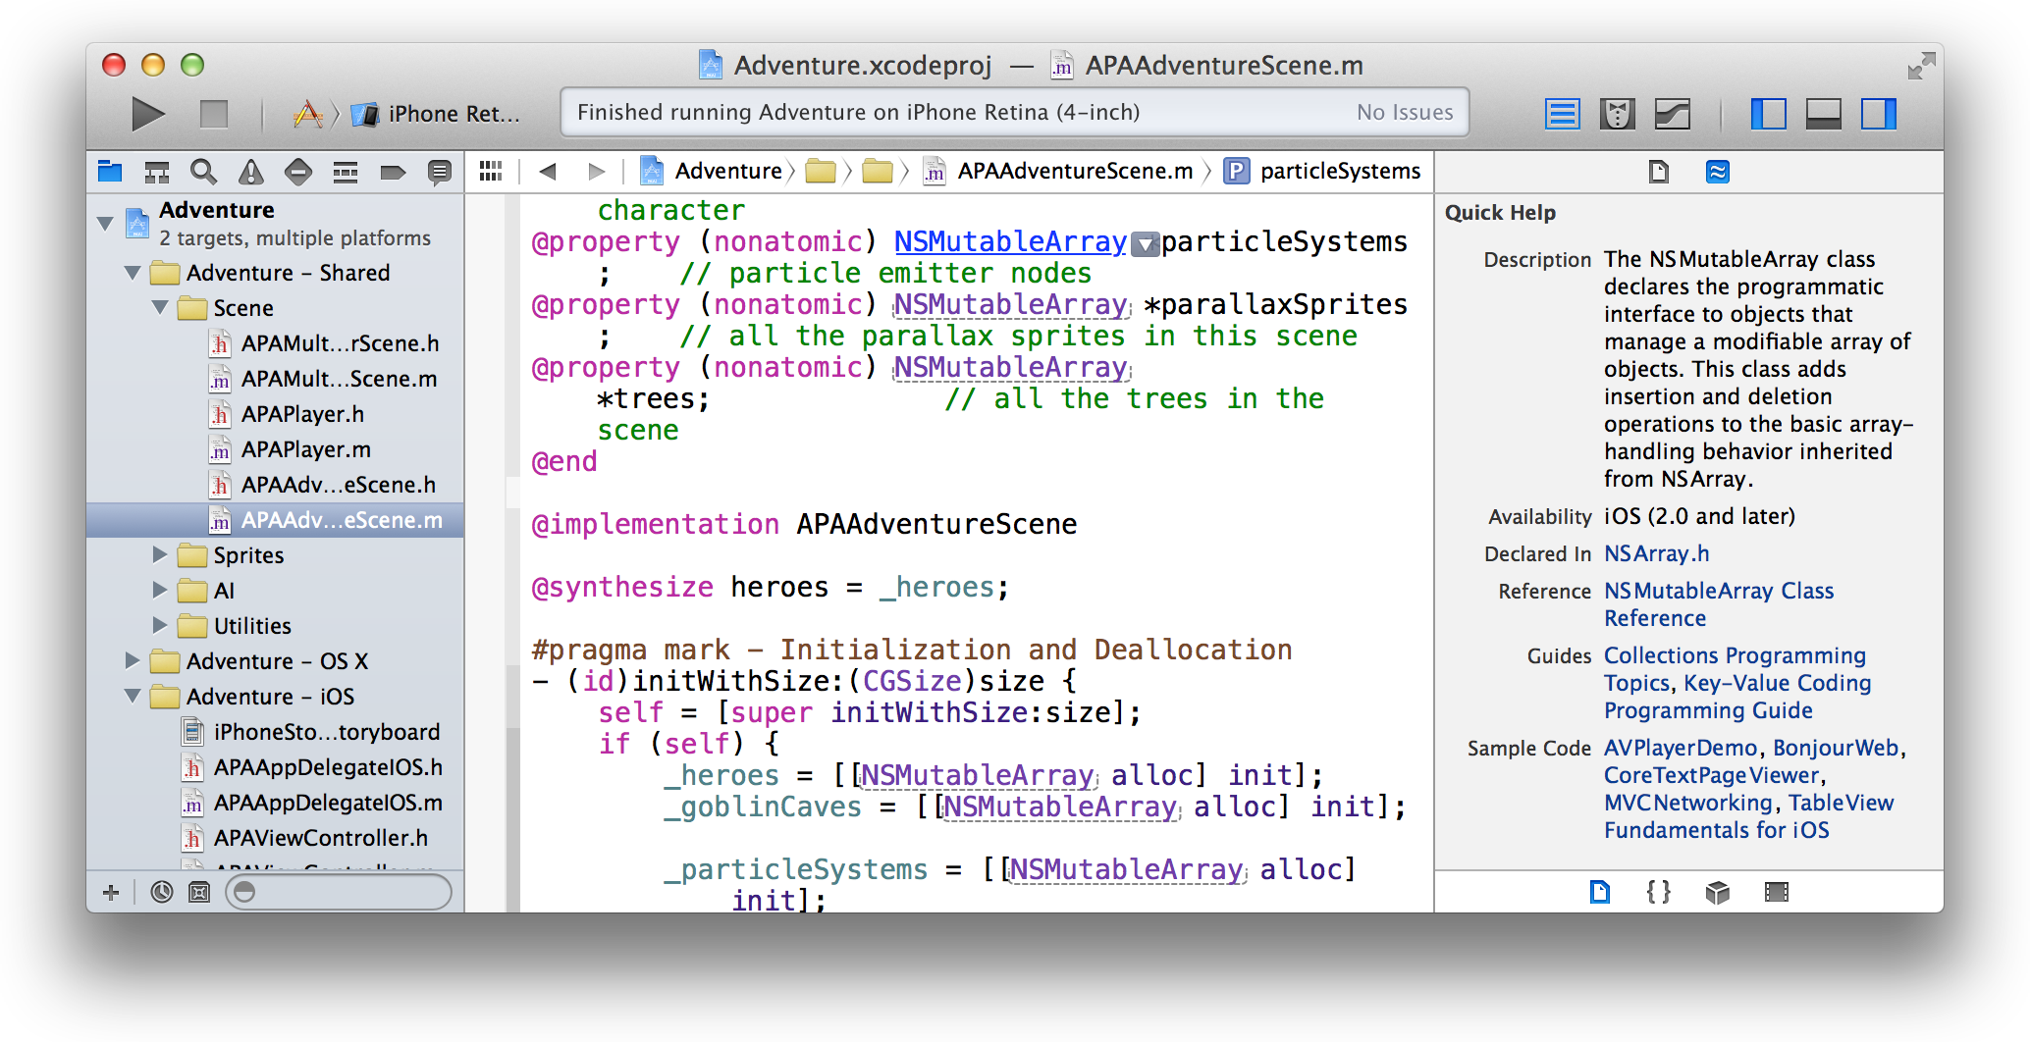

Click a link in Quick Help, and Xcode opens a separate Xcode documentation viewer window. The Xcode documentation viewer provides access to information without taking your focus away from the file you’re editing.

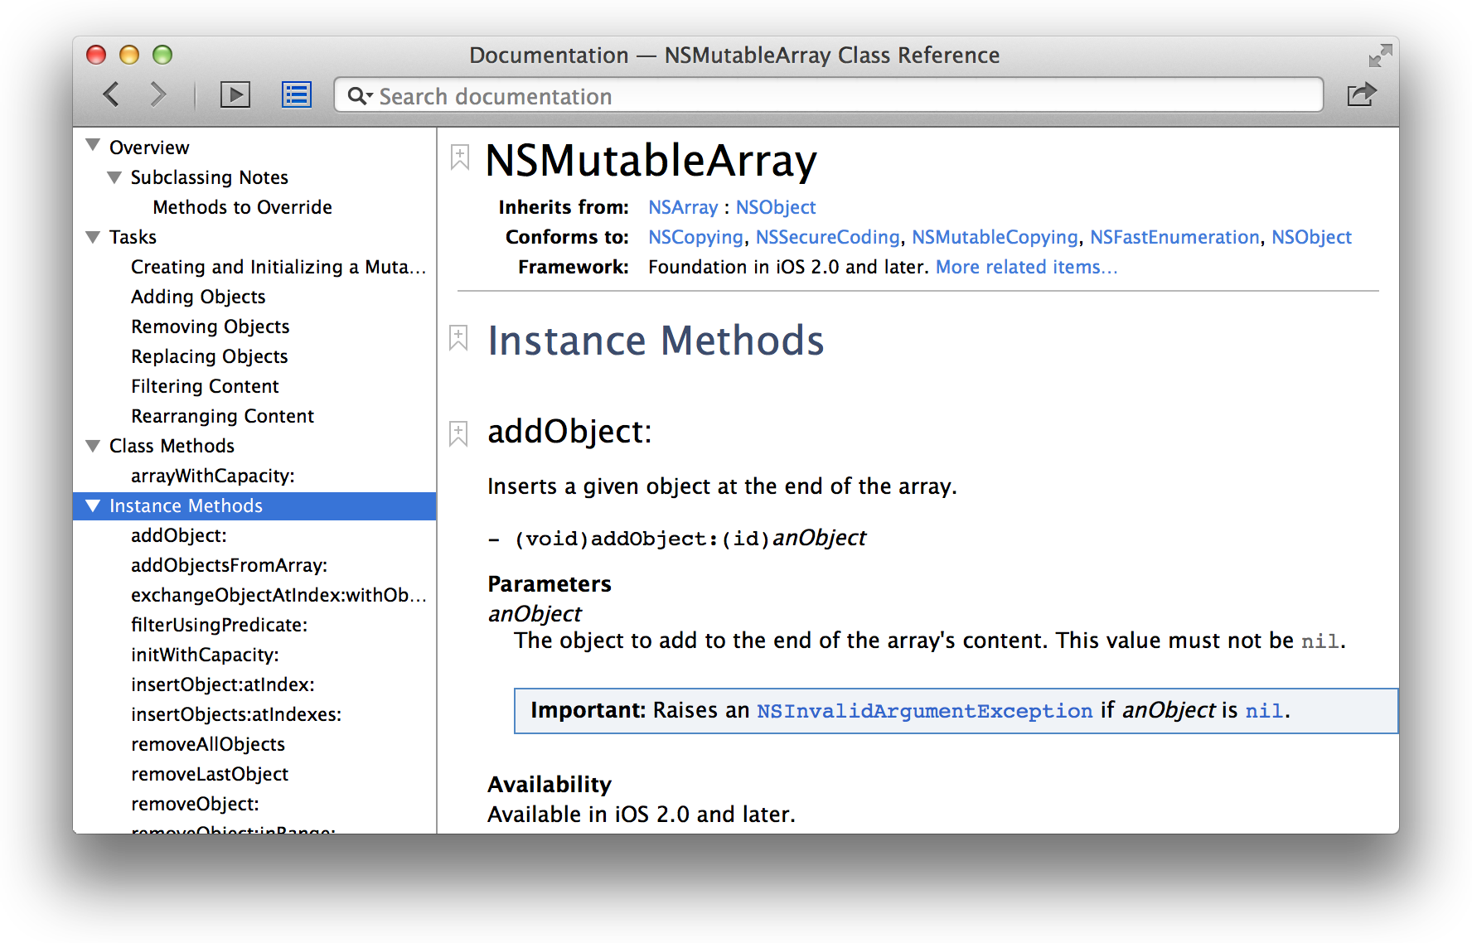

The document viewer delivers in-depth programming guides, tutorials, sample code, and video presentations by Apple engineers, in addition to detailed framework API references. From a class reference, click “More related items” near the top of the viewer for links to additional documents relevant to your programming task.

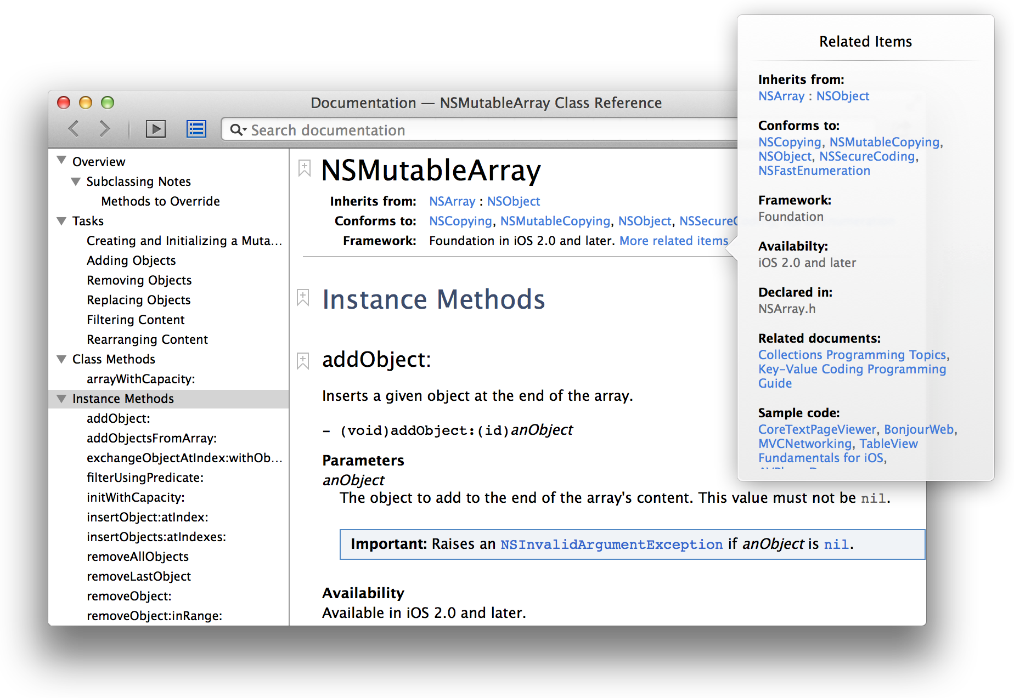

Use the Search bar to locate additional information about the API or programming concept.

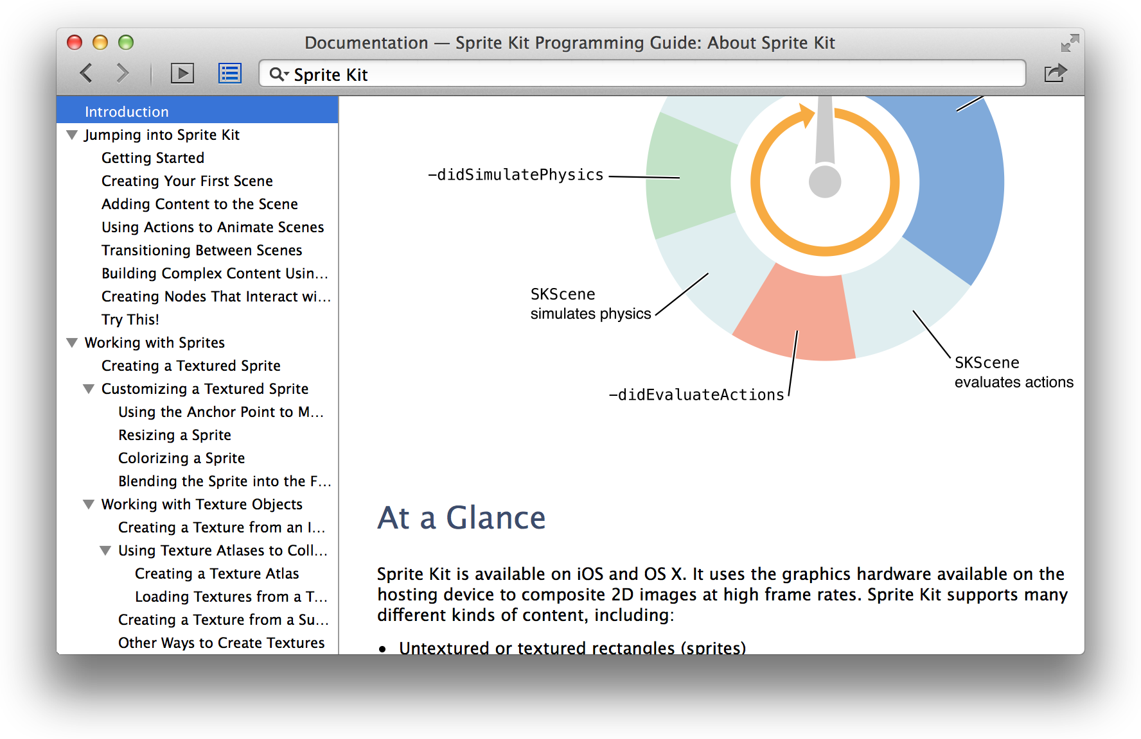

To include a link to the document in a message, click the Share button ( ) and choose Email Link or Message. You can open the document in Safari in HTML or PDF format from this menu. For a sample code project, click Open Project at the top of the window to download the project and open it in Xcode.

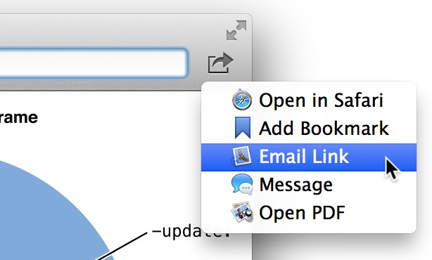

Find Help for Using the Source Editor

# Find Help for Using the Source Editor

Step-by-step instructions for performing common source editor tasks are available directly in Xcode. Control-click anywhere in the source editor to see a short list of the most common operations. Choose Show All Help Topics to see all help articles for the source editor. Select a task, and a help article appears in the Xcode documentation viewer window.

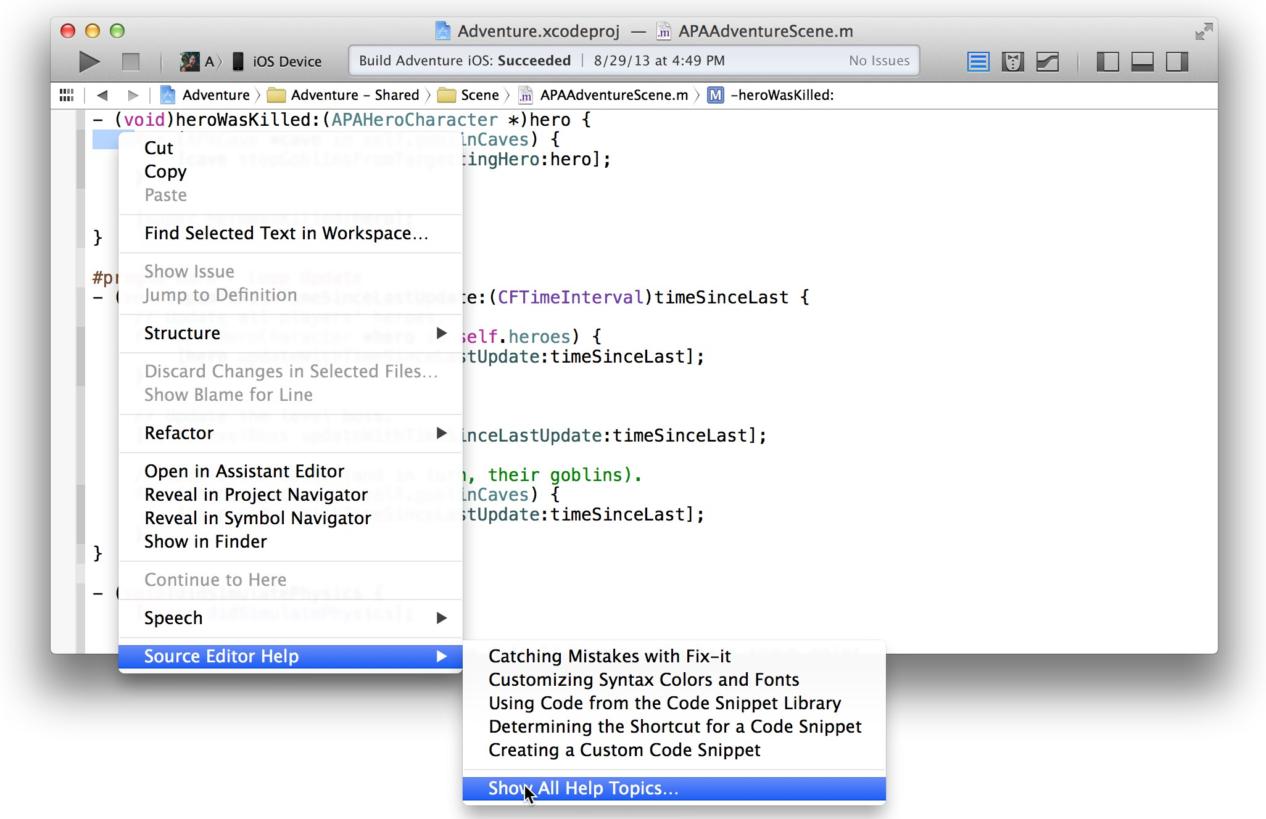

Find Help for Using the Source Editor

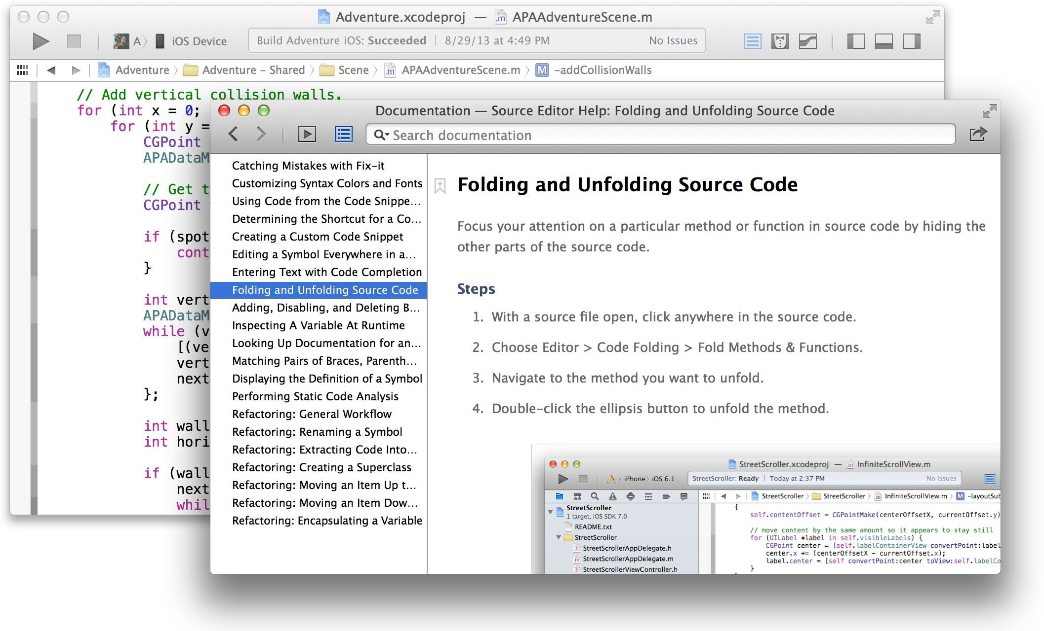

Xcode Help articles are available from shortcut menus throughout Xcode. Control-click in any of the main user interface areas to see a list of help articles available for that area.

# Build a User Interface

You create your app’s user interface in Interface Builder. To add user interface elements, drag objects from the utility area into Interface Builder, where you arrange the elements, set their attributes, and establish connections between them and the code in your source files. You save these configured objects in a user interface file.



A user interface file for an iOS app has the filename extension storyboard. A user interface file for a Mac app has the filename extension xib. To view and edit a user interface file, select it in the project navigator. Interface Builder displays the file’s contents in the editor area of the workspace window.

As you lay out your app’s user interface elements in Interface Builder, you can write the code that implements their behavior in the assistant editor.

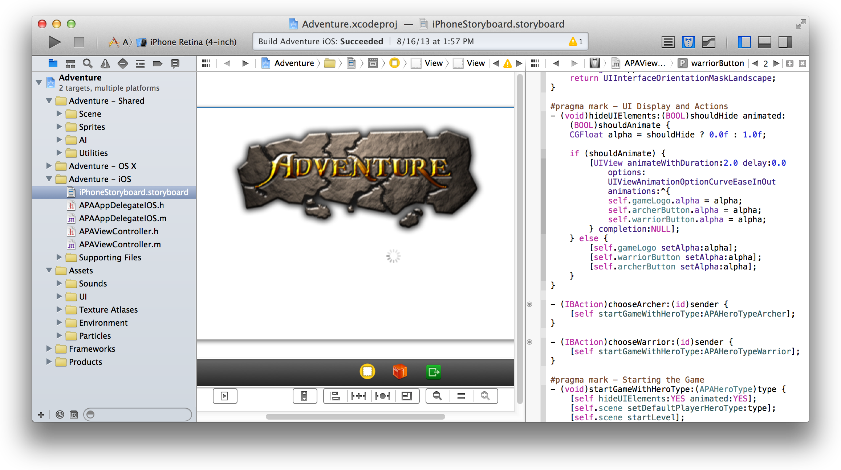

# Add User Interface Elements from the Object Library

Interface Builder has two major areas: the dock (on the left) and the canvas (on the right). The dock lists the objects contained in the user interface file. The canvas is where you lay out these objects in your app’s user interface.

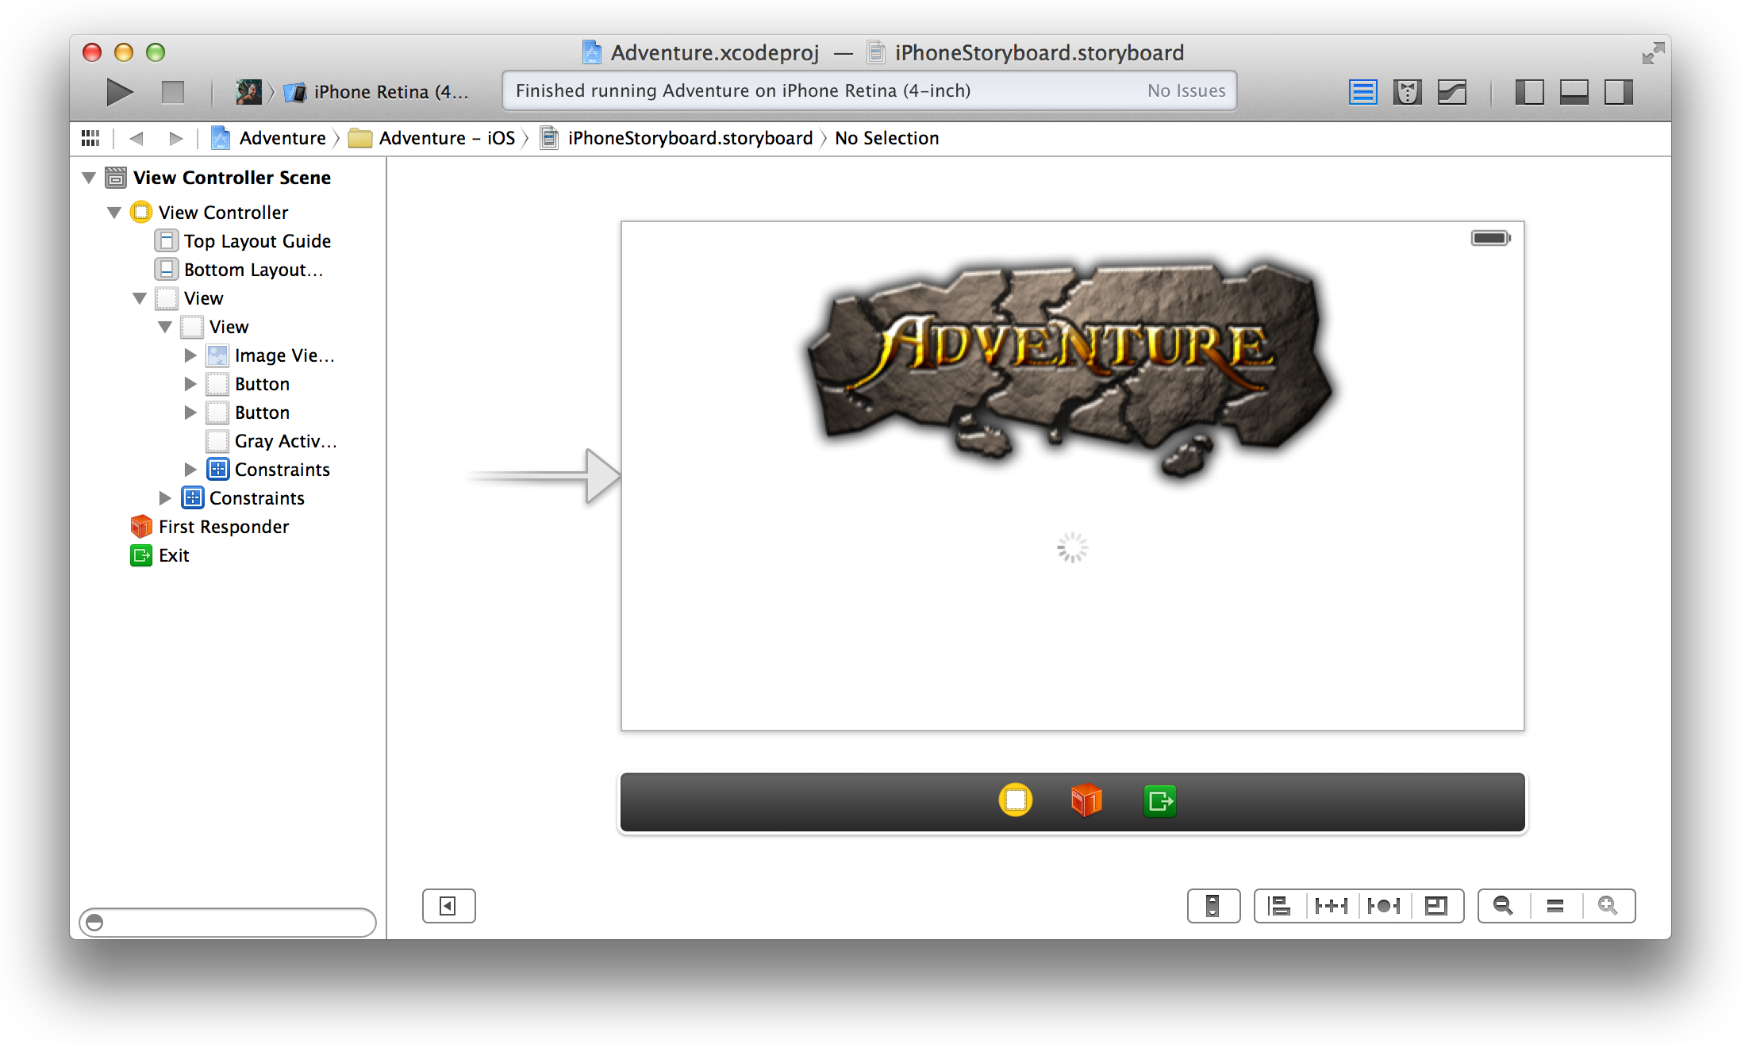

The *outline view* in the dock shows all the objects nested inside higher-level objects.

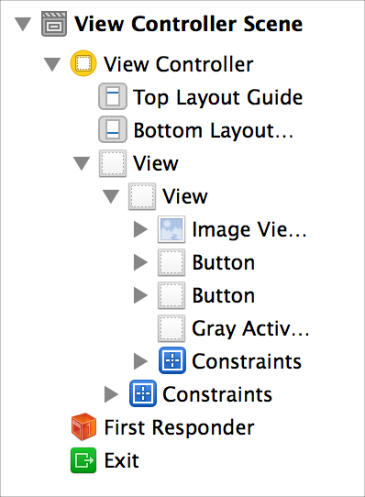

For xib files, you can display the high-level objects in an *icon view*, as well as in an outline view.

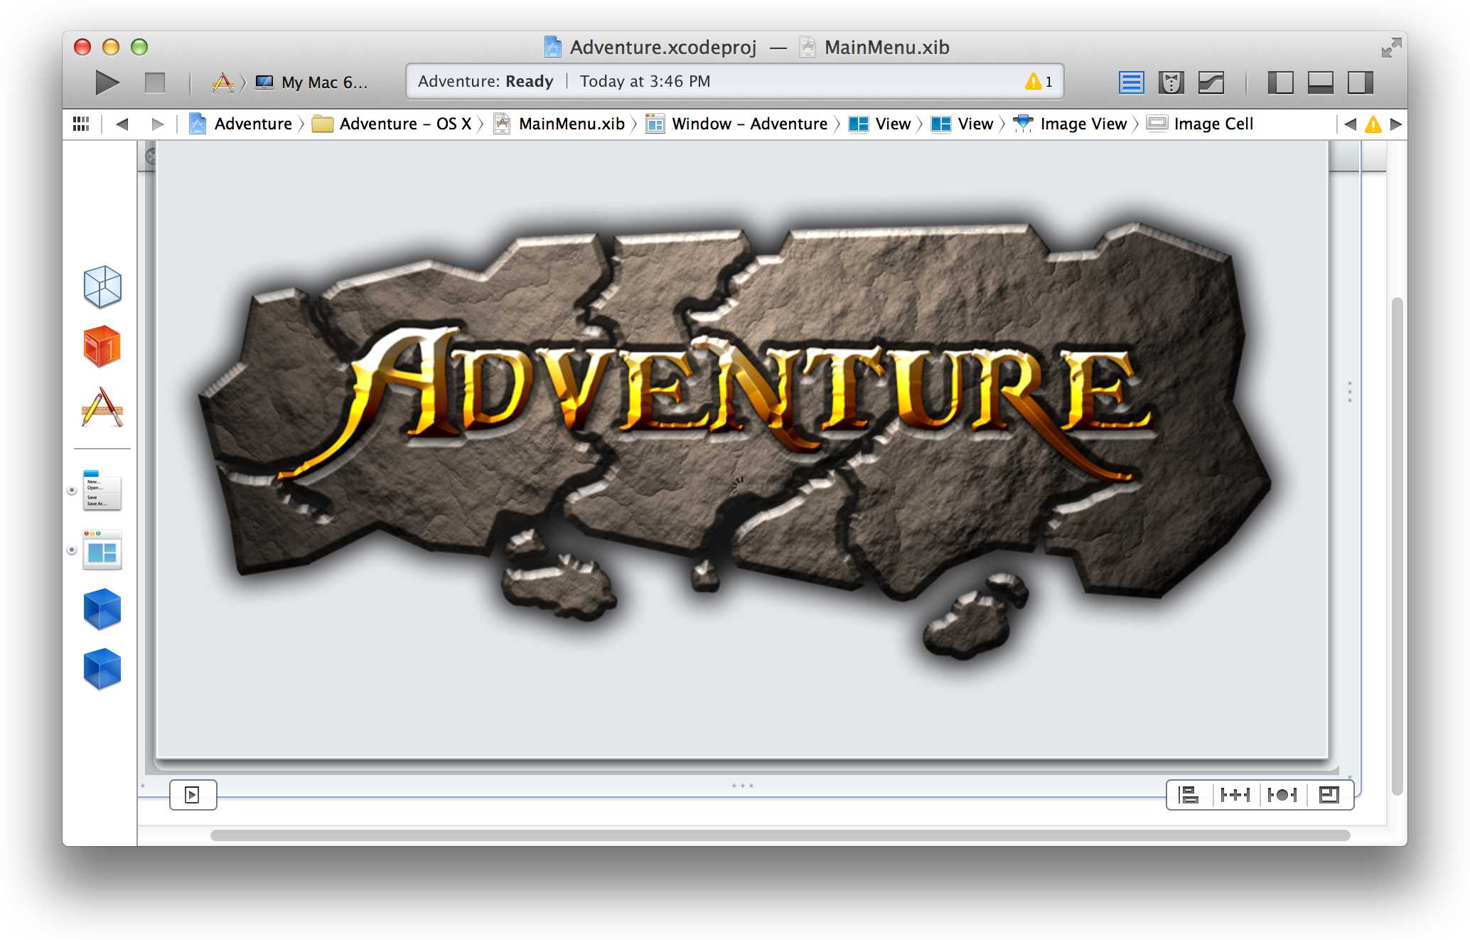

For storyboard files, only an outline view appears in the dock. However, every individual scene in a storyboard has its own scene dock directly below the canvas. The scene dock shows objects only in icon view.



To add an object to your app’s user interface, open the utility area for the workspace window by clicking in the view selector in the toolbar. Select the object library from the library pane by clicking  in the library selector bar. Drag an object (like Button in the screenshot) from the library to either the outline view in the dock or onto the canvas.

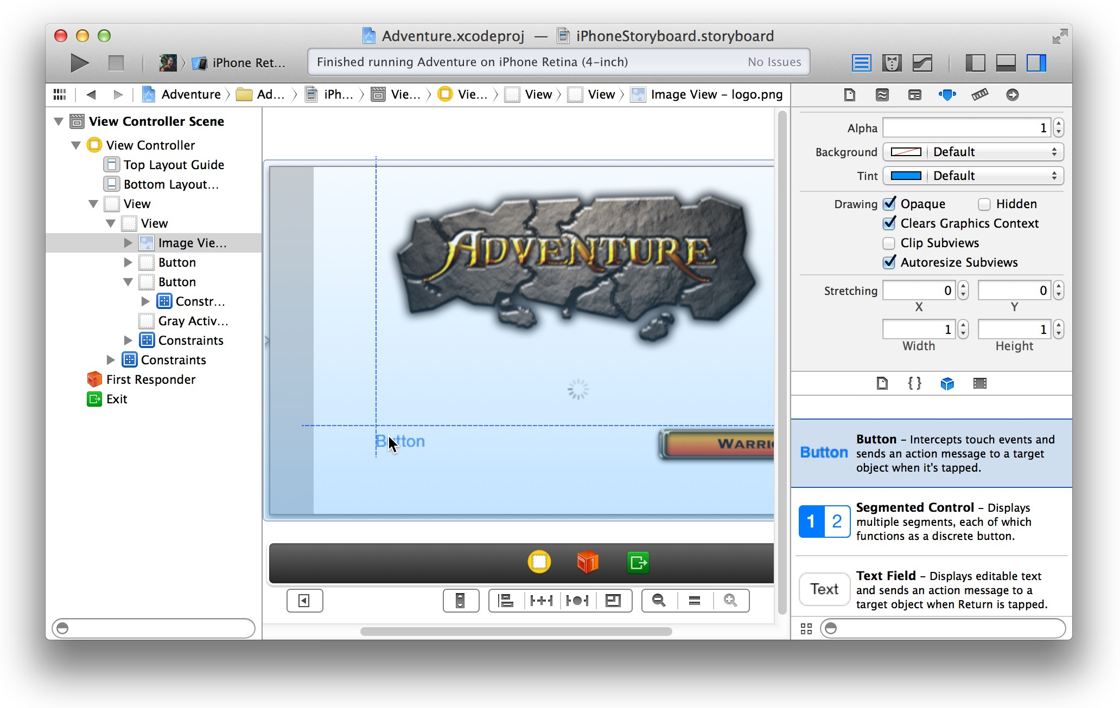

As you add objects to Interface Builder, you resize them by their handles and reposition them by dragging. As you move items, dashed blue lines help you align and position the item within the view.

Above the object library in the utility area are the Interface Builder inspectors. You use these inspectors to specify some of the interface objects’ appearance and behavior. In the screenshot below, the Attributes inspector ( ) is used to specify the button type Custom.

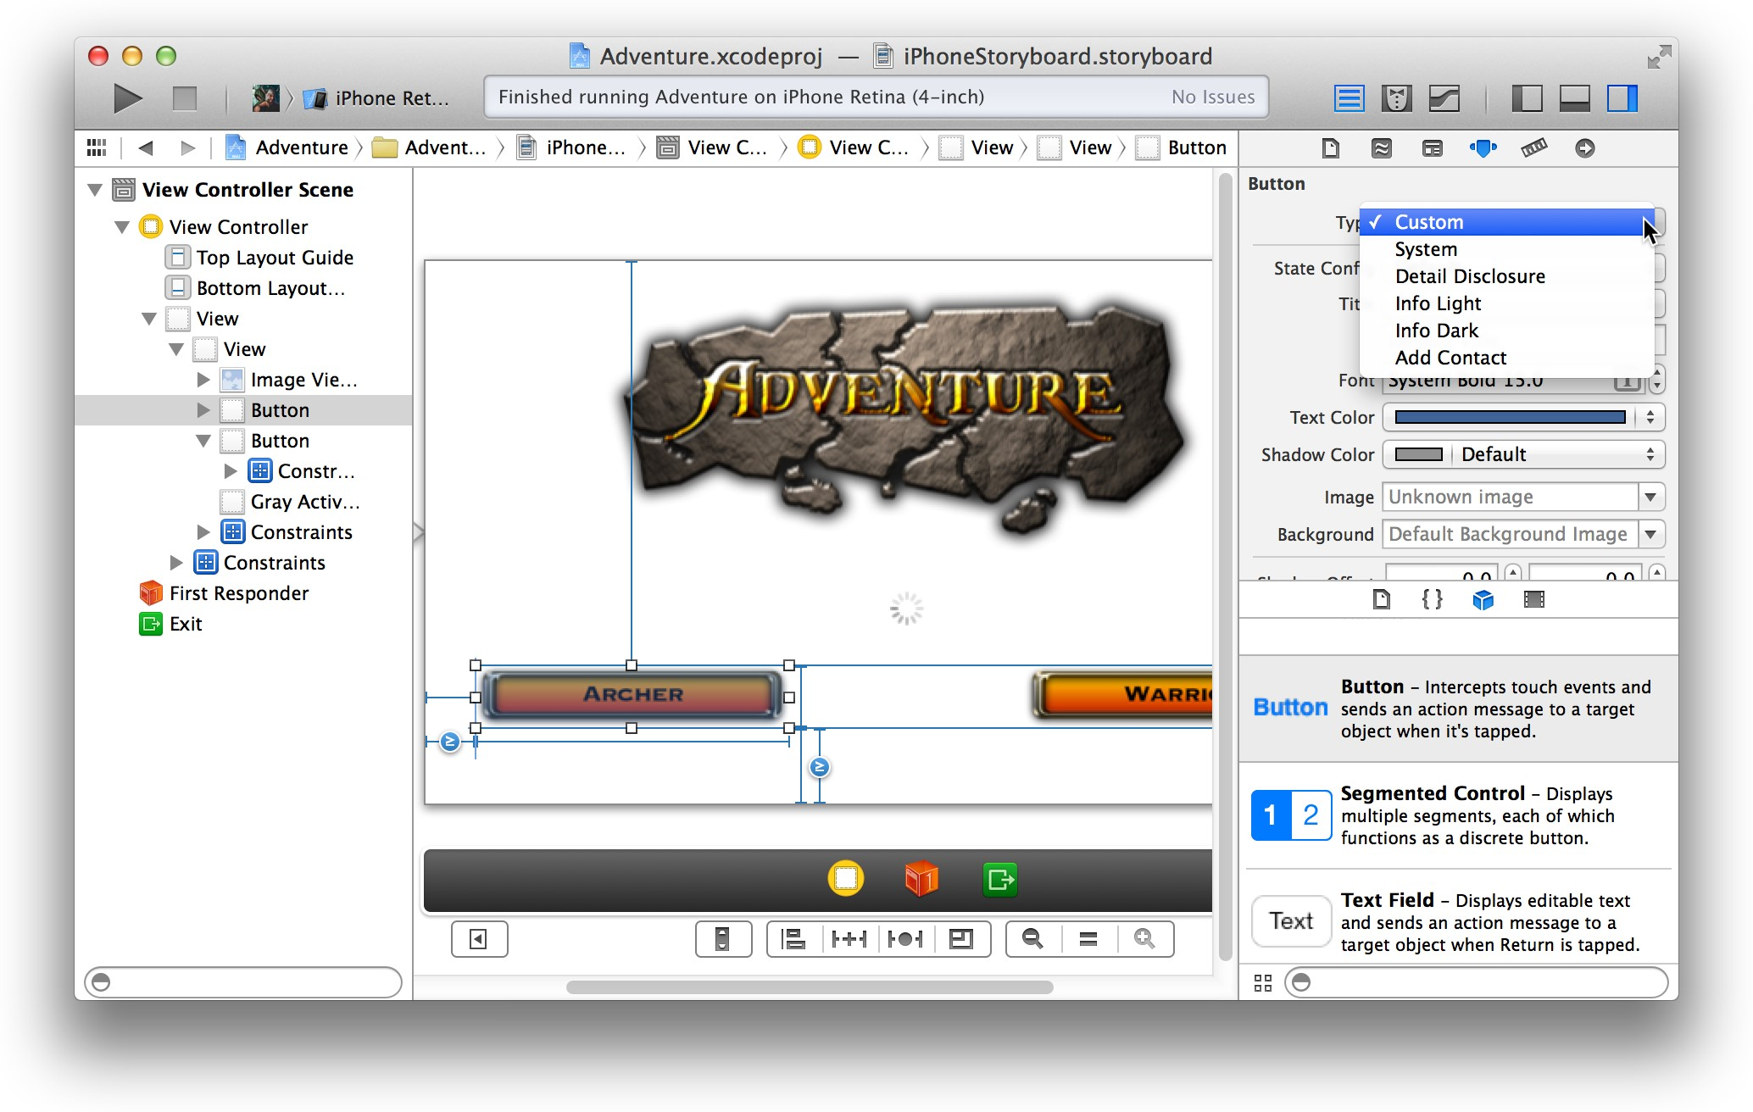

# Lay Out User Interface Objects for Automatic Resizing and Positioning

Use Auto Layout to define rules for your app’s user interface so that when one object changes its size or position, that object and its neighboring objects adjust their sizes and positions appropriately. For example, you can center an image horizontally in a storyboard scene. As the user rotates the iOS device, the image remains horizontally centered in both landscape and portrait orientations of the device.

Auto Layout uses relationships called *constraints* to govern the layout of objects in a user interface. As you make changes to the layout of your app, add constraints to your objects. As a result, the objects in your user interface automatically resize and reposition themselves whenever:

* The user changes the screen orientation of an iOS device
* The user resizes a window in a Mac app
* Content dimensions change (for example, when the length of a text string changes in a label or button) When you Control-drag between two objects, Interface Builder presents you with a list of appropriate constraints. Add constraints to your objects by choosing from this list. In the screenshot, the constraint to Center Horizontally in Container is selected for the image view and its containing view.

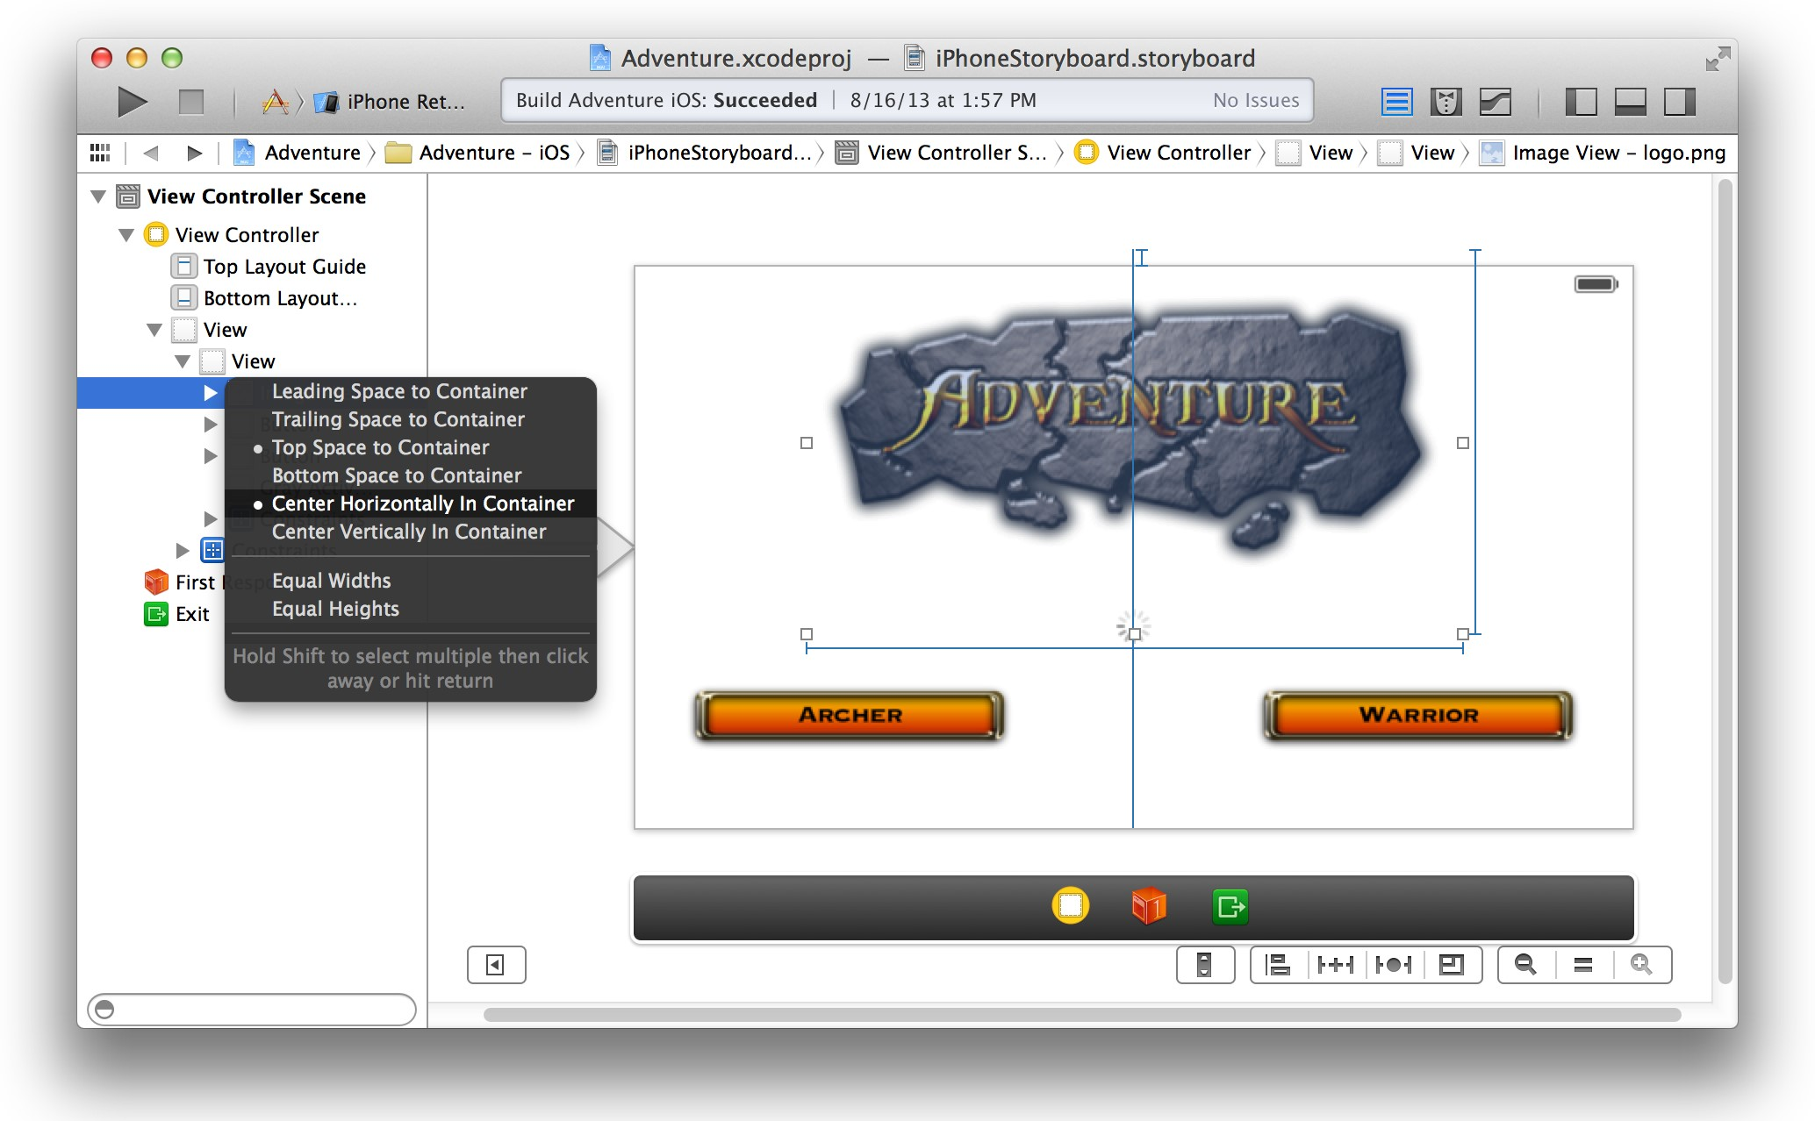

To see the constraints for an object, select the object from the outline view in the Interface Builder dock.

Constraints are represented on the canvas by solid blue lines. View their properties in the size inspector ( ).

From the size inspector, click the action ( ) icon to edit the properties of a constraint.

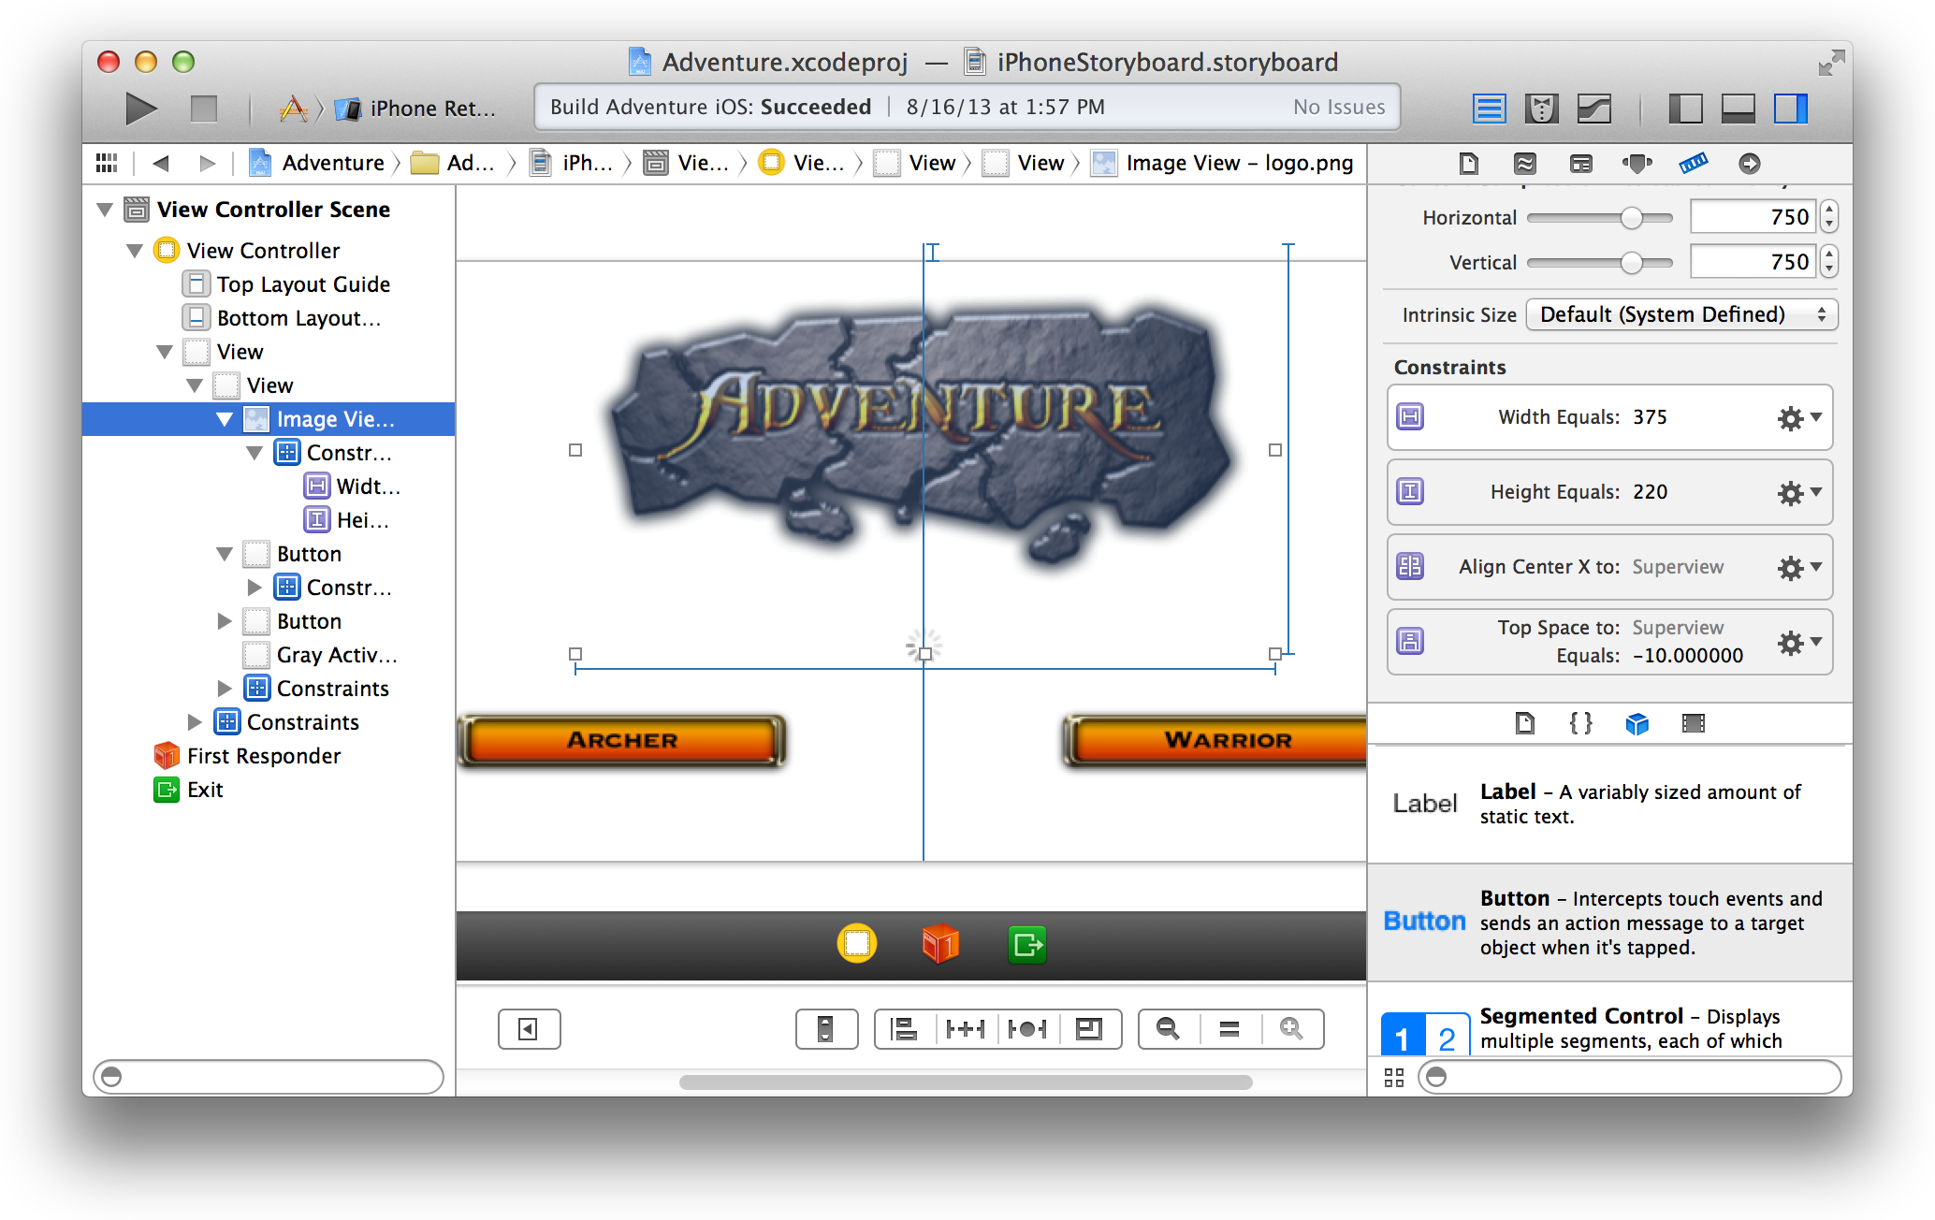

If you double-click a constraint on the canvas, a pop-up window also lets you view and edit the properties of that constraint.

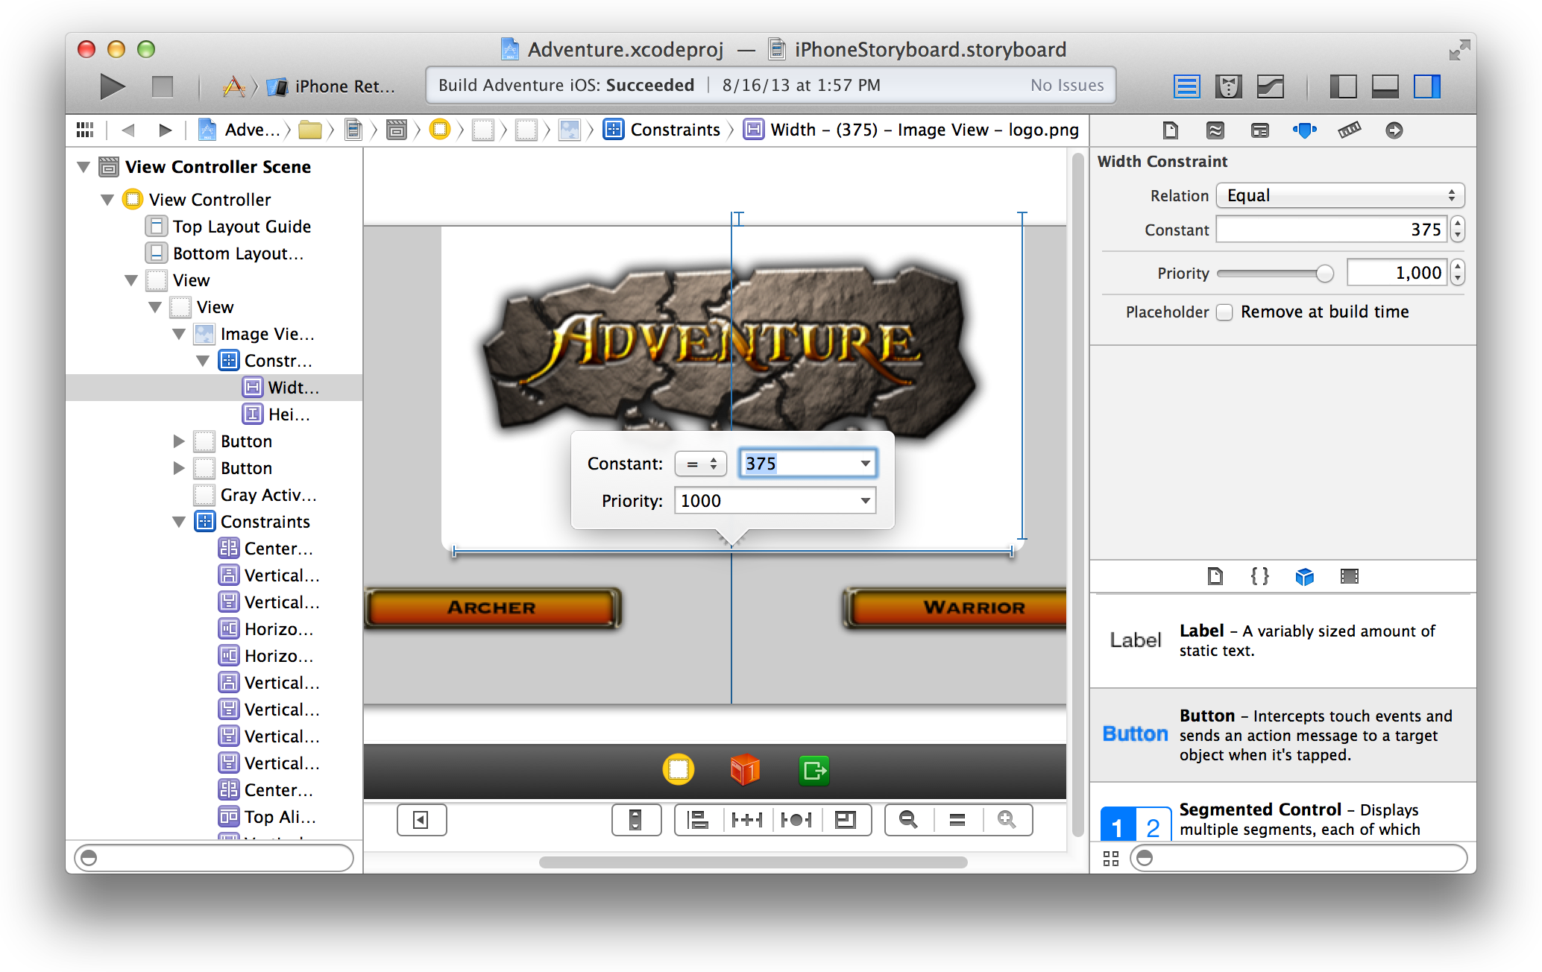

# Connect User Interface Objects to Your Code

You implement the behavior of your user interface objects in code. When the user clicks a button, for example, the button should send an action message to another object that performs a corresponding action method.

You must connect the button to the action method, and you must write the code that performs the action.

The easiest way to connect a user interface object to its implementation code is by Control-dragging from the object to the appropriate implementation file.

With Interface Builder open in the standard editor pane, select the Assistant Editor button ( ) in the workspace toolbar. The related implementation file opens in the assistant editor. Control-drag from the user interface object in Interface Builder to the implementation file. As you Control-drag from the object to your source code, Xcode indicates where a new action is valid.

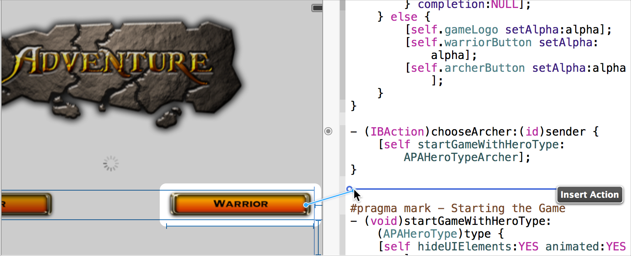

Release the Control-drag. The assistant editor displays a Connection menu. From this menu, choose Action, type the name of the action method (chooseWarrior in the screenshot below), and click Connect.

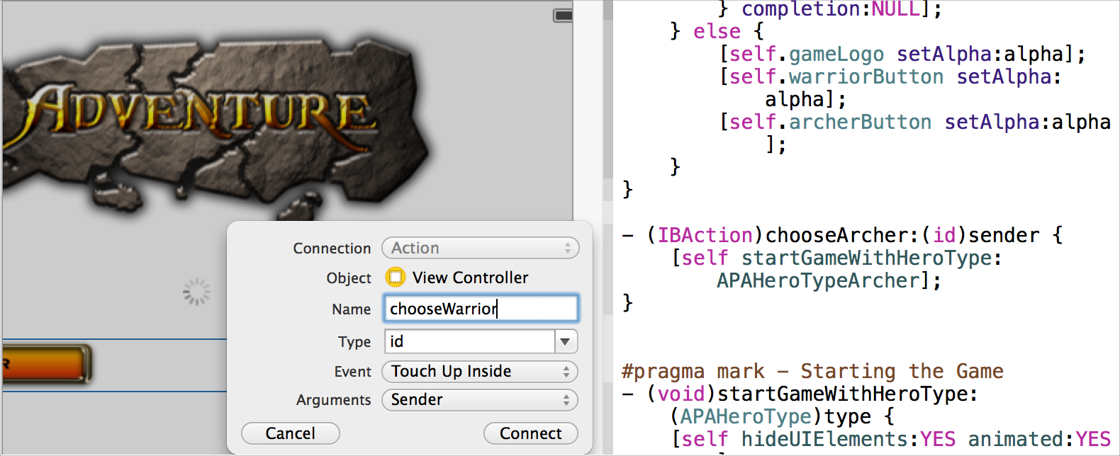

In the implementation file, Xcode inserts a skeletal definition for the new method, which Xcode connects to the user interface object. (The IBAction return type is a special keyword. It’s like the void type, but it indicates that the method is an action that can be connected to and from your storyboard or xib file.)

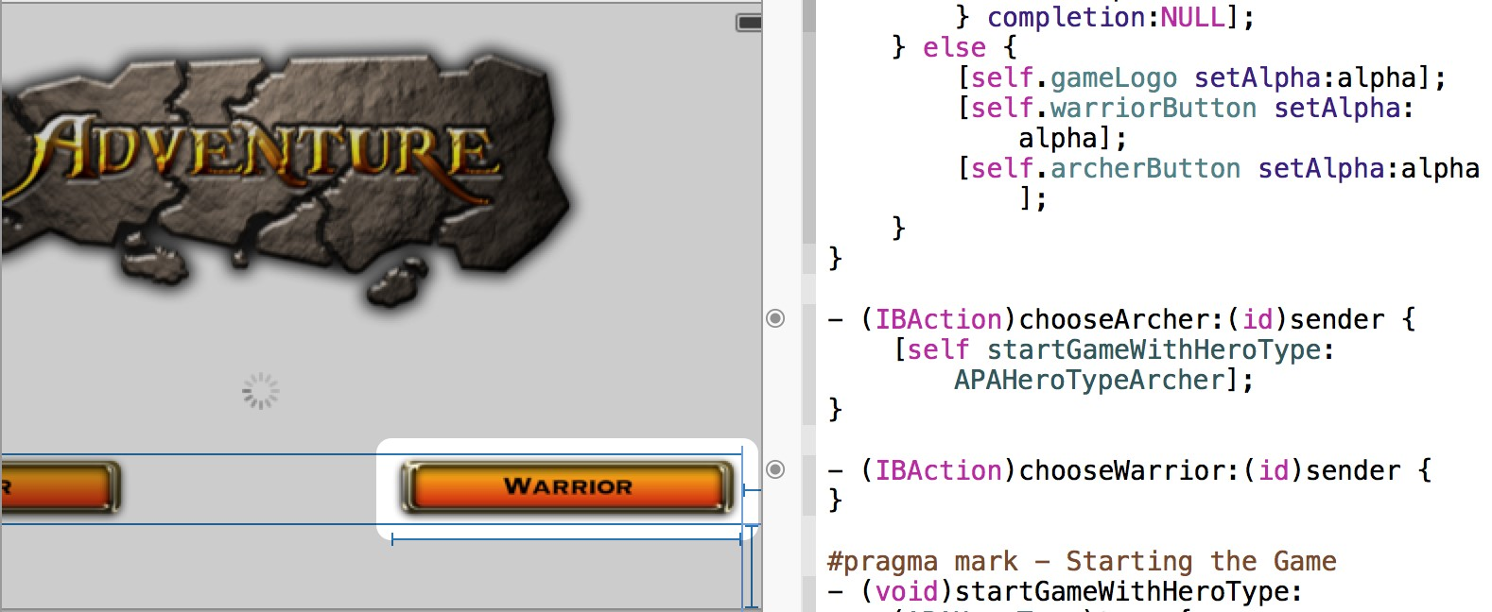

To this skeletal definition, add the source code that implements the action method.

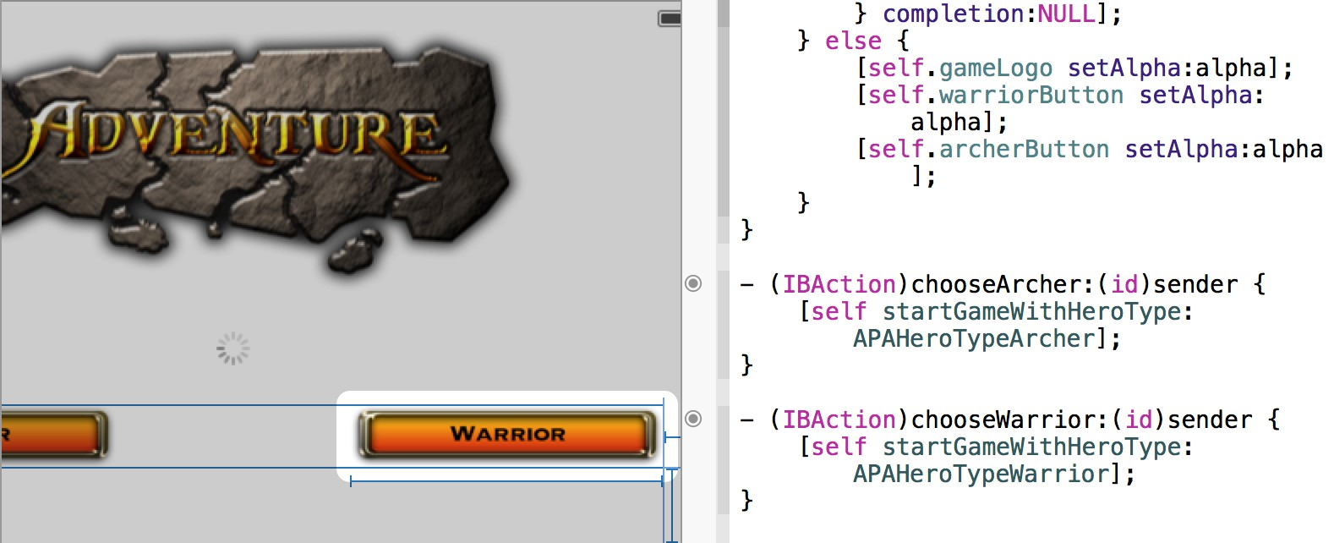

You often need to establish communication between one user interface object and an object that it contains. For example, a view controller containing a button needs to receive a message whenever the user clicks the button.

An outlet describes a connection between two objects. The easiest way to make an outlet connection is by Control-dragging from one object in Interface Builder to the implementation file for its containing object. For example, to set up a button as an outlet for its view controller, Control-drag from the button object in Interface Builder to the implementation file in the assistant editor. Xcode indicates where the new outlet is valid.

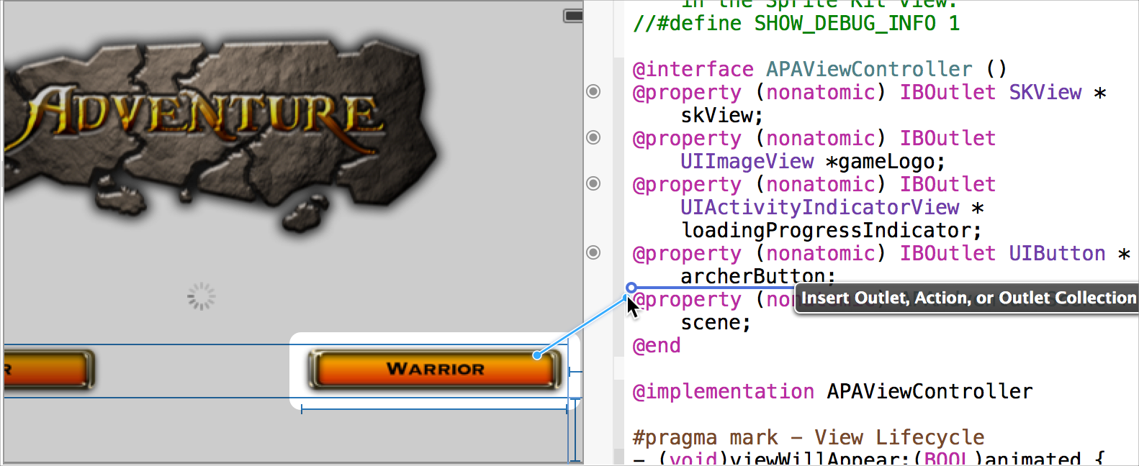

Release the Control-drag. The assistant editor displays a Connection menu. From this menu, choose Outlet, type the name of the outlet (warriorButton in the screenshot below), and click Connect.

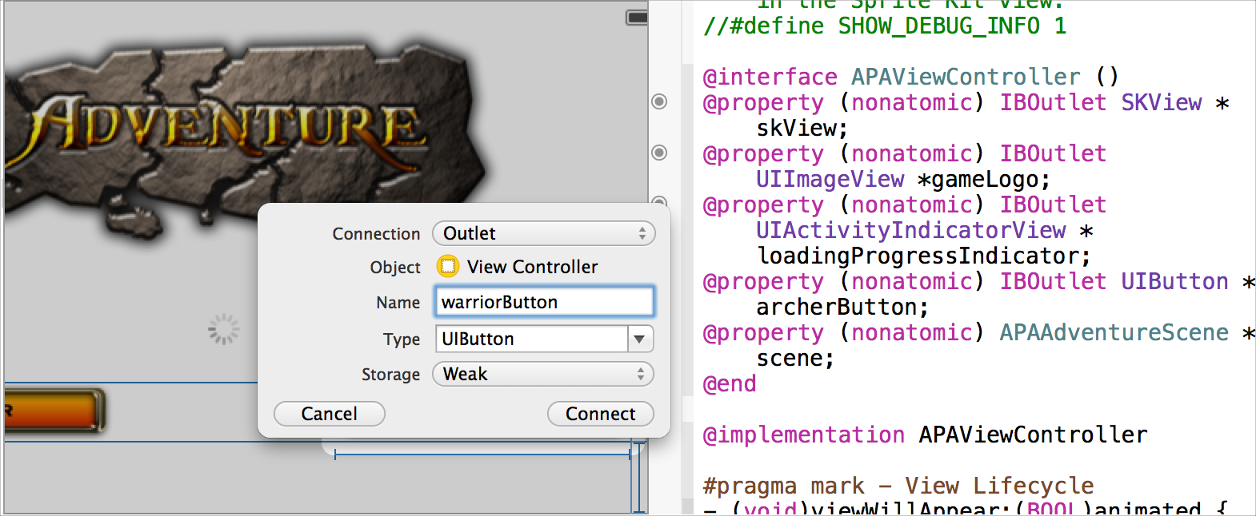

Design the User Interface of Your iOS App with Storyboards

In the source file, Interface Builder declares the outlet, allowing the two objects to communicate. (Outlets are defined as IBOutlet properties. The IBOutlet keyword tells Xcode that this property can be connected to and from your storyboard or xib file.)

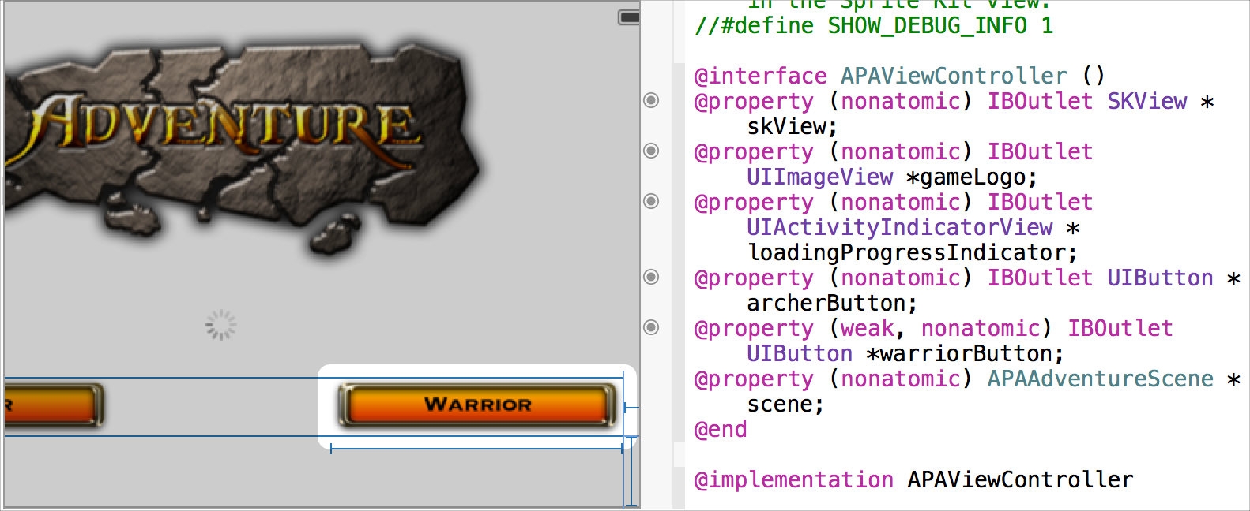

# Design the User Interface of Your iOS App with Storyboards

You use a storyboard to graphically lay out the user’s path through your iOS app. Use Interface Builder to specify your user interface in terms of:

* Scenes
* Segues between scenes
* Controls used to trigger the segues

A **scene** represents an onscreen content area. On iPhone and iPod touch, a screen generally contains a single scene. On iPad, a screen can be composed of more than one scene. A **segue** represents the transition from one scene to the next scene, such as when one scene slides over another.

The screenshot shows the default storyboard for an iOS project that you create in Xcode with the Master-Detail Application template. This storyboard contains three scenes and two segues. The leftmost scene represents a navigation controller, which manages user navigation between the master and detail scenes. When working

Design the User Interface of Your iOS App with Storyboards

from this template, add additional scenes as necessary by dragging view controllers from the object library to the canvas and configuring the view controller with the Identity inspector ( ). Drag objects from the objects library to lay out each scene. Configure the objects and the segues with the Attributes inspector ( ).

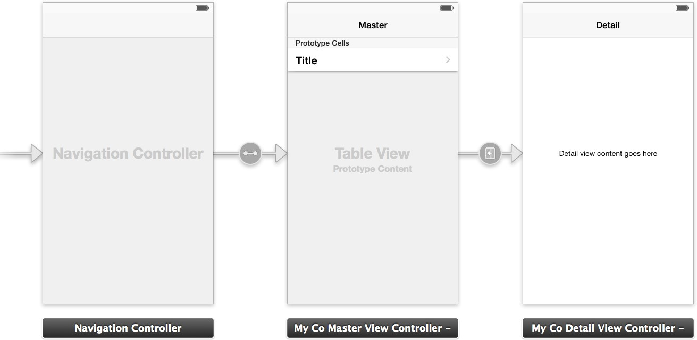

Your master scene might, for example, contain a table listing multiple items. Each item in the master scene might then have a corresponding detail scene that provides additional information about the item. The navigation controller provides the back button that returns the user to the master scene from all detail scenes.

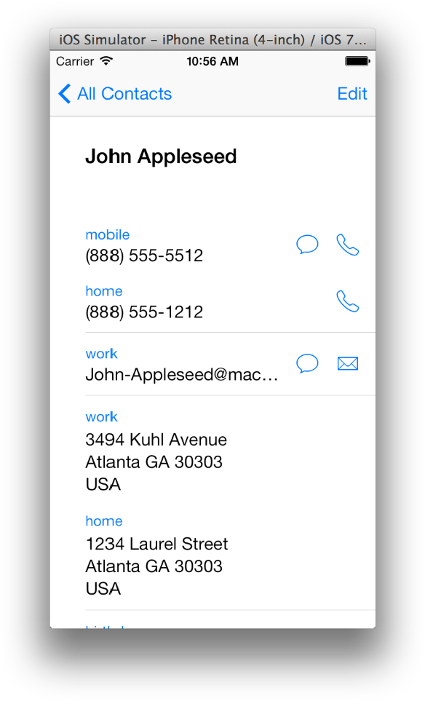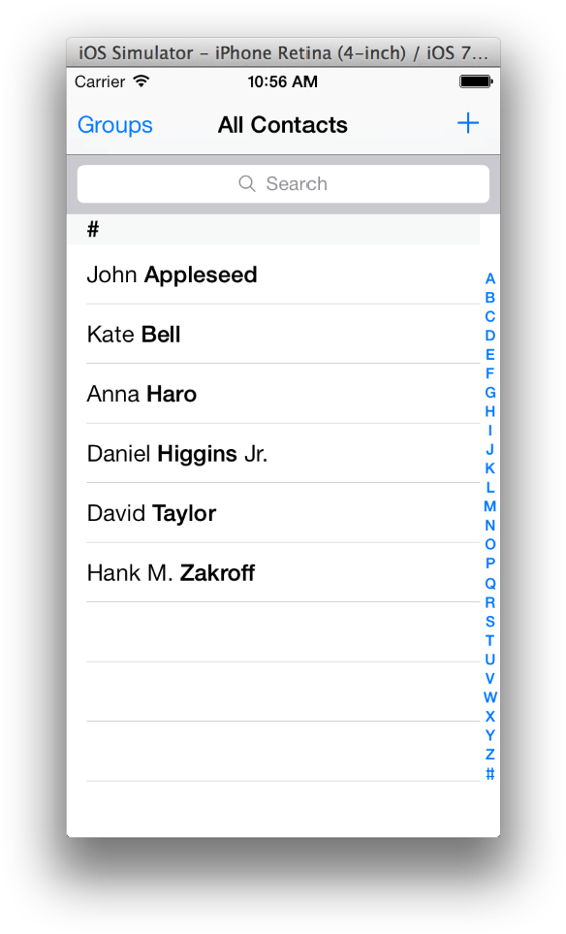

Look Up Documentation for an Object

# Look Up Documentation for an Object

You can find concise class reference documentation for a user interface object without taking your focus away from Interface Builder. With a file open in Interface Builder, open the utility area by clicking the right button (

) in the view selector in the toolbar. Select the Quick Help button ( ) in the inspector selector bar. In Interface Builder, click the object about which you want information. Documentation appears in the inspector pane of the utility area.

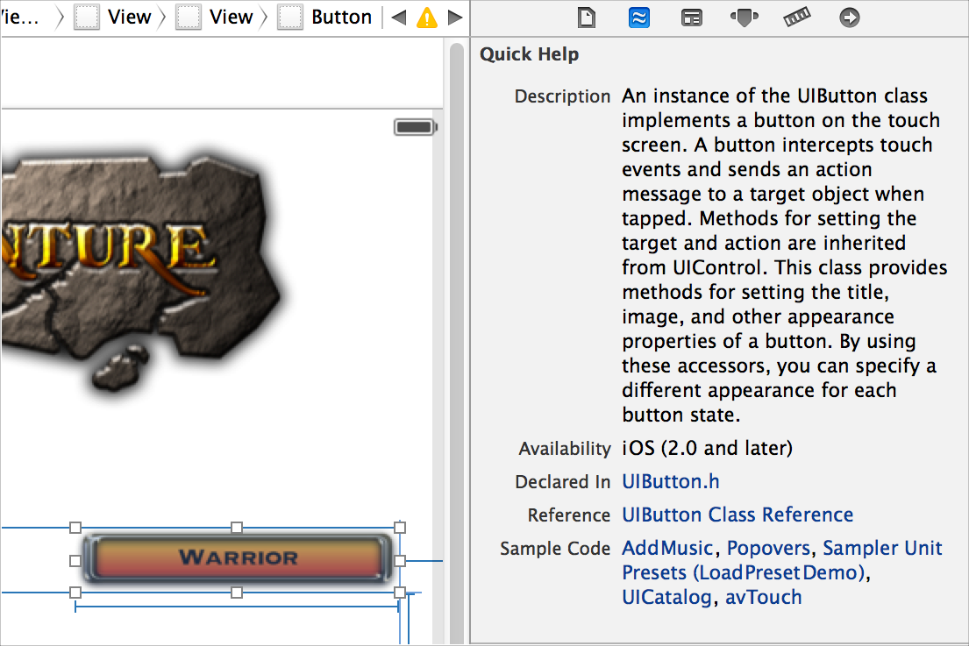

For complete reference information about the object, click the title of the reference document listed in Quick Help. The reference document opens in the documentation viewer window. You can also open relevant programming guides, sample code, and other related documents by clicking their titles in Quick Help.

Look Up Documentation for an Object

For additional information about settings you configure in the inspectors, move the pointer over a control in an inspector. A help tag appears.

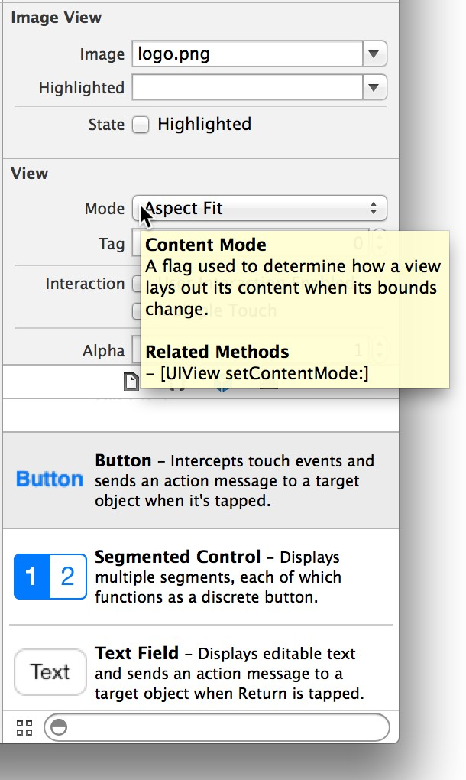

Find Help for Using Interface Builder

# Find Help for Using Interface Builder

Step-by-step instructions for performing common Interface Builder tasks are available directly in Xcode.

Control-click anywhere on the Interface Builder canvas to see a short list of the most common operations.

Choose Show All Help Topics to see all help articles for the source editor.

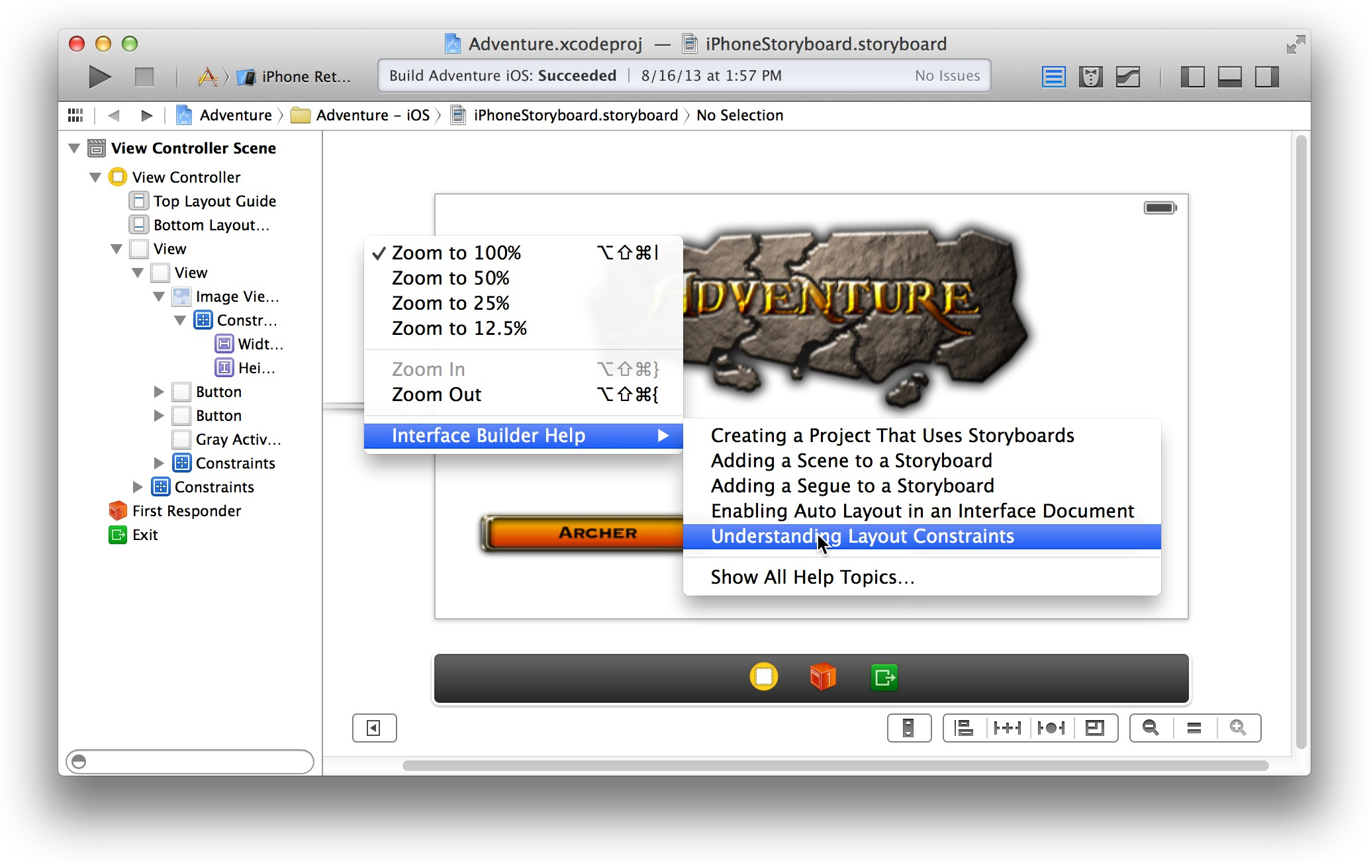

Because the Control-click key combination is used by Interface Builder to make connections, you must Control-click on the canvas—not on any object in the user interface—to get the shortcut menu with the list of help articles.

Find Help for Using Interface Builder

Select a task, and a help article appears in the Xcode documentation viewer window.

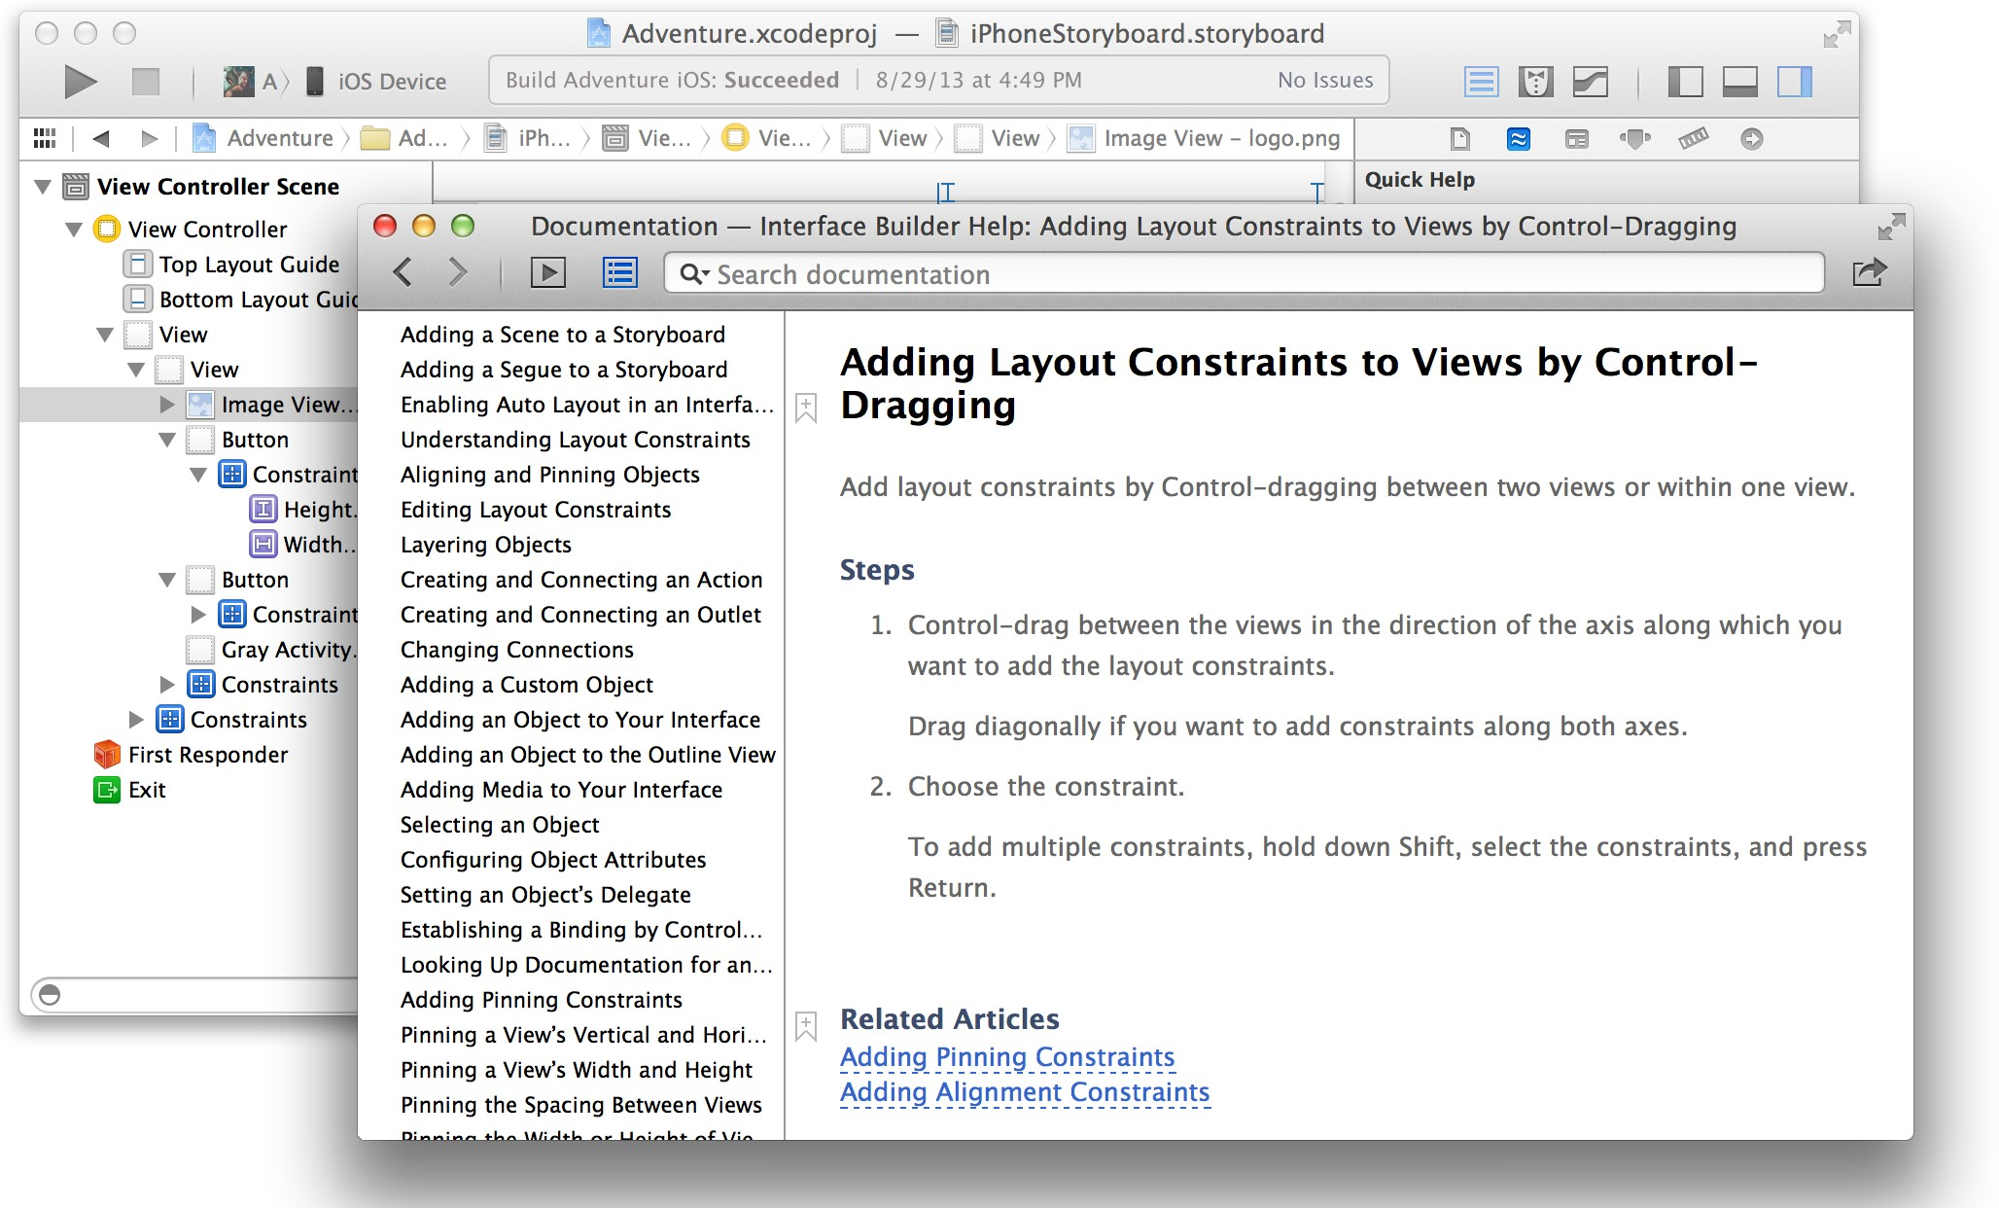

# Add Icons, Images, and Effects

To create and manage user interface elements for your app, Xcode offers several tools in addition to Interface

Builder.

You create many images for your app, including icons, custom artwork, and launch screens for different iOS devices. Some of these images are required for App Store submission. The asset catalog helps you manage them.

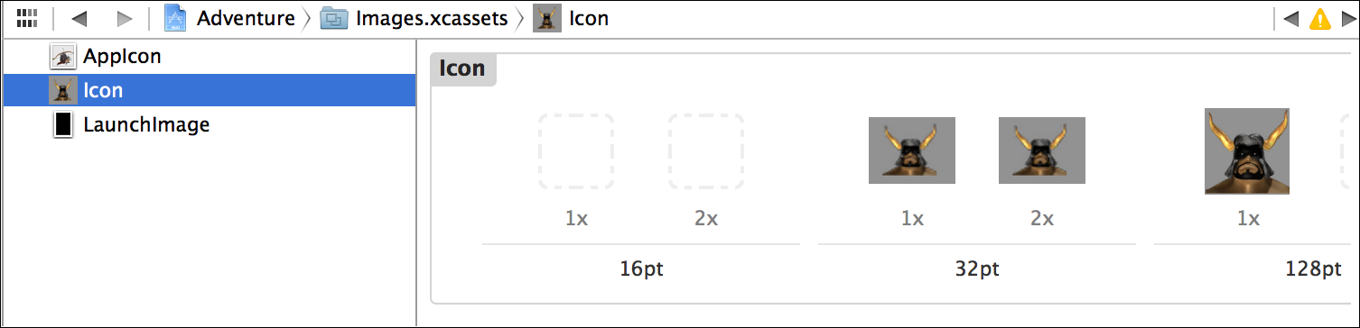

With the particle emitter editor, you can enhance your app by adding animation effects involving moving particles such as snow, sparks, and smoke. These effects are especially useful in games for iOS and Mac.



App Icons

For Mac apps, the Scene Kit editor helps you work with scenes created in 3D authoring tools and exported as COLLADA Data Asset Exchange (DAE) files.

# Add App Icons

Create app icons for all of the operating system versions and devices that your app supports. iOS apps and Mac apps require different types of icons. For either platform, add the required versions of your app icons to an asset catalog in Xcode.

For an iOS app, create an icon to be displayed on a device’s Home screen and in the App Store. Xcode doesn’t include graphics tools for creating icons; use a graphic design app. You should create several different versions of the icon for use in different situations. Your iOS app can include a small icon (to use when displaying search results) and a high-resolution icon (for devices with Retina displays). When your iOS app’s target is universal, you also create versions of the icon for iPad and iPhone devices.

For a Mac app, create a set of icons, consisting of pairs of icons (standard and high resolution) for each icon size—16 x 16, 32 x 32, 128 x 128, 256 x 256, and 512 x 512—used by the Finder to represent your app to the user.

When you create a new project, Xcode creates an asset catalog named Images.xcassets. Select the asset catalog from the project navigator, and Xcode opens the catalog in the editor area.

Create and Set iOS Launch Images

The asset catalog contains a list of image sets. Each image set, such as AppIcon in the screenshot, contains all the versions of an image that are necessary to support various devices and scale factors. You can add icon images to your app by dragging them to the appropriate cell in the icon set grid.

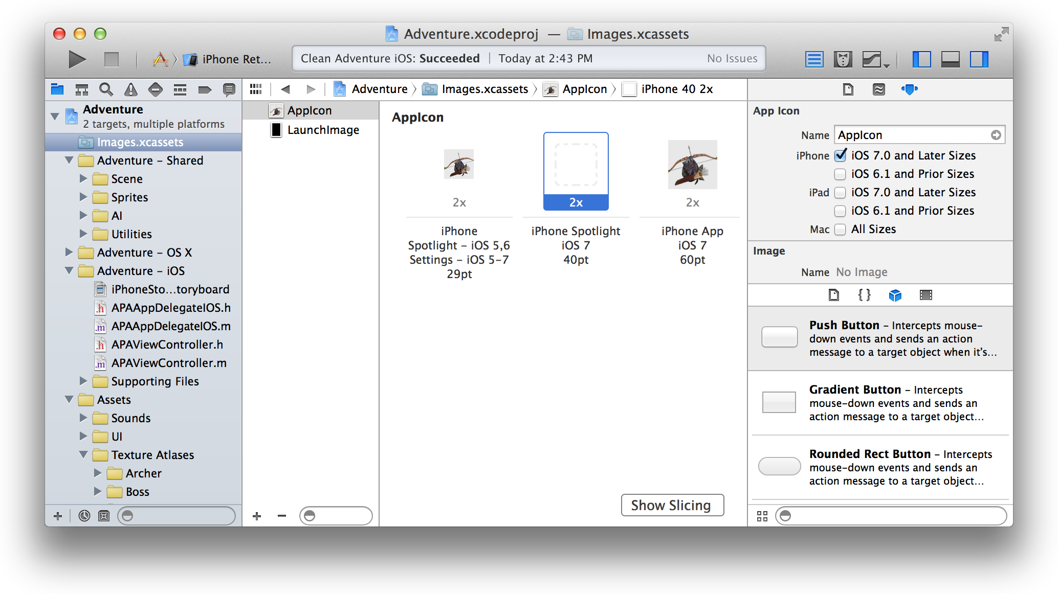

You can create additional image sets, such as for buttons and other controls in your app. To create an empty image set or to import images into a new set, click the Add button (+) at the bottom of the image set list.

# Create and Set iOS Launch Images

Launch images are displayed while your app is launching on iOS. A launch image matching the device resolution appears as soon as the user taps your app icon. Use screenshots to create your app’s launch images, and use the asset catalog to manage all the representations of the launch image.

You can easily capture screenshots for launch images on a device. On the device, configure the screen the way you want it to appear. Press the Lock and Home buttons simultaneously. Your screenshot is saved in the Saved Photos album in the Photos app. Copy the screenshot from the device to your Mac. You can use the iPhoto app, for example, to import the screenshot from the device and then export the screenshot to your Mac as a PNG file.

To set the screenshot as a launch image, select the asset catalog in the project navigator, and select the LaunchImage set. Drag your screenshot to the appropriate cell in the grid.

Particle Emitter Effects

# Add Particle Emitter Effects

Especially useful for developers of iOS and Mac games, Sprite Kit provides a graphics rendering and animation infrastructure. This infrastructure includes particle emitters. Particle emitters can range from a single image that barely moves, to thousands of small particles flying across the screen. You can use particle emitters to simulate fire, rain, smoke, snow, sparks, and other animated effects.

Xcode provides eight particle emitter templates and an editor for manipulating the appearance and behavior of particles.

Create a Sprite Kit–enabled game from the New Project template in Xcode, or use the General pane in the project editor to add the Sprite Kit framework to an existing target. Then add a particle emitter to your project by choosing File > New > File and choosing Resource > SpriteKit Particle File.

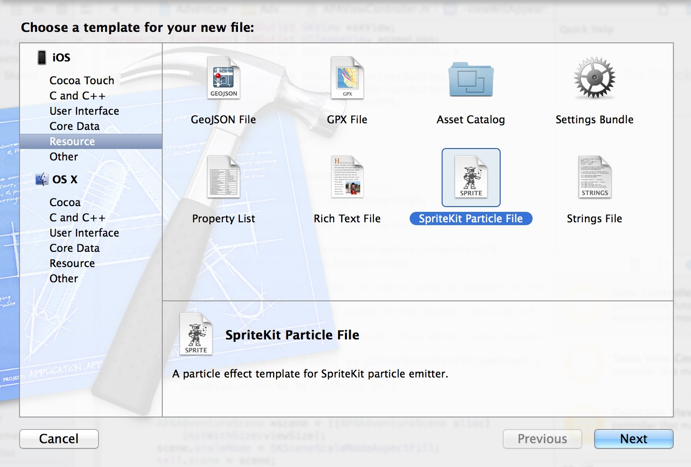

Select the particle template from the drop-down menu, and click Next. Enter a name for the emitter in the Save As field. Select the checkbox associated with your project in the Targets area. Xcode creates a file with the extension .sks.

3D Scenes to Your Mac App

Select your particle emitter file in the project navigator, and Xcode opens the file in the particle emitter editor.

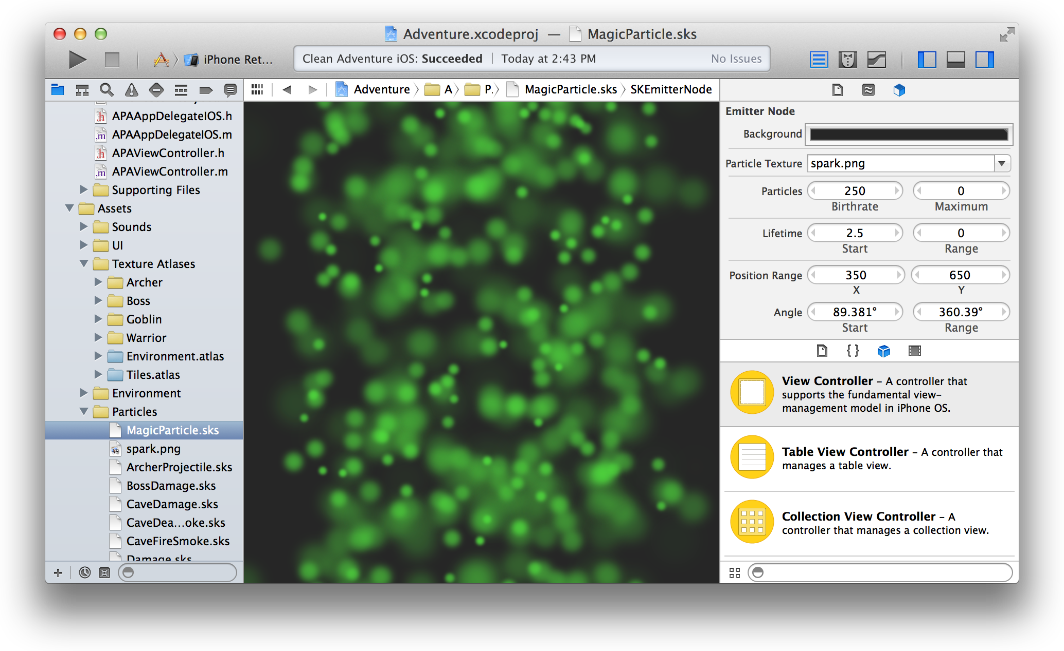

Modify the look and feel of the particles with the particle emitter inspector ( ). For example, you can change the rate at which particles are created, what a particle looks like, and how it acts after it’s created. Changes made to the inspector take effect immediately and can be viewed in the editor.

# Add 3D Scenes to Your Mac App

Scene Kit is a 3D-rendering framework for Mac apps. Sprite Kit supports the import, manipulation, and rendering of 3D assets without requiring advanced 3D graphical programming skills on your part. With the Scene Kit editor, you can preview 3D scenes, inspect them for information needed for your source code, and adjust scene object parameters to enhance and fine-tune the rendering for your app.

To import a COLLADA Data Asset Exchange (DAE) file into the project, use the project navigator. Select a folder in which you want to save the file. Choose File > Add Files, select the file, and click Add. To browse the 3D scene in Xcode, select the DAE file in the project navigator. Xcode opens the file in the Scene Kit editor.

To preview the scene and run animations, use the controls in the Scene Kit editor’s main area. Press the Play button to play an animation. Click the Pause button to pause the animation, and drag the slider to scroll through it. Use the trackpad or mouse to manipulate the point of view.

3D Scenes to Your Mac App

The inspectors in the utility area allow you to view and edit information about the node in the scene graph list or the object in the entities list. For example, with the nodes attributes inspector, you can adjust camera, light, or geometry attributes, and with the materials inspector, you can adjust many settings on a material and its properties, such as by selecting a lighting model for it and colors and textures for its contents.

# Run Your App

To build and run your iOS or Mac app, choose a scheme and a run destination in the workspace toolbar, and click the Run button. Clicking the Stop button causes your app to quit.

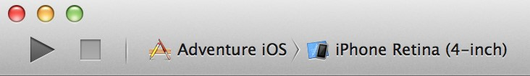

If you are running an iOS app, Xcode launches it either in iOS Simulator or on an iOS device connected to your Mac. If you are running a Mac app, Xcode launches it directly on your Mac.

# Choose a Scheme to Build Your App

A **scheme** is a collection of settings that specify the targets to build for a project, the build configuration to use, and the executable environment to use when the product is launched. When you open an existing project (or create a new one), Xcode automatically creates a scheme for each target. The default scheme is named after your project and includes settings to perform five actions:

* Run the app.
* Run unit tests against the target.
* Profile the app’s performance characteristics.
* Perform static analysis on the code.
* Archive the app for distribution, such as for sending to testers or submitting to the App Store.

Each action includes building the app as an executable product. To choose the scheme, use the **Scheme menu** in the Xcode workspace toolbar. (You’ll use the Scheme menu to choose a destination, too.)

Choose a Destination to Run Your App

# Choose a Destination to Run Your App

When you build an app, the **destination** determines where the app runs after it’s built. For Mac apps, the destination is the Mac on which the app is built. For iOS apps, the destination can be a provisioned iOS device connected to the Mac, or iOS Simulator. Installed as part of the Xcode tools along with the iOS SDK, **iOS Simulator** runs on your Mac and simulates an iPhone or iPad environment.

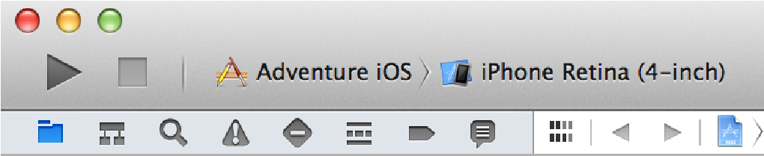

The Scheme menu lets you select a combination of scheme and destination, but the two settings are distinct. A scheme does not include a destination. In the screenshot above, Adventure iOS is selected as the scheme, and the iPhone Retina (4-inch) simulation environment is selected as the destination. As a result, the Adventure iOS scheme builds an iOS executable that runs on a simulated iPhone in OS Simulator. As shown below, the same scheme could be used to run the app on a different destination, such as a simulated iPad or a connected iOS device.

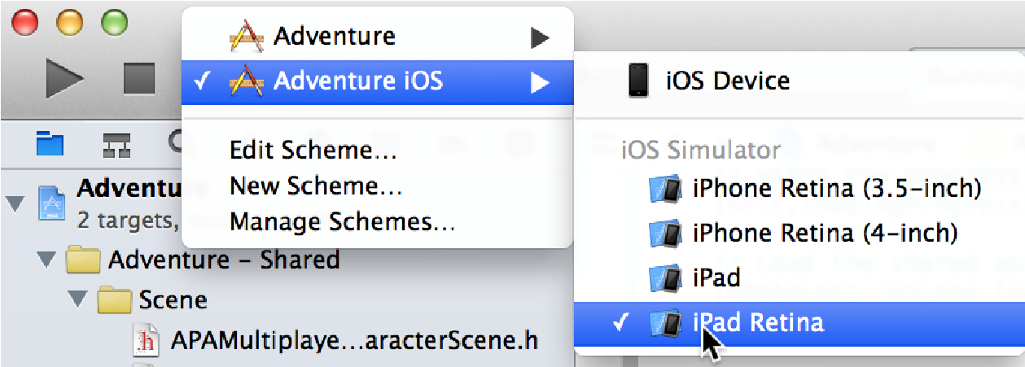

# Run Your App

Click the Run button in the workspace toolbar to compile, link, and execute your code. If the app builds successfully, Xcode runs it and starts a debugging session.

Depending on your destination, Xcode launches your iOS app either in iOS Simulator or on a connected iOS device.



Xcode launches a Mac app on your development Mac.

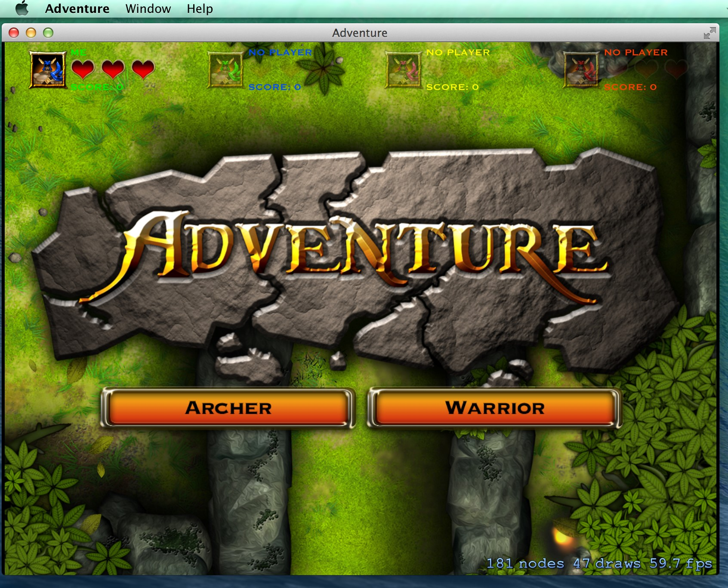

Xcode displays any errors or warnings it encounters in the issue navigator, available by clicking  in the navigator selector bar. If there are errors during the compilation or link phase, Xcode doesn’t run your code.

## Run Your App in iOS Simulator

iOS Simulator enables you to simulate several iPhone and iPad devices and several versions of the iOS operating system. You interact with iOS Simulator by using the keyboard and trackpad to emulate taps, device rotation, and other actions. For example, you can use the Hardware menu in iOS Simulator to:

* Rotate the simulator to the left and right
* Simulate a user shaking the device
* Send the frontmost app a simulated low-memory warning

As a preliminary tool for use before testing your app on devices, iOS Simulator allows you to prototype and test builds of your iOS app during the development process. Although you can test your app’s basic behavior in iOS Simulator, the simulator is limited as a test platform. Therefore while developing your app, it is essential that you run and test it on connected iOS devices.

## Run Your App on a Connected Device

To run your iOS app on a device (an iPad, iPhone, or iPod touch) during development, the device must be connected to your Mac, and the device must be provisioned for development by Apple. If your Mac app uses certainAppletechnologies—suchasiCloud,GameCenter,andIn-AppPurchase—yourMacmustbeprovisioned.

Apple implements an underlying security model to protect user data and to protect your app from being modified and distributed without your knowledge. Throughout the development process, you create assets and enter information that Apple uses to verify the identify of you, your devices, and your apps. These assets include provisioning profiles, which identify your development devices.

To obtain a provisioning profile for a device, you need an Apple Developer Program membership.

#### Add an Apple Developer Program Account to Xcode

If you’re not already a member, you can join an Apple developer program in Xcode. To join, choose Xcode > Preferences, and click Accounts. Click the Add button (+) in the lower-left corner, and select Add Apple ID from the pop-up menu. Click “Join a Program” in the lower-left corner of the dialog.

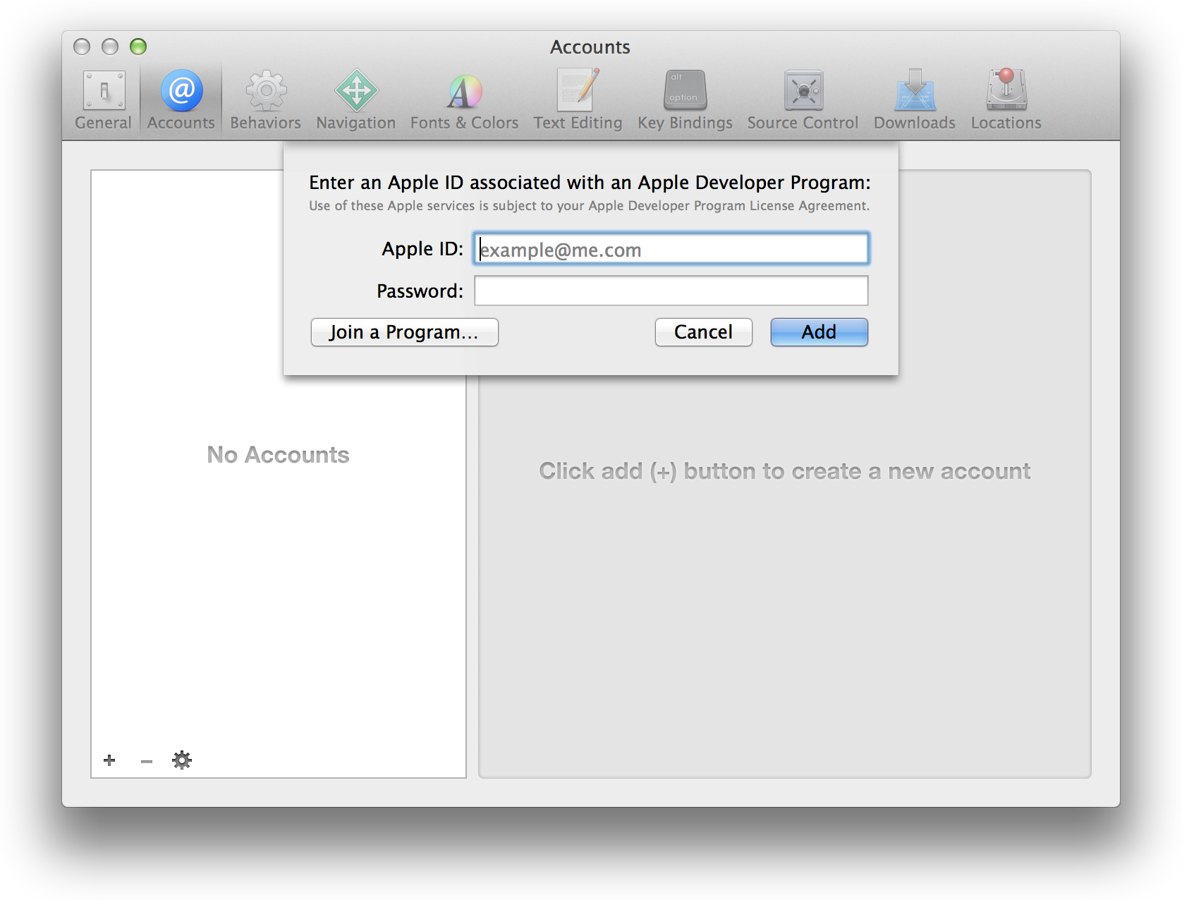

Your default browser displays the Apple Developer Programs enrollment webpage. In your browser, click the developer program you want to join and follow the instructions.

If you’re already a member of an Apple developer program, add your account to Xcode. Choose Xcode > Preferences, and click Accounts. Click the Add button (+) in the lower-left corner, and select Add Apple ID from the pop-up menu. Enter your credentials, and click Add.

If you're developing a Mac app, Xcode then automatically provisions the Mac that’s running Xcode. If you’re developing an iOS app, you need to provision the devices that you’ll run and test your app on during development.

#### Provision an iOS Device for Development

To provision an iOS device in Xcode, choose Window > Organizer, and click Devices to display the Devices organizer. For an iOS app, connect your device to your Mac. In the Devices section of the Devices organizer, select your device. Click the “Use for Development” button (or if the device was previously used for development, click the “Add to Member Center” button). Select the checkbox next to your Apple developer program account name, and click Choose.

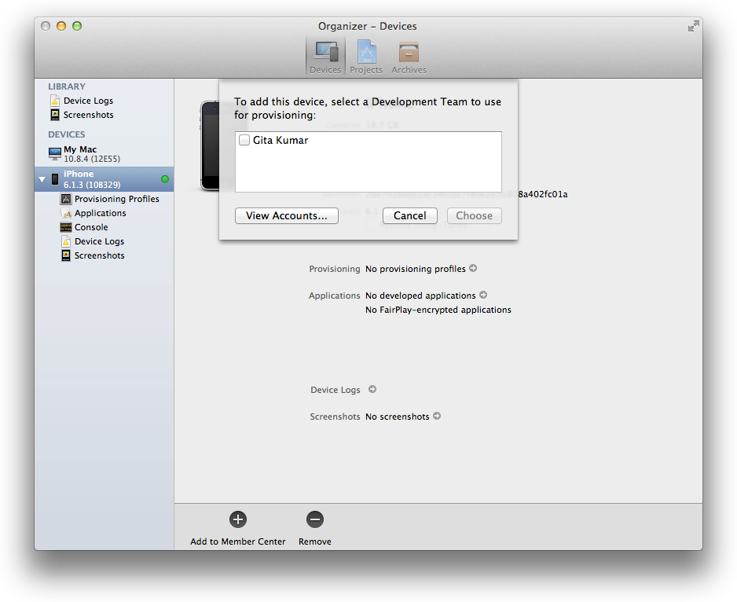

#### Choose Your Device for the Run Destination

After provisioning your device for development, tell Xcode to launch your app on the device. When you plug the device into your Mac, the device’s name and the iOS release it’s running appear as a destination in the Scheme menu. Choose your device as the destination, and then click the Run button to build and run your app on the device.

# Edit, Create, and Manage Schemes

To edit a scheme, choose Edit Scheme from the Scheme menu. The left column of the scheme configuration dialog lists the actions that the scheme can perform. You can modify settings for each action. In the screenshot, the Run action is modified to simulate the location of Mexico City when Xcode launches the app.

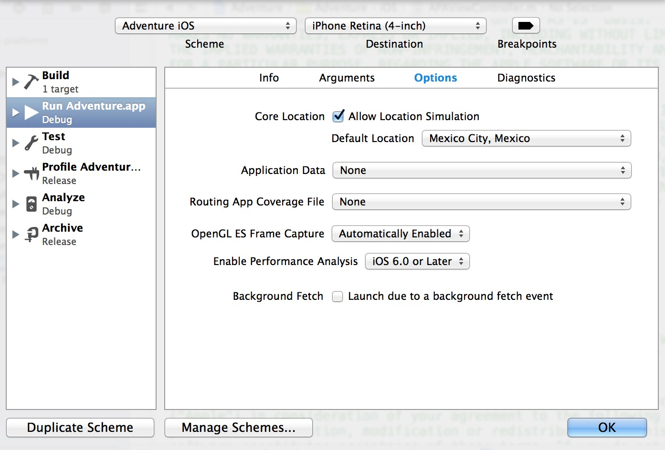

You can edit a scheme so that it performs such actions as:

* Building multiple targets
* Executing scripts before or after any action
* Sending emails before or after any action
* Running with memory management diagnostics
* Producing either a debug or release build for any action, such as for the Run action in the screenshot below

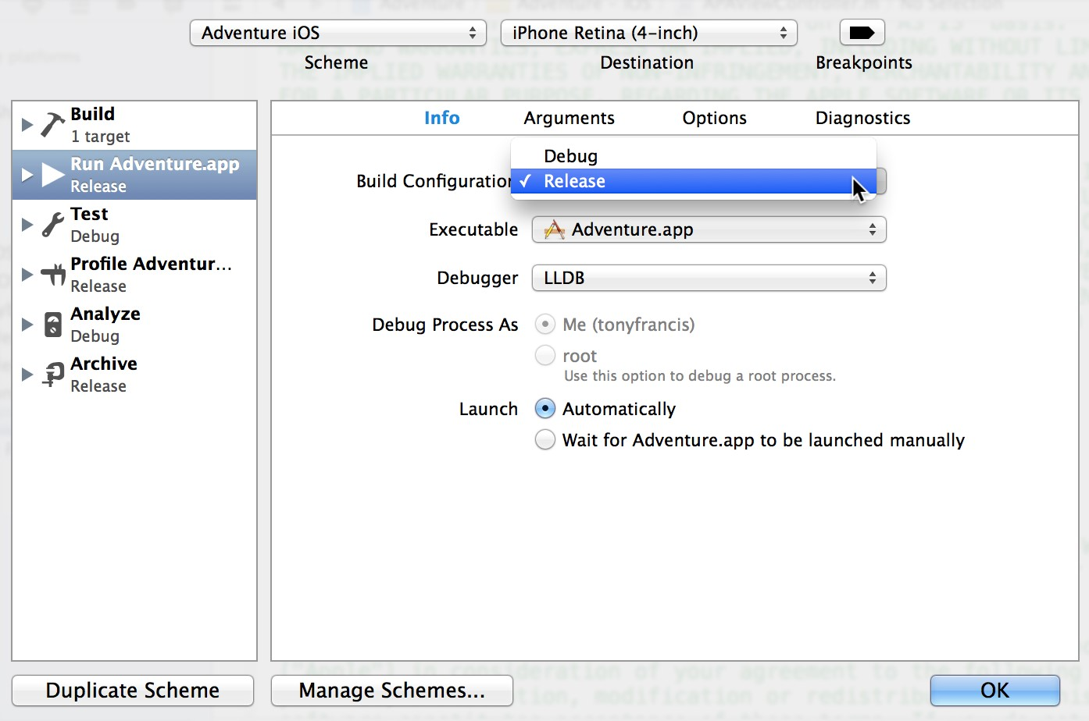

A convenient way to create a new scheme is to click the Duplicate Scheme button. This button uses the active scheme as a template for you to rename, edit, and save.

If you create schemes, you can manage them by clicking the Manage Schemes button in the scheme configuration dialog or by choosing Manage Schemes from the Scheme menu. You can rename or reorganize how schemes appear in the Scheme menu. You can also specify whether a scheme should be displayed in the menu, where a scheme is stored in the project or workspace, and whether a scheme should be shared, such as with team members accessing a project from a source code repository. You can click the Autocreate Schemes Now button to make Xcode create schemes for any targets that don’t have them.

Step-by-step instructions for creating, editing, and managing schemes are available by Control-clicking anywhere in the scheme configuration dialog.

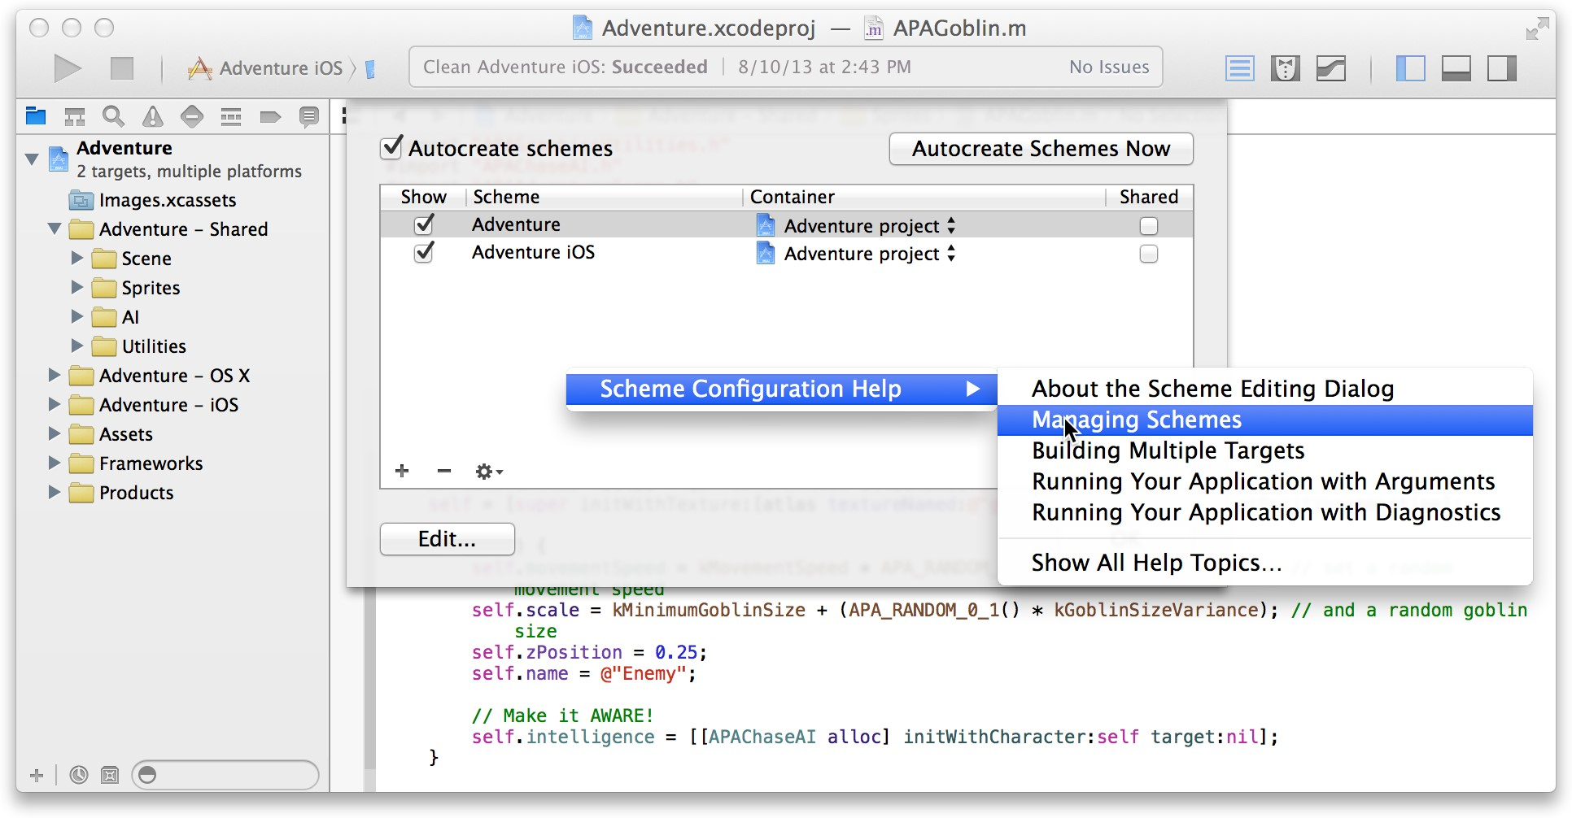

# Debug Your App

After you click the Run button in the workspace toolbar and your app builds successfully, Xcode runs your app and starts a debugging session. You can debug your app directly within the source editor with graphical tools such as data tips and the variables Quick Look.

The debug area and the debug navigator let you inspect the current state of your running application and control its execution.

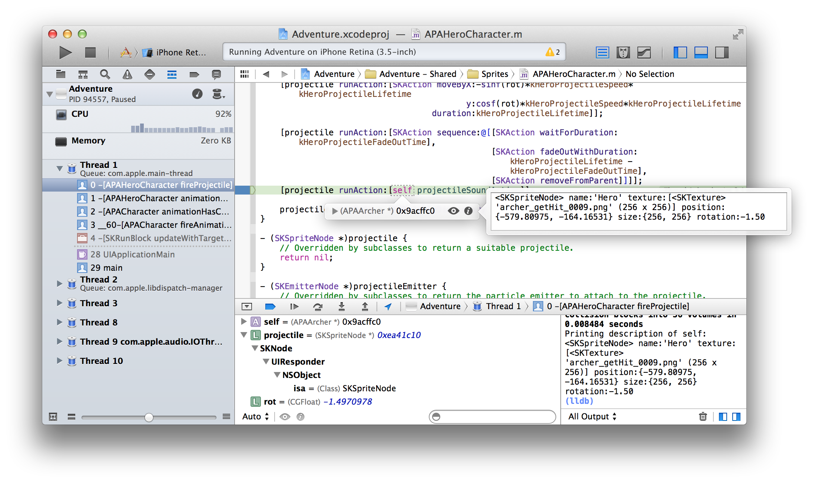

Creating a quality app requires that you minimize your application’s impact on your users’ systems. Use the debug gauges in the debug navigator to gain insight into your app’s resource consumption, and when you spot a problem, use Instruments to measure and analyze your app’s performance.

If you are developing an iOS app, use iOS Simulator to find major problems during design and early testing.

You can configure Xcode to help you better focus on your debugging tasks. For example, when your code hits a breakpoint, you can make Xcode automatically play an alert sound and create a window tab named Debug, where Xcode displays the debug area, the debug navigator, and your code at the breakpoint.

# Control Execution and View State Information

Xcode lets you step through your code line by line to view your program’s state at a particular stage of execution. Use the debug area to control the execution of your code, view program variables and registers, view its console output, and interact with the debugger. You can also use the debug area to navigate the OpenGL calls that render a frame and to view the rendering-state information at a particular call.

Display the debug area by clicking the center button ( ) in the view selector in the workspace window toolbar.

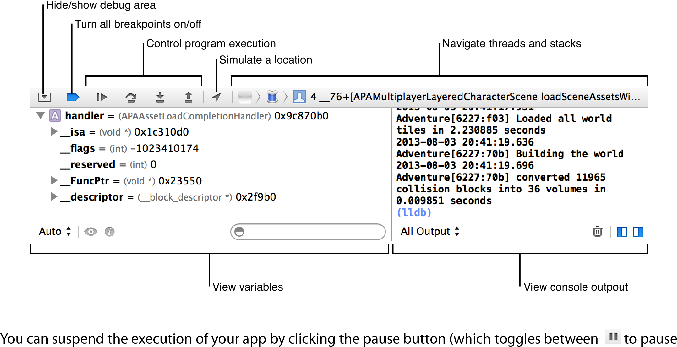

and  to continue) in the debug area toolbar. To set a breakpoint, open a source code file and click the gutter next to the line where you want execution to pause. A blue arrow ( ) in the gutter indicates the breakpoint.

When execution pauses, the debug navigator opens to display a stack trace. Select an item in the debug navigator to view information about the item in the editor area and in the debug area. As you debug, expand or collapse threads to show or hide stack frames.

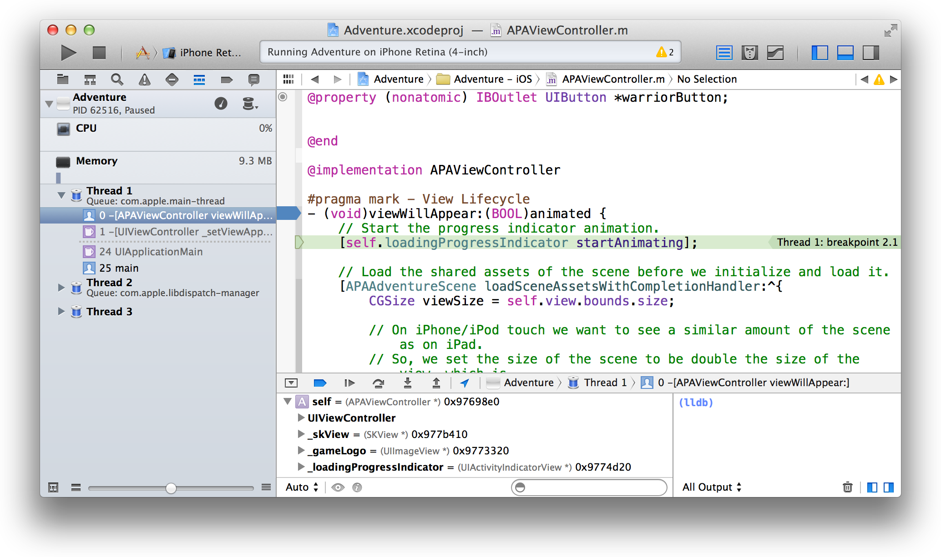

Hover over any variable in the source code editor to see a data tip displaying the value for the variable. Click the inspector icon ( ) next to the variable to print the Objective-C description of the object to the debug area console and to display that description in an additional popover.

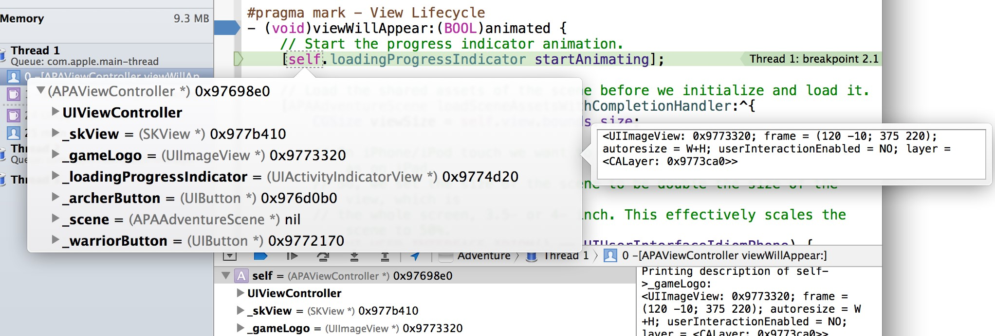

Click the Quick Look icon ( ) to see a graphical display of the variable’s contents.



When you build and run an OpenGL ES application on a connected device, the debug area toolbar includes a frame capture button ( ). Click that button to capture a frame. You can use OpenGL ES frame capture to:

* Inspect OpenGL ES state information
* Introspect OpenGL ES objects such as view textures and shaders
* Step through the state calls that precede each draw call and watch the changes with each call
* Step through draw calls to see exactly how the image is constructed
* See in the assistant editor which objects are used by each draw call

Examine Impact on System Resources

* Edit shaders to see the effect upon your application

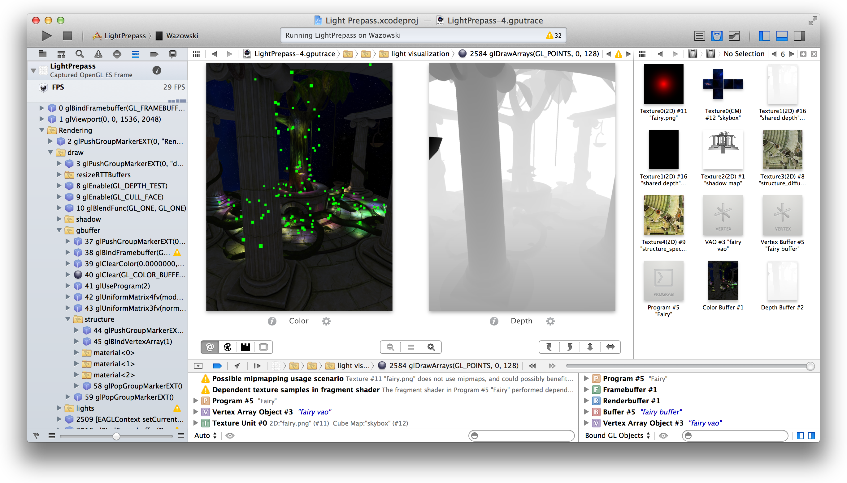

# Examine Your App’s Impact on System Resources

The debug navigator displays gauges that provide insight into how your app is performing. For example, the CPU gauge shows a readout of your app’s CPU usage, making it easy to spot unexpected spikes. Depending on the capabilities of your app and the characteristics of its destination, gauges can report your app’s impact on memory, iCloud, OpenGL ES, energy, and the CPU.

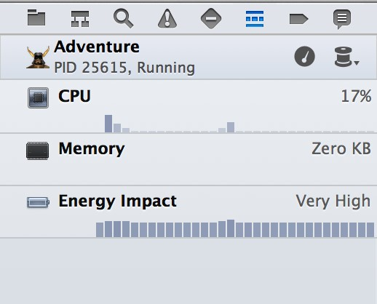

Examine Impact on System Resources

To see a full report, click a gauge in the debug area. To perform a deeper analysis of your app’s performance, click the “Profile in Instruments” button.



For problem areas, the energy report offers a preliminary diagnosis of what may be plaguing your app.

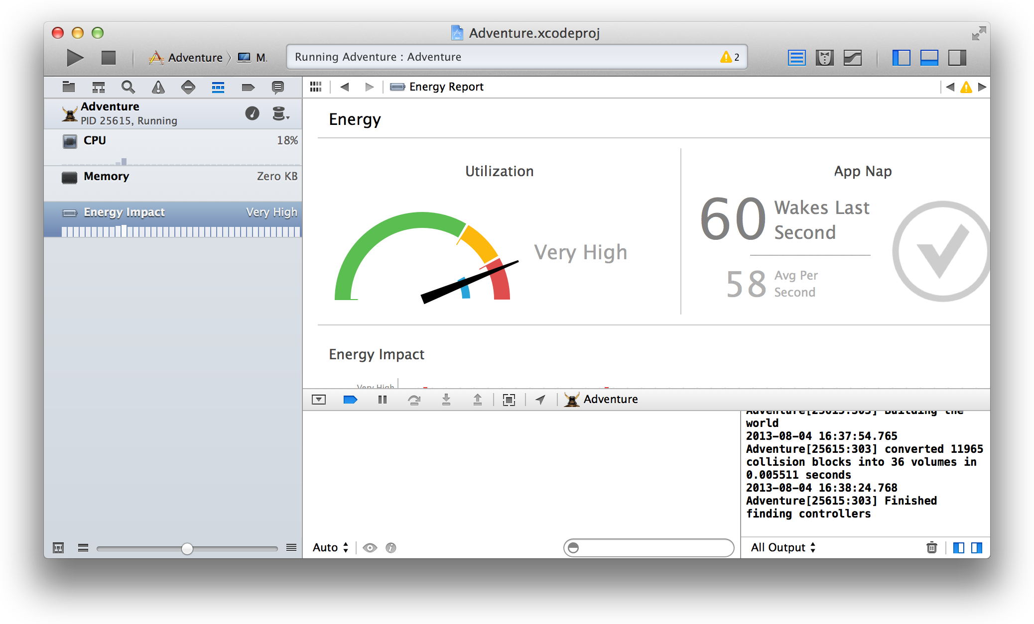

Measure Performance

# Measure Your App’s Performance

The Instruments app, which is included with Xcode, gathers data from your running app and presents it in a graphical timeline. With Instruments, you can gather data about such performance areas as your app’s memory usage, disk activity, network activity, and graphics operations. By viewing the data together, you can analyze different aspects of your app’s performance to identify potential areas of improvement. You can also automate the testing of your iOS app’s user interface elements.

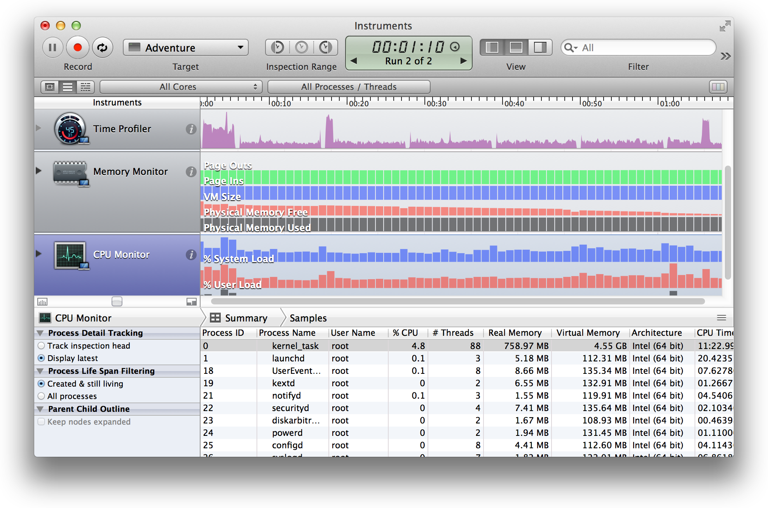

There are several ways to start Instruments from Xcode. For example:

* Click the Profile in Instruments button from a debug gauge report.
* Choose Product > Profile.
* Specify an Instrument in the Profile action for a scheme.

The Instruments app uses individual data collection modules, known as *instruments*, to gather data about a process over time. The Instruments app includes a library of templates. Each template contains instruments for obtaining a set of related information.

Perform Early Testing in iOS Simulator

# Perform Early Testing in iOS Simulator

iOS Simulator helps you find major problems in your app during design and early testing. For example, the Debug menu in iOS Simulator offers tools that help you:

* Slow an animation to spot any problems
* Trigger iCloud sync
* Identify blended view layers that harm app performance
* Identify images whose source pixels aren’t aligned to the destination pixels
* See what content is rendered offscreen
* Simulate different locations

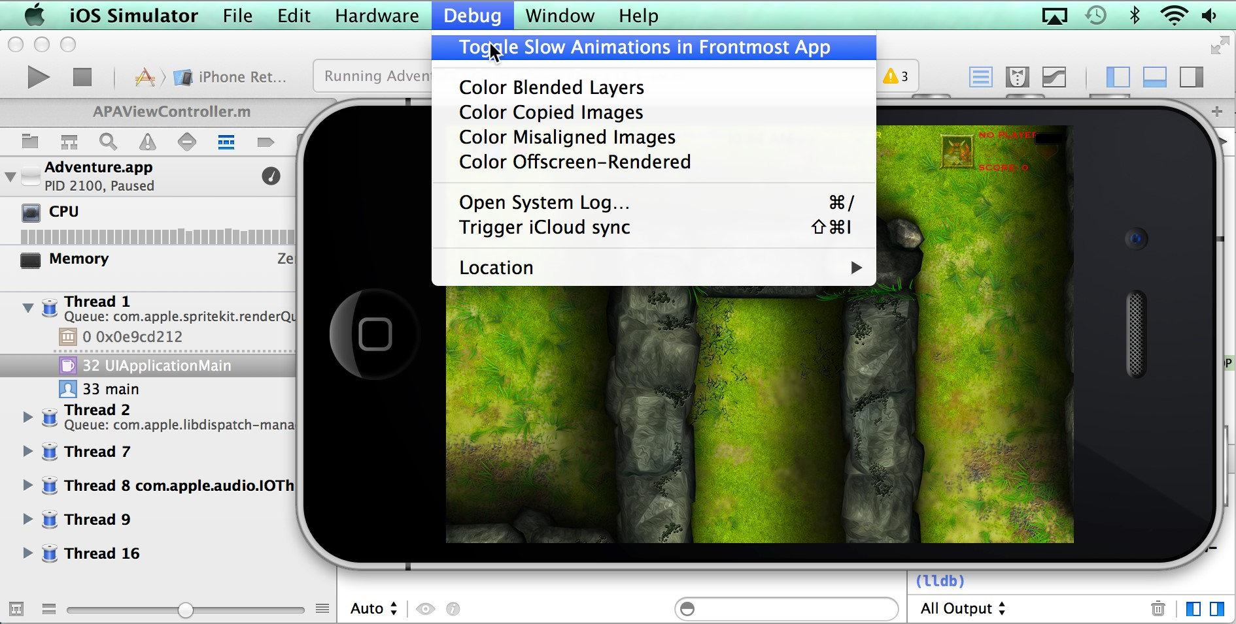

In every simulated environment in iOS Simulator, the Home screen provides access to apps—such as Safari, Contacts, Maps, and Passbook—that are included with iOS on the device. You can perform preliminary testing of your app’s interaction with these apps in iOS Simulator. For example, if you are testing a game, you can use iOS Simulator to test that the game uses Game Center correctly.

The Accessibility Inspector in iOS Simulator helps you test the usability of your app regardless of a person’s limitations or disabilities. The Accessibility Inspector displays information about each accessible element in your app, and you can use the Accessibility Inspector to simulate VoiceOver interaction with those elements.

To start the Accessibility Inspector, click the Home button on iOS Simulator. Click Settings and go to General > Accessibility. Slide the Accessibility Inspector switch to On.

You can test your app’s localizations in iOS Simulator by changing the language. In Settings, go to General > International > Language.

Although you can test your app’s basic behavior in iOS Simulator, the simulator is limited as a test platform for multiple reasons. For example:

* Because iOS Simulator is an app running on a Mac, iOS Simulator has access to the computer’s memory, which is much greater than the memory found on a device.
* The iOS Simulator runs on the Mac CPU rather than the processor of an iOS device.
* iOS Simulator doesn’t run all threads that run on devices.
* iOS Simulator can’t simulate hardware features like the accelerometer, gyroscope, camera, or proximity sensor.

While developing your app, run and test it on all of the iOS devices and iOS versions that you intend to support.

# Customize Your Debugging Workflow

You can specify behaviors that affect your workflow through the Xcode Behaviors preferences. Choose Xcode > Behaviors to specify what should happen when a variety of events occur while building, running, and debugging your app.

For example, you can have Xcode display the debug area when your code pauses at a breakpoint, and you can have Xcode display the issue navigator when a build fails.

In the screenshot below, behaviors are customized for whenever the code pauses. Here are some examples of customized behaviors:

* Play an alert sound at every pause.
* Create a tab named Debug in the workspace window for displaying the debug navigator.
* Show both the variables view and the console view in the Debug tab.
* Hide the utilities area in the Debug tab.

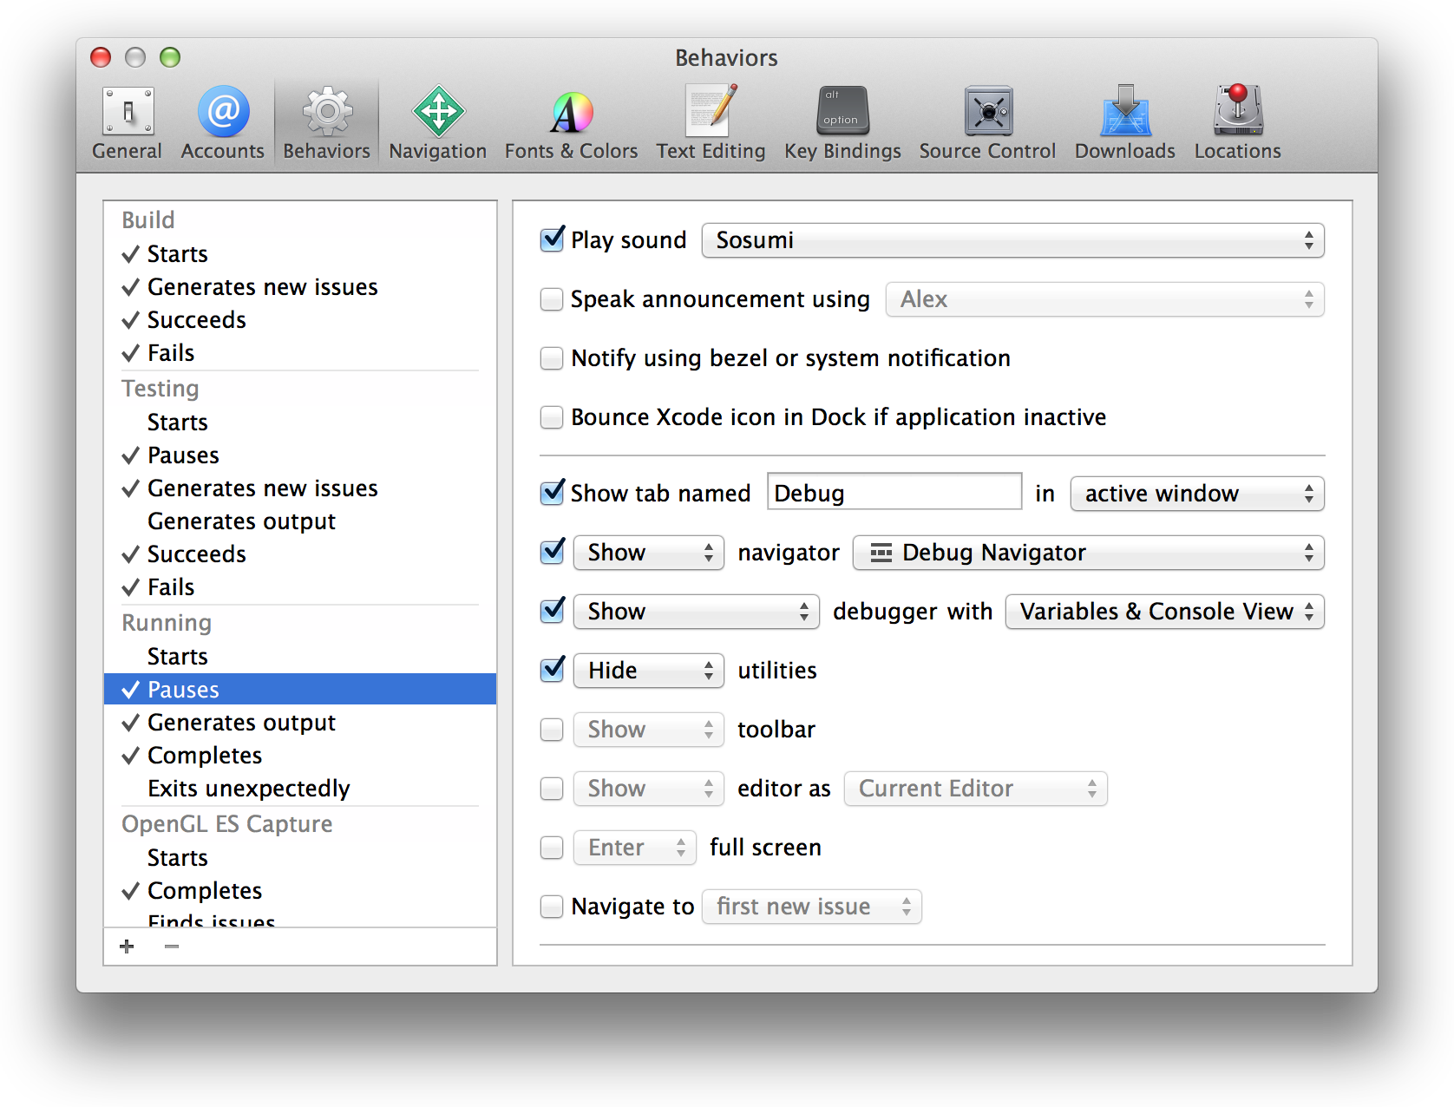

As a result, when the code in the project hits a breakpoint, Xcode creates a Debug tab in the workspace window with the specified content.

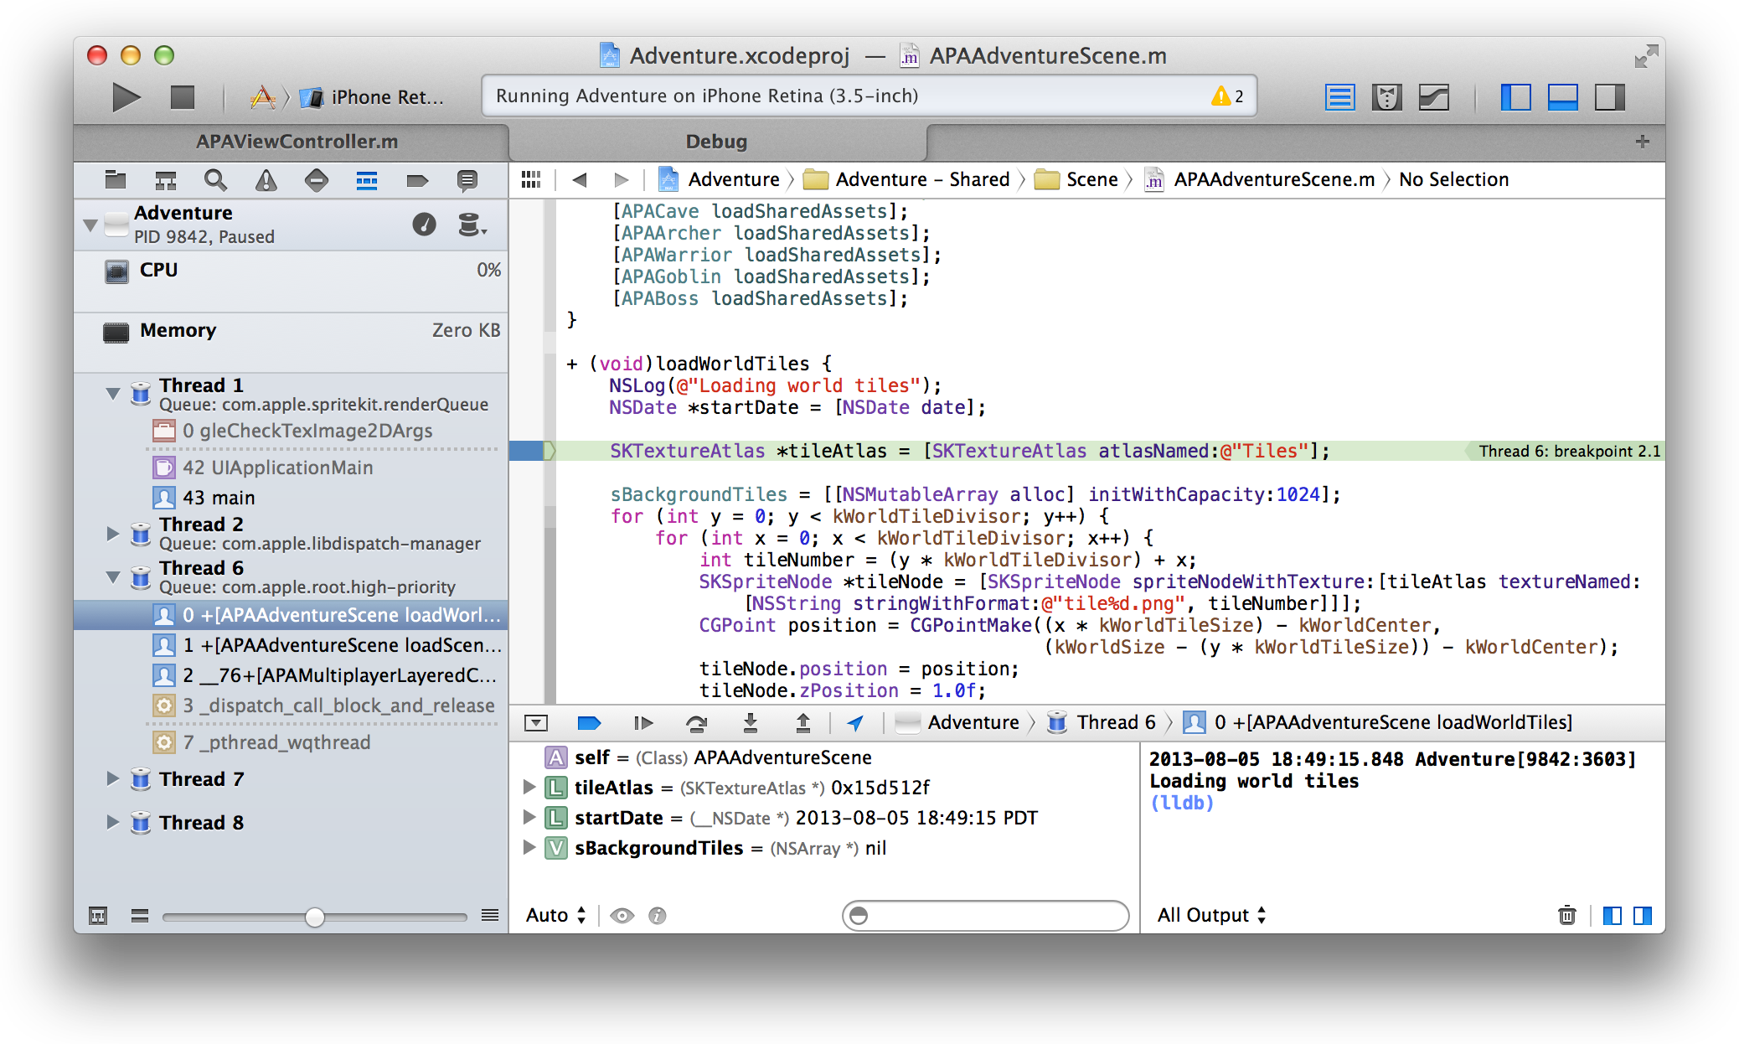

You can design custom behaviors that are triggered by menu items or their keyboard equivalents. Click the Add button (+) at the bottom of the Behaviors preferences pane. Type the name of the new behavior, and press Return. Select checkboxes to specify what should happen when you invoke this behavior. For example, you can create a Unit Testing behavior that saves a snapshot of your project and runs your unit tests. After you’ve created a behavior, it appears in the Xcode > Behaviors menu.

To assign a keyboard equivalent to a custom behavior, choose Xcode > Preferences and click Key Bindings. In the Key Bindings preferences pane, select the Customized tab to find the custom behavior you want. In the text field, enter the keys you want to use for the key binding in the text field, and click outside the text field to complete the operation.

Unit Test Your App

Create unit tests that automatically exercise the features of your application. Monitor the results of the tests and fix any issues from the test navigator.

You can use the Xcode service, available in OS X Server, to automate the execution of unit tests. From Xcode on your development Mac, you create **bots** that run on a separate server. In addition to running unit tests, bots automatically perform static analysis on your code, build your app, and archive it for distribution to testers or the App Store. Bots help you ensure that your product is always in a releasable state—and when there's a failure, the service notifies you or the person whose code change caused the failure.

Create and Run Unit Tests

Unit tests are programs that automatically exercise the features of your application and check the results. Unit tests are often used to detect regressions introduced by code changes to a project. Some developers write unit tests first, and then implement methods that pass the tests.

A **unit** of code is the smallest testable component of your project—for example, a method in a class or a set of methods that accomplish an essential purpose. A **test case** exercises a unit of code in a specific way; if the result of the test is different from the expected result, the test case fails. A **test suite** is made up of a set of test cases. You create test suites based on the XCTest framework. You can develop one or more test suites to test different aspects of your code.

When you create a project or a target, Xcode includes a unit test target in the scheme that builds the app. The implementation file for the target includes stubs for the setUp, tearDown, and testExample methods.

Complete these stub implementations and add other code as necessary to perform unit tests on your app.

Create and Run Unit Tests

Use the test navigator to run unit tests and review their status. You can add a test target to a project (or add a class to a test) by clicking the Add button (+) in the bottom-left corner of the test navigator. To view the source code for a particular test, select it from the test list. The file opens in the source code editor.

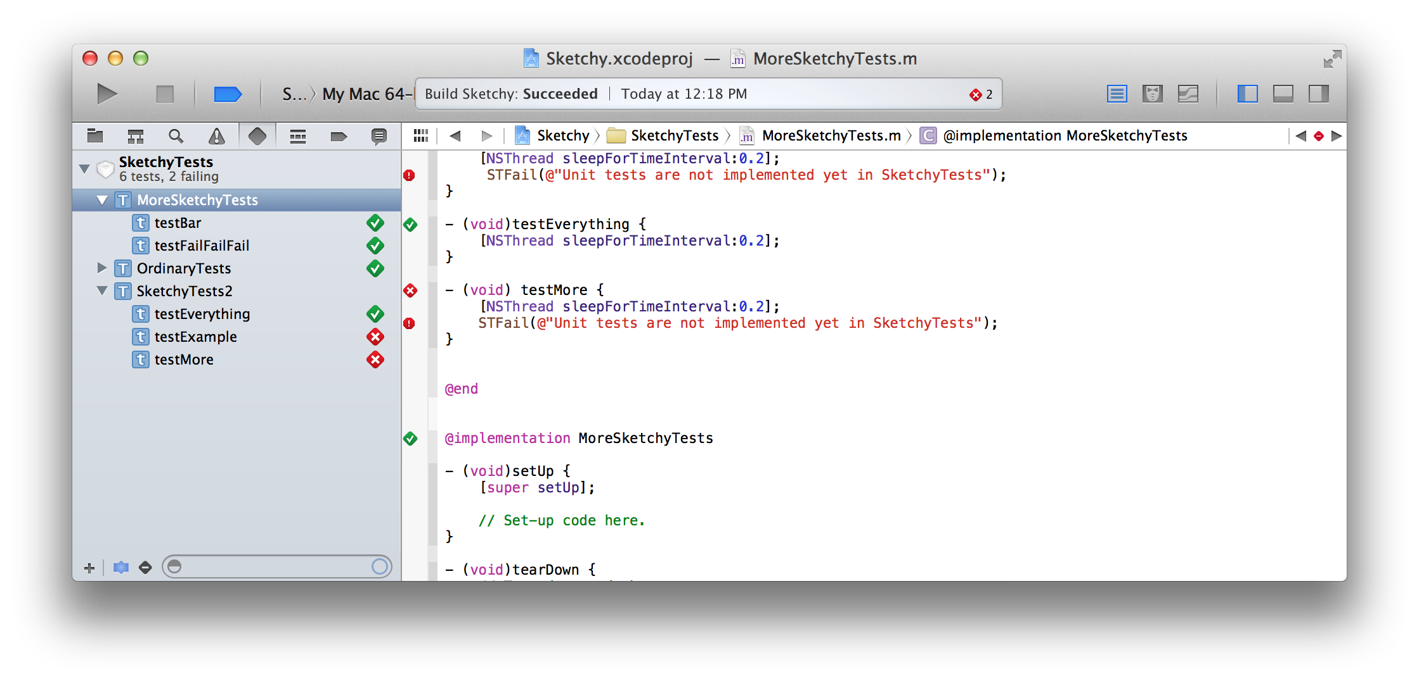

To run a test suite, click the arrow to the right of the name. To run a subset of test methods, select them in the test navigator and choose Product > Perform Action > Run Test methods. To run an individual test method, click the arrow to the right of the method name. Choose Product > Test to run all tests in the active scheme.

When a test succeeds, a green diamond with a checkmark denoting success appears to the right of the test name. When a test fails, a red diamond with an X denoting failure appears to the right of the test name, and the issue is displayed in the issue navigator, available by clicking  in the navigator selector bar.

To view only the failed tests, click the Failed Test button ( ) at the bottom of the test navigator. Select a failed method to examine it in the source code editor. After addressing the reason for the failure, click the failed test indicator (a red diamond with an X) to rerun the test.

From the jump bar menu for the assistant editor, you can use the Test Classes and Test Callers categories to place your tests and application code side by side in the workspace window.

Automate Unit Testing as Part of a Continuous Integration Workflow

Xcode supports a continuous integration workflow through the Xcode service. The **Xcode service**, available in OS X Server, automates the integration process of building, running unit tests, performing static analysis, and archiving your product. The service reports build errors and warnings, static analyzer problems, and unit test failures.

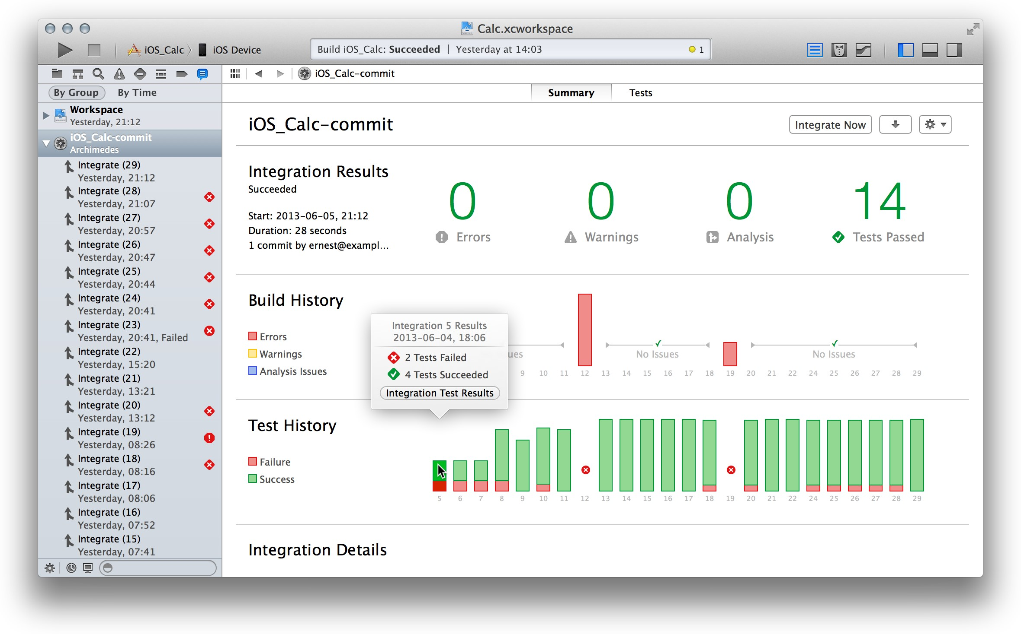

To run the Xcode service, install and configure OS X Server and Xcode on a Mac running OS X Mavericks. A continuous integration workflow typically relies on one or more development Mac computers running Xcode and on a separate server running the Xcode service. However, you can install OS X Server and run the Xcode

service on your development Mac. Such a configuration can be helpful for evaluating how to adopt continuous integration. Afterward, you’ll find it more useful to have a dedicated server running the Xcode service, hosting your source code repositories, and performing integrations.

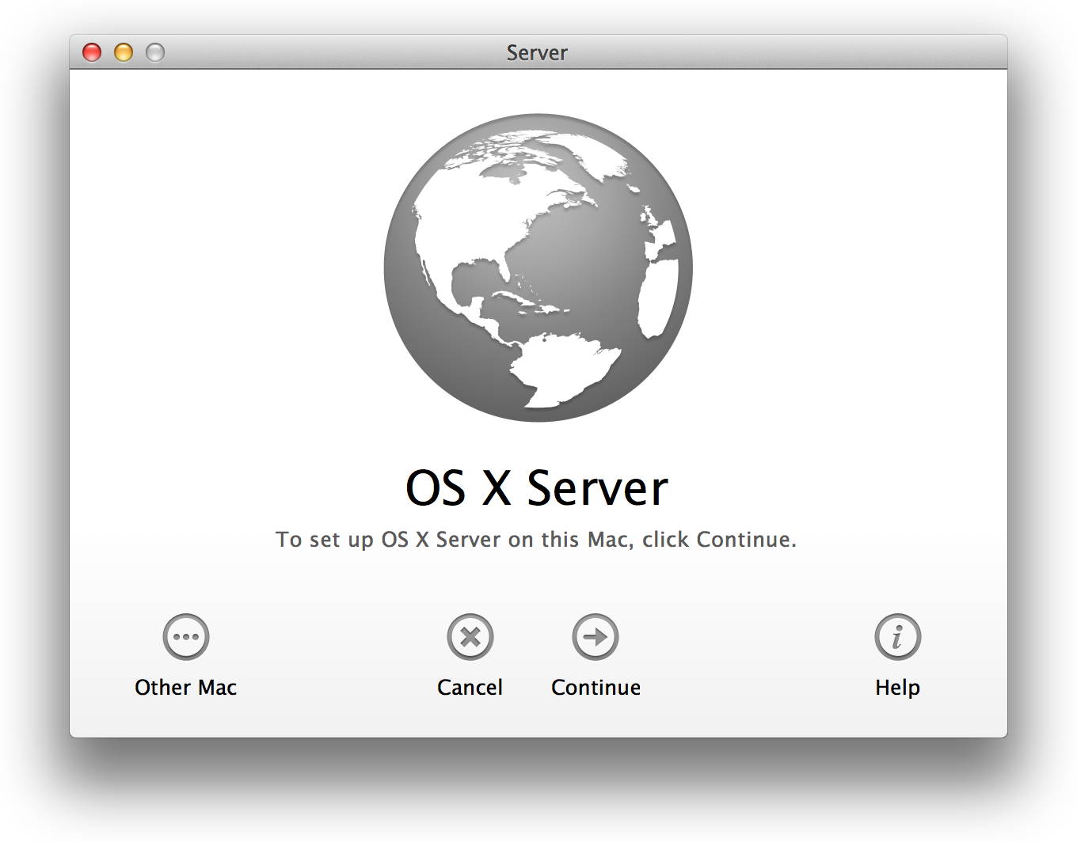

The Xcode service operates on projects contained in source code repositories. The Xcode service supports two popular source control systems: Git and Subversion. You can use Git and Subversion repositories hosted on remote servers. The Repositories tab in the Xcode service on the server allows you to connect to remote repositories.

Another valuable feature of the Xcode service is that you can use it to host Git repositories on your own server. Use the Repositories tab in the Xcode service on the server to configure access to its hosted repositories. On your development Mac, choose Preferences > Accounts, and add your credentials for the server and its repositories. When you create a project on your development Mac, you can simultaneously create a repository for it on the server.

If you already use a Git repository local to your development Mac, you can clone the repository to the server running the Xcode service. To clone a local repository to a server running the Xcode service, open the project onyourdevelopmentMac,andchooseSourceControl> *ProjectName* >Configure *ProjectName*.ClickRemotes, click the Add button (+), choose Create New Remote, and select the server.

Bots are at the heart of the automated workflow. Bots build and test products with the schemes of your choosing. You must share a scheme to enable a bot to access it. A **shared scheme** is one that you publish in a repository, along with the other shared project files. To share a scheme, choose Product > Scheme > Manage Schemes on your development Mac, and click the Shared option. Commit the change, and select the “Push to remote” option to publish the shared scheme in the repository.

You can create and schedule bots to run either periodically or on every source code commit. On your development Mac, open the project that contains the scheme that defines the actions to automate. Choose Product > Create Bot, and specify the attributes of the bot, including:

* The integration schedule: periodically (hourly, daily, or weekly), on every commit, or manually
* Who should receive email notifications from the bot when it succeeds and when it fails
* For an iOS app, what kinds of devices or simulators the bot will test on

From the log navigator, available by clicking  in the navigator selector bar on the development Mac, you can manage bots, view their test results, read integration logs, initiate integrations, and download product builds and archives. The Tests pane of the viewer provides a tabulated list of unit test results.



The Xcode service also hosts a bots website where you and members of your development team can perform these operations.

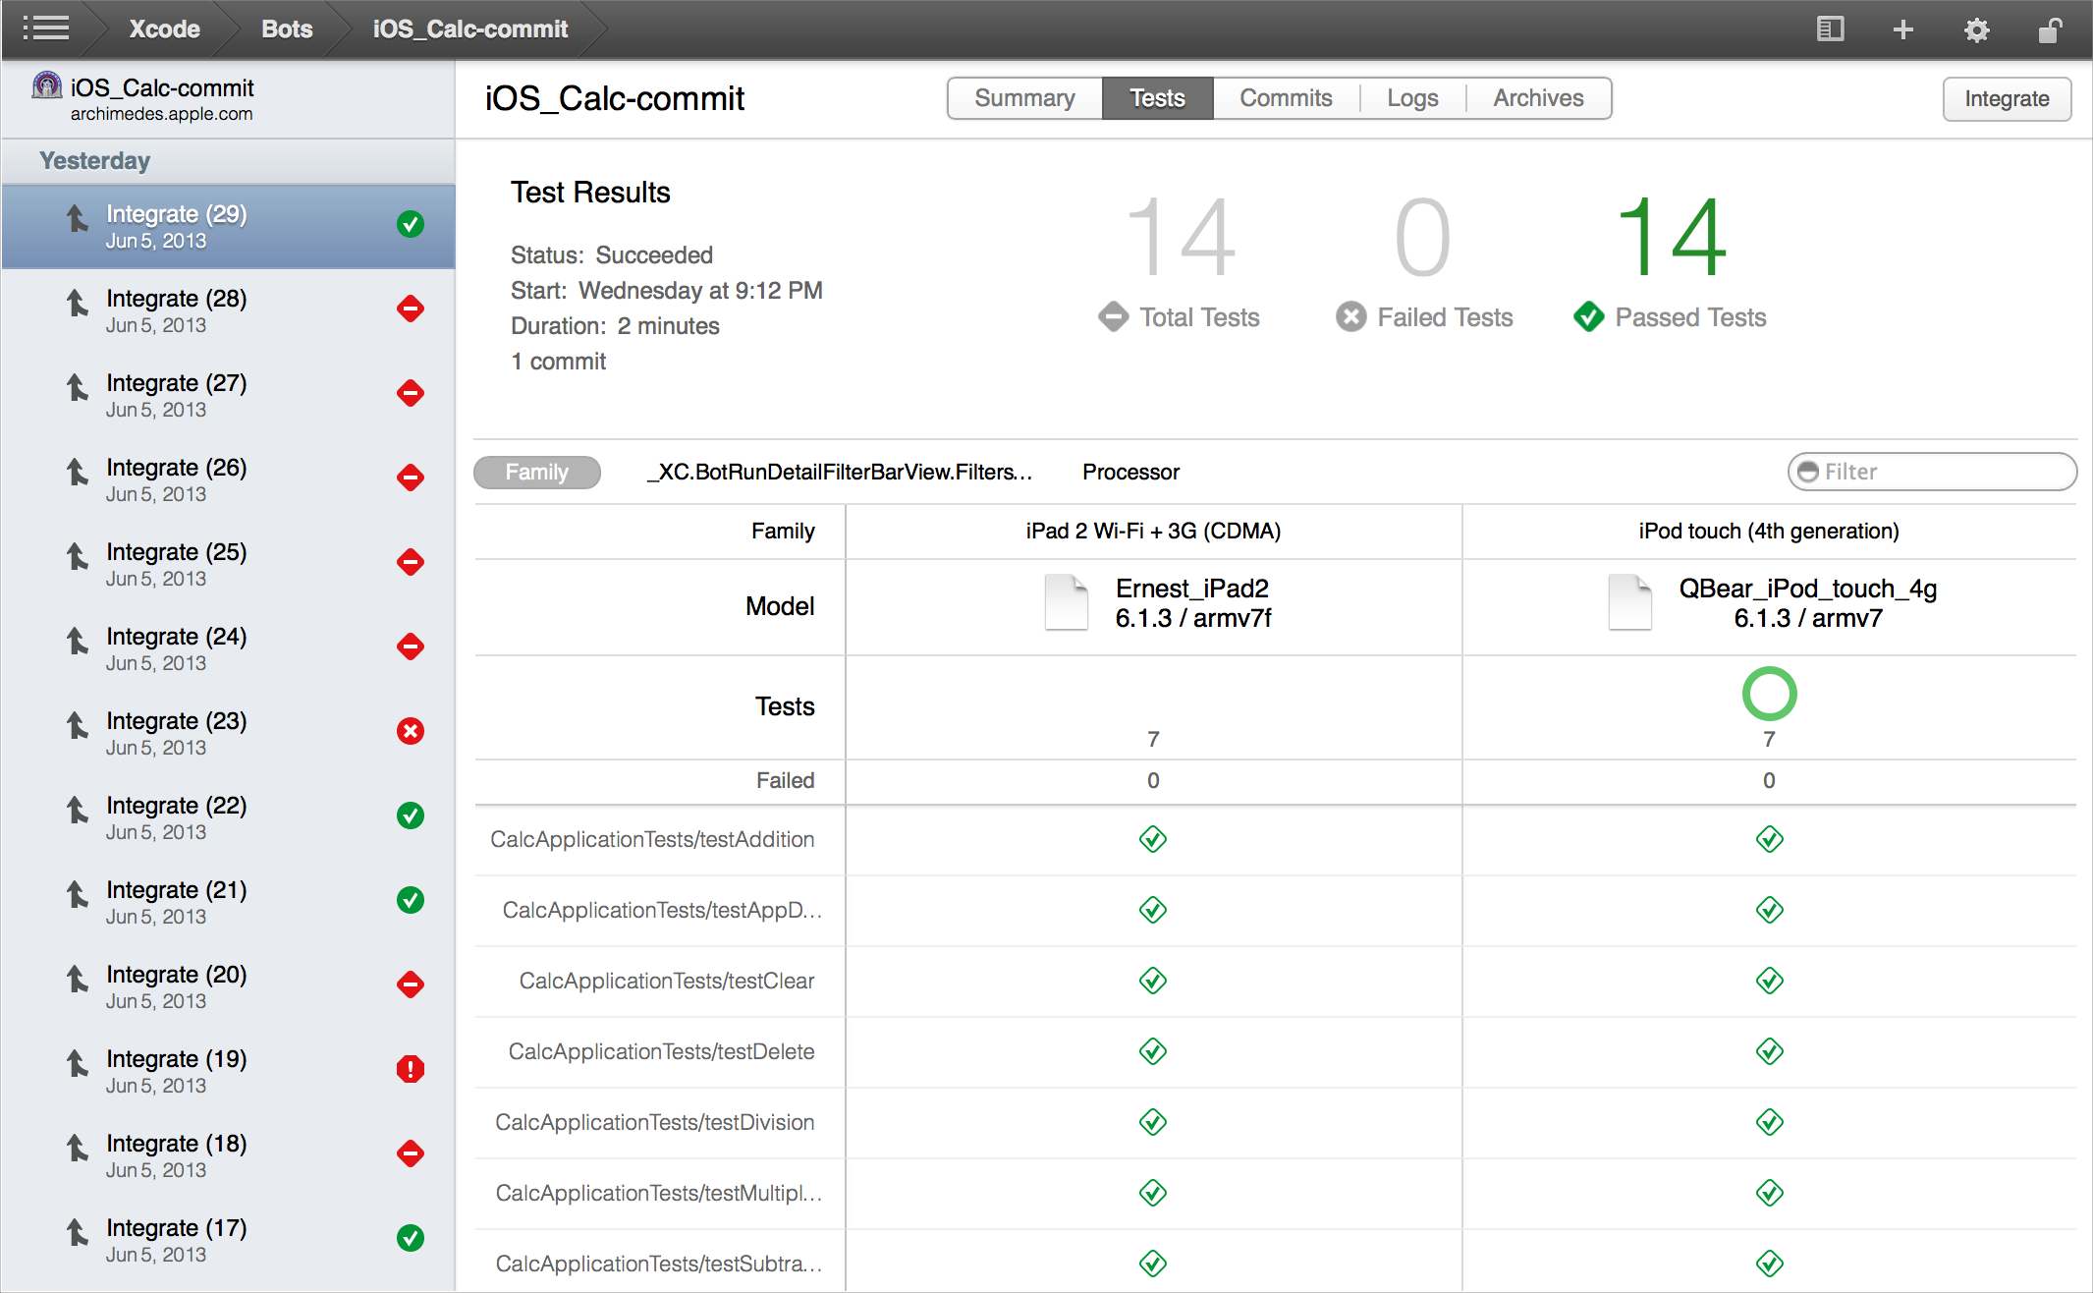

Save and Revert Changes

Xcode automatically saves changes to source, project, and workspace files as you work. This feature requires no configuration, because Xcode continuously tracks your changes and saves them in memory. Xcode then writes these changes to disk whenever you:

* Build and run your app
* Commit files to a source code repository
* Close the project
* Quit Xcode
* Create a snapshot

You can also manually save changes to disk by choosing File > Save.

You’ll occasionally want to revert a file to a previous state. For example, you might experiment with a new user interface layout and then decide to revert to the previous layout. Or you might need to undo some code changes because they introduced a problem. The Revert Document command in the File menu and the Undo command in the Edit menu let you discard changes to a file.

You might want to revert an entire project to a previous state. For example, after performing a global search-and-replace operation across multiple files in a project, you might decide to return all the files to their previous state. You can restore all your files and settings from a project snapshot.

You should also use source control management to keep track of changes at a fine-grained level. A source code management system saves multiple versions of each file onto disk, storing historical metadata about each version of each file in a source code repository. You can use the Xcode version editor to compare changes between versions of a file. You can copy portions from earlier versions of the file and paste them into the current version. With a source control system, you can also branch from a stable version of your project, add new features and make other changes to the branch, and then merge and reconcile those changes back into your project.

Revert to the Last Saved Version of a File

Revert to the Last Saved Version of a File

To discard all changes you’ve made to a file since it was last saved to disk, choose File > Revert Document. The Revert Document command operates only on the file that has the editing focus. You can give editing focus to a file either by clicking its editor pane or by selecting it in the project navigator.

The Revert Document command always returns the contents of the file to the last saved version on disk. If you would prefer to back out changes one change at a time, use the Undo command in the Edit menu.

Undo File Changes Incrementally

To back out changes to a file incrementally, choose Edit > Undo *change*. The Undo command is contextualized by your last operation. For example, the command appears as Undo Typing if you make an edit to an implementation file; the command changes to Undo Add Button if you add a button object to a storyboard.

With the Undo command, you can back out every change to a file since the start of your editing session. An editing session begins when you open a project and ends when you close the project. Xcode lets you undo *all* the edits in that session, even those already saved to disk. (Note, however, that the Revert Document command clears the Undo history, and you cannot undo a revert operation.)

After you’ve chosen the Undo command, you can choose Edit > Redo to reverse the last undo operation.

Use Snapshots to Restore Projectwide Changes

The Revert Document and Undo commands are not supported for three types of projectwide changes:

* Xcode operations that involve changes to many document files and potentially to project settings. These operations include refactoring code, performing project validation, and adding Automatic Reference Counting to an existing project.
* Adjustments to the workspace and project settings.
* Global search and replace operations.

Therefore, use a snapshot to revert changes across a project.

Snapshots are archives that include the current state of all project and workspace settings and all document files in the project. Snapshots provide an easy way to back up the current version of your project or workspace. If something goes wrong because of a code change you make, a snapshot makes it easy to restore your entire project, even a deleted project, to a previous state.

Use Snapshots to Restore Projectwide Changes

Xcode automatically creates a project or workspace snapshot before you perform any mass-editing operation, such as refactoring your code or executing a Find and Replace operation. You can also set Xcode to automatically create snapshots in other circumstances, such as before a build, by choosing Xcode > Preferences, selecting Behaviors, and selecting the Create Snapshot option. You can also create a snapshot manually by choosing File > Create Snapshot.

To see the snapshots for a project or workspace, choose Window > Organizer, select Projects to open the projects organizer, and click the project.



To restore a snapshot, choose File > Restore Snapshot and select the snapshot to restore. Xcode displays a preview dialog in which you can review the differences between the current version of the project and the snapshot version. When you click Restore, Xcode replaces the current version of the project with the version in the snapshot. Xcode takes a snapshot of the current version before replacing it.

To restore a snapshot in a new location instead of restoring on top of the current project, select the project in the Projects pane of the Organizer window, select the snapshot you want to restore, and click the Export Snapshot button at the bottom of the window.

You can restore a deleted project from a snapshot because Xcode keeps track of all your projects, even deleted ones, and displays them in the projects organizer.

Store and Track Changes with Source Control

Use commands in the Source Control menu to manage your project files with a source code repository. A repository saves multiple versions of each file onto disk, storing historical metadata about each version of each file. Source control allows you to keep track of file changes at a finer level of detail than snapshots allow. Source control also helps you coordinate efforts if you work with a team of programmers.

A source control system helps you reconstruct past versions of a project. You can commit a file to your repository each time you make a major change. Then, if you find you’ve introduced bugs, you can compare the new version of the file with a past version that worked correctly to help to locate the source of the trouble.

When multiple people work on a project, source control helps prevent conflicts and helps resolve conflicts should they arise. By keeping a central repository that holds the master copy of the software, the source control system allows each programmer to work on a local copy without danger of corrupting the master. With a file checkout system, you can ensure that two people don’t work on the same code at the same time. If two people do change the same code, the system helps you merge the two versions.

Xcode supports two popular source control systems: Git and Subversion. Subversion (often abbreviated svn) is always server based. The server is normally on a remote computer (although it is possible to install the server locally). Git can be used purely as a local repository, or you can install a Git server on a remote computer to share a repository among team members.

If you are working alone, it’s easiest to use Git, because you won’t need to set up a server. When you create a project, Xcode automatically sets up a Git repository for you.

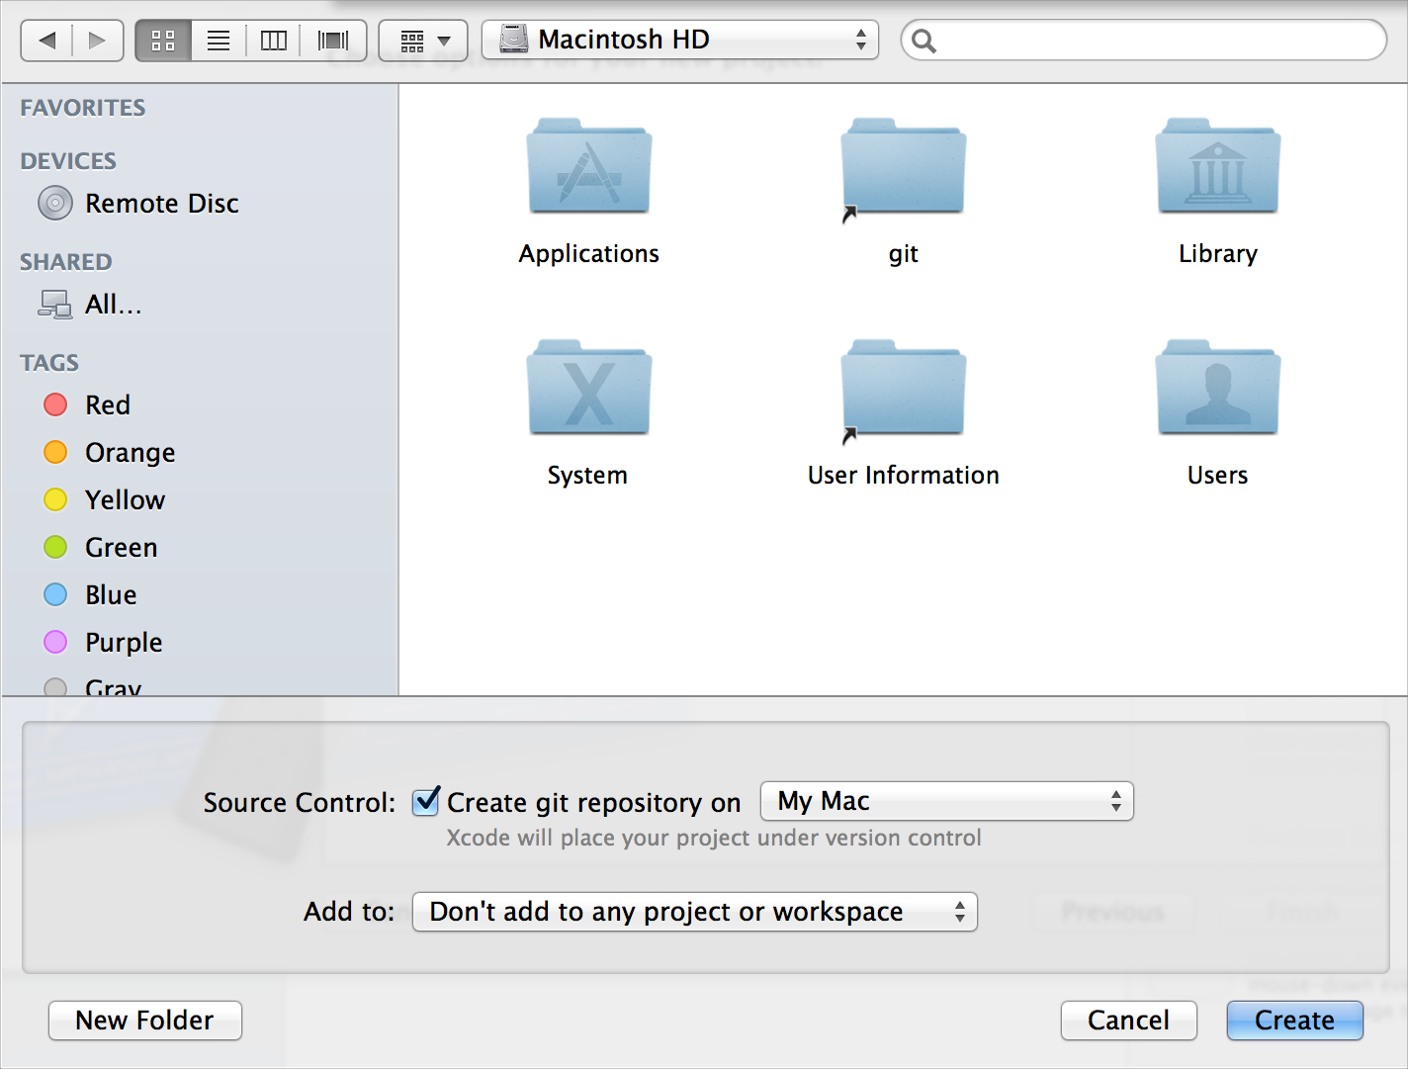

In addition to performing continuous integrations, the Xcode service, available with OS X Server, hosts Git repositories.

If your repository is on a server, choose Source Control > Check Out to create a local working copy of the project on your computer. If you use a local Git repository, you don’t check out a working copy, because your local repository is your master copy.

When you are satisfied with changes you've made to a file, choose Source Control > Commit to ensure that those changes are preserved in the repository. You are required to provide a comment explaining the nature of your commit. If your Git repository is on a server, the commit operation adds your changes to your local repository. Perform a push operation to add your committed changes to the Git repository on the server. For example, when you choose Source Control > Commit on your development Mac, select the “Push to remote” option, specify the remote repository in the pop-up menu, and click Commit Files.

You can see the source control status of your files in the project navigator. The status is shown as a badge next to the filename.

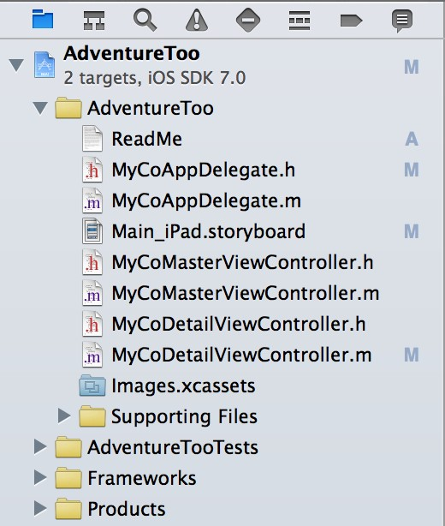

|  |  |
| --- | --- |
| **Badge** | **SCM status** |
| M | Locally modified |
| U | Updated in repository |
| A | Locally added |
| D | Locally deleted |
| I | Ignored |
| R | Replaced in the repository |
| – | The contents of the folder have mixed status; display the contents to see individual status |
| ? | Not under source control |

### Compare File Versions to Revert Lines of Code

Choose View > Version Editor > Show Comparison View to compare versions of files saved in a repository. Use the jump bars to choose file versions based on their position within a repository. Each jump bar controls the selection for the content pane above it. To display a version, browse through the hierarchy to find it, then click to choose it. Shaded areas indicate changes between versions.

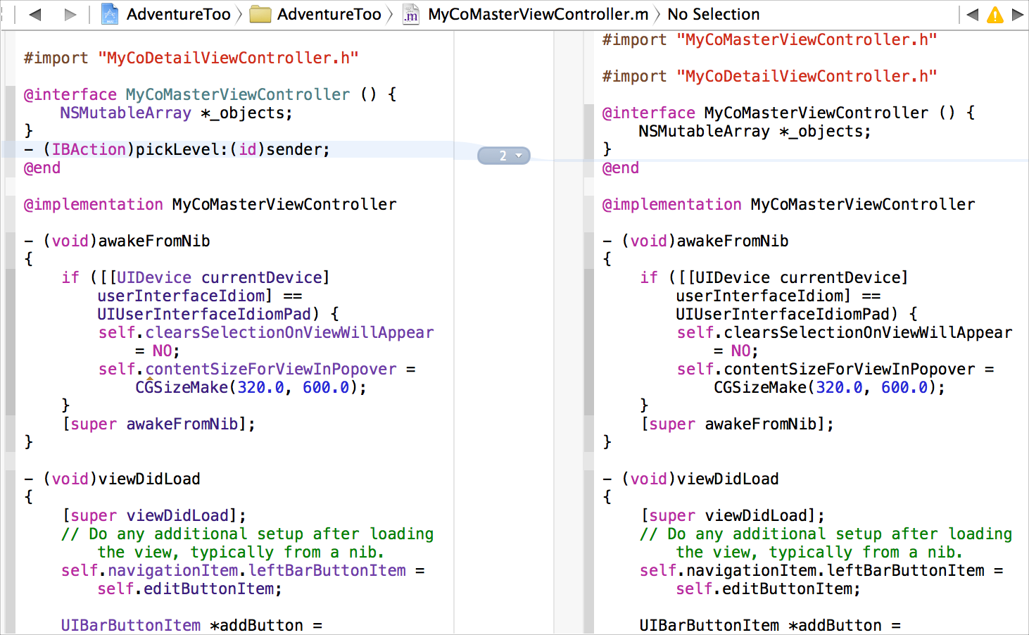

You can use the version timeline to choose file versions based on their chronological order. Click the timeline viewer icon ( ) in the center column to display the timeline between the two editing panes. Move the pointer up or down through the timeline to browse the available versions. When you find the version you want, click the left or right indicator triangle to display that version in the corresponding editor pane.

You can edit the current working copy of the file in the version editor. If you want to revert changes between versions, you can copy code from an older version and paste it into the current version.

### Create a Branch to Isolate Risky Changes

After you’ve worked on a project for a while, you are likely to have a body of reliable, stable code. You can choose Source Control > *Working Copy* > New Branch to create a copy of that code. Then you can work on new features and other changes without destabilizing your existing code base. When you are satisfied with your changes, you can merge them back into the body of stable code. Use Source Control > *Working Copy* > Merge from Branch and Source Control > *Working Copy* > Merge into Branch to combine and reconcile differences between versions of your project.

Learn More About Xcode

This guide introduced you to features and capabilities of Xcode. To help you become an expert Xcode user, Apple provides additional documentation within Xcode. You'll find identical Xcode documentation online in the [iOS](https://developer.apple.com/library/ios/navigation/index.html#section=Topics&topic=Xcode) [Developer](https://developer.apple.com/library/ios/navigation/index.html#section=Topics&topic=Xcode) [Library](https://developer.apple.com/library/ios/navigation/index.html#section=Topics&topic=Xcode) and [Mac](https://developer.apple.com/library/mac/navigation/index.html#section=Topics&topic=Xcode) [Developer](https://developer.apple.com/library/mac/navigation/index.html#section=Topics&topic=Xcode) [Library.](https://developer.apple.com/library/mac/navigation/index.html#section=Topics&topic=Xcode)

Get a Hands-On Introduction

If you’re new to iOS or Mac programming, work through *Start Developing iOS Apps Today* or *Start Developing Mac Apps Today*. Each document provides a perfect starting point for app development. In each, you use Xcode to create a simple app, and you learn the basics of programming with Objective-C using either the Cocoa Touch or Cocoa framework.

For a guided tour through the development of a game project that can be built for both iOS and Mac, look at *code:Explained Adventure*, which includes a link to download the complete Xcode project.

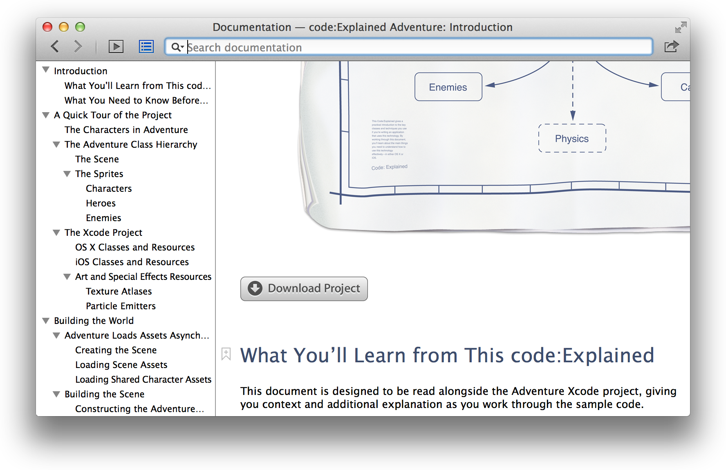

Find Step-by-Step Instructions

Find Step-by-Step Instructions

As you saw earlier, step-by-step instructions for performing common tasks are available directly in Xcode.

Control-click areas of the Xcode user interface to see a short list of the most common operations. Choose Show All Help Topics to see a larger list. Select an operation from the list, and a help article appears in the Xcode documentation viewer window.



Many articles include links to additional articles describing related tasks. Many articles also include links to lengthier discussions in user guides, which offer additional context and details about performing tasks in Xcode.

Find Step-by-Step Instructions

The Help menu also offers quick access to help articles. Type a search term or phrase, and a list of relevant help articles and related documents appears directly in the menu.

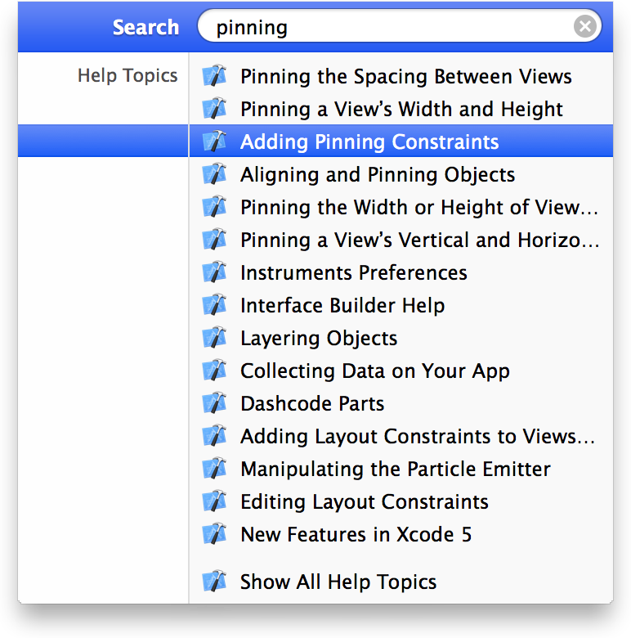

You can also use the search bar in the Xcode documentation viewer to locate help for a task. In Xcode, choose Help > “Documentation and API Reference” to display the documentation viewer. As you type into the search field, a menu appears of top search results. Select a document directly from this list, or click Show All Results at the bottom of the list to see a comprehensive list of search results.

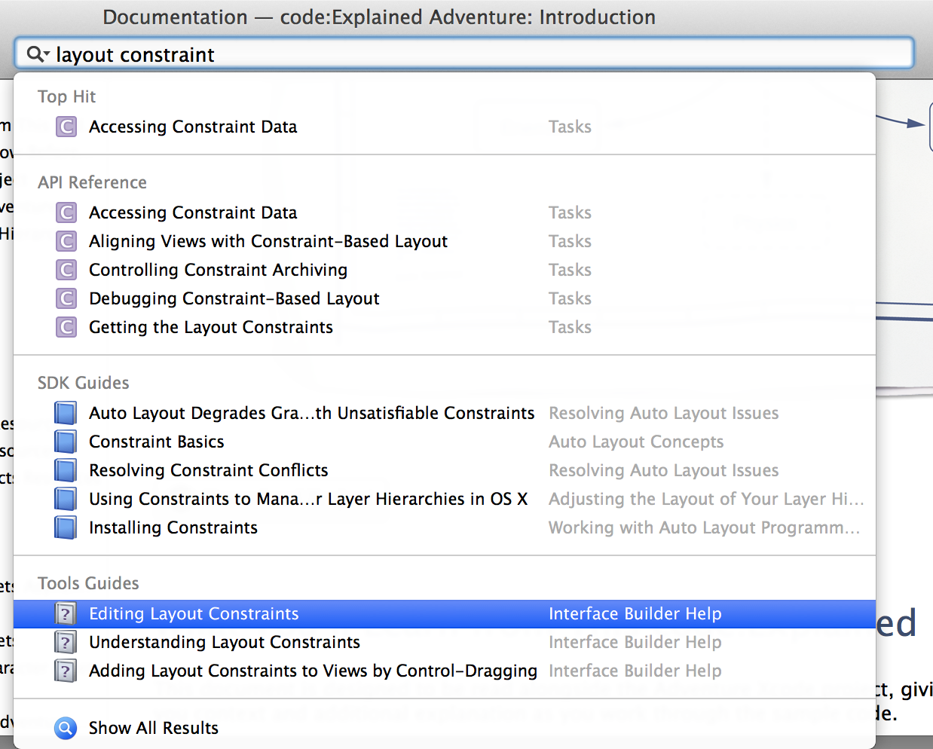

Xcode obtained these results by searching through all of the documentation relevant to your project’s SDK. You’ll find results for API symbols listed under API Reference, programming guide results under SDK Guides, and Xcode documentation results under Tools Guides, thereby providing access to all of the relevant material for a complex programming task.

Learn from Detailed User Guides

Apple provides detailed teaching guides for developer tool topics, including iOS Simulator, Instruments, app distribution, and continuous integration. To locate user guides for features in Xcode, use the search bar in the Xcode documentation viewer and look for results under Tools Guides.

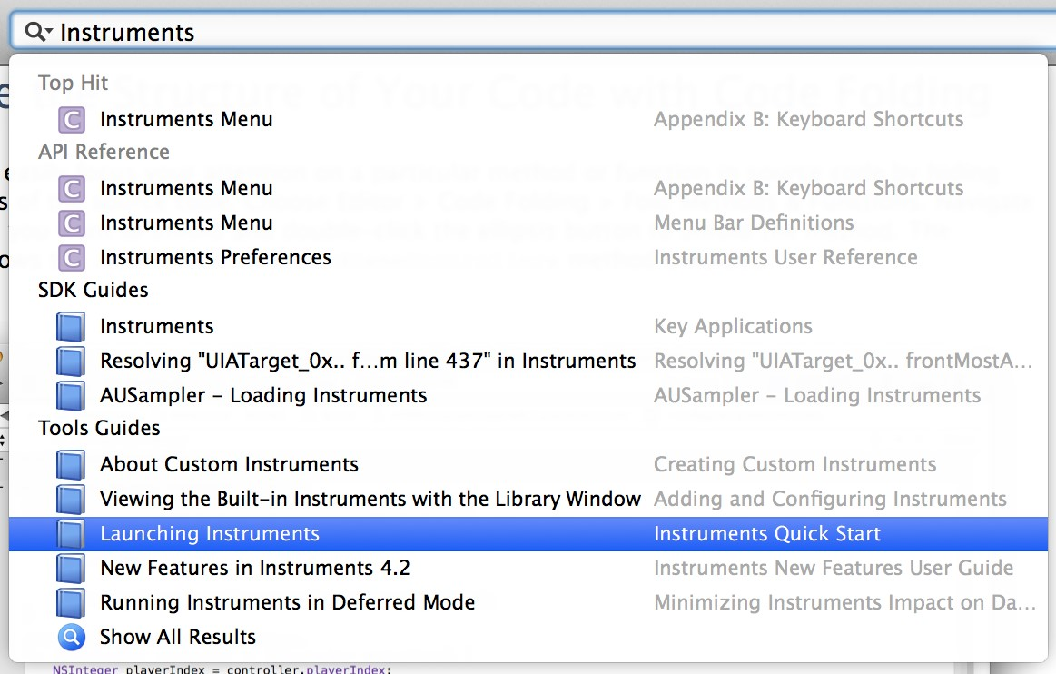

The *Instruments User Guide*,forexample,explainshowtousetheInstrumentsapptoexamineprogrambehavior.

Like many developer tool guides, it begins with a quick start tutorial.

To hide or show a list of the chapter and section titles for the document, click the table of contents button ( ) to the left of the search bar .

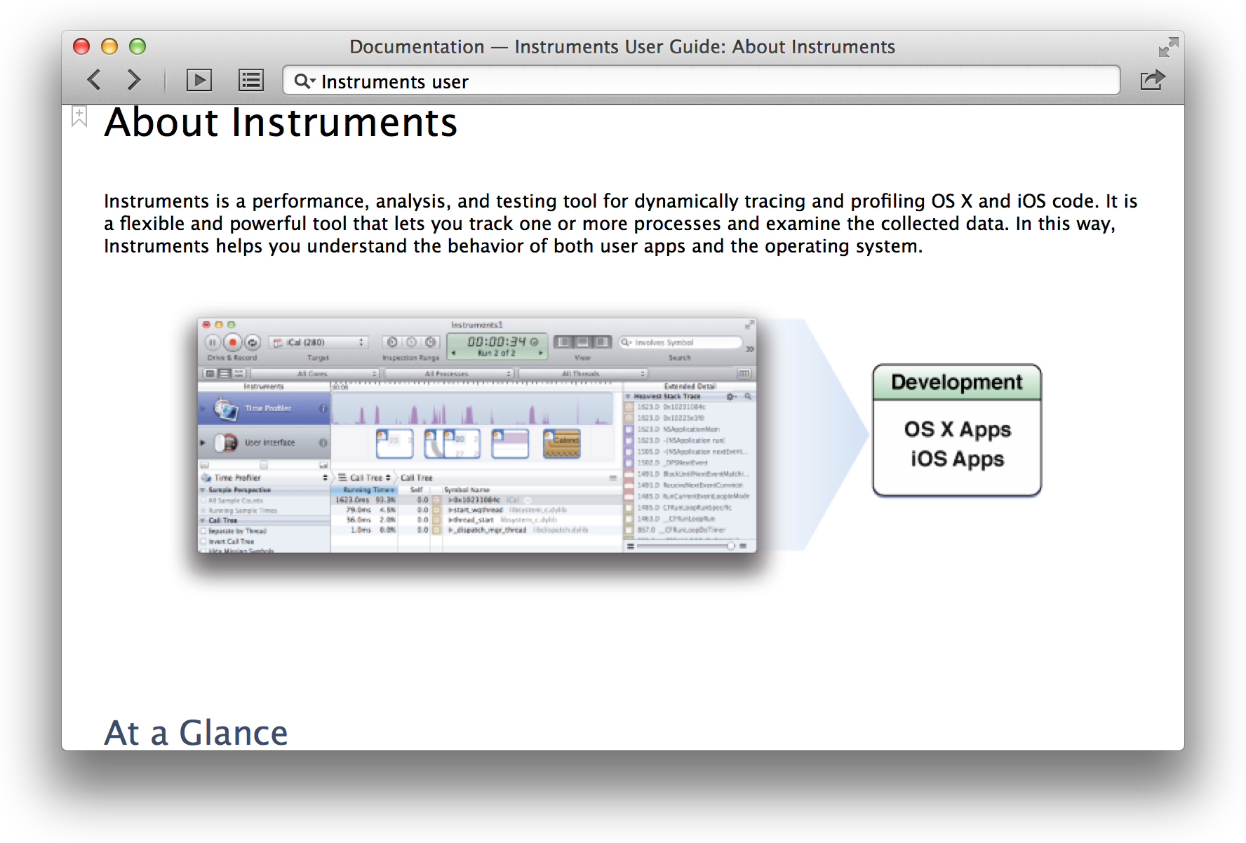

Click the documentation navigator button ( ) to the left of the table of contents button to display a navigation sidebar. To browse the list of Apple developer documentation installed in Xcode, click the documentation library button ( ).

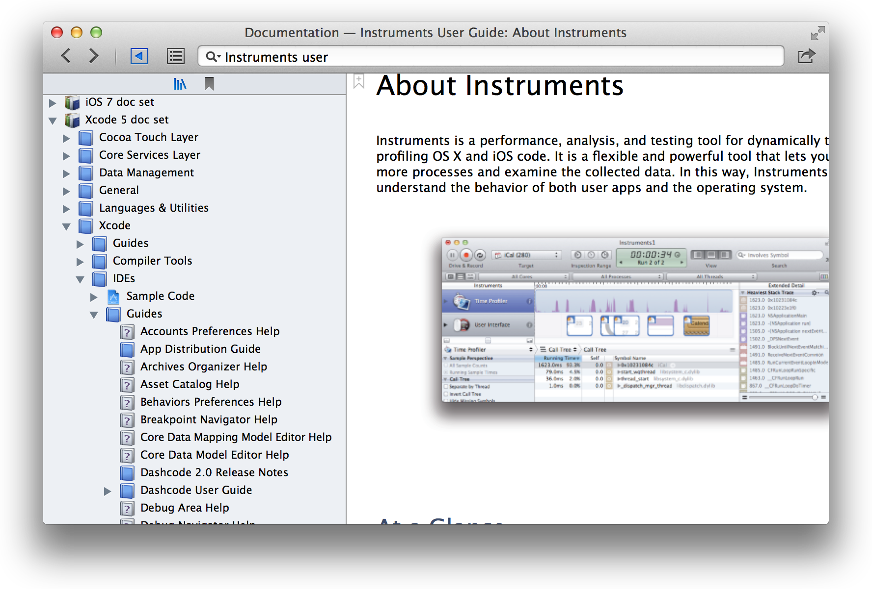

Use the tab bar in the doc viewer to keep multiple related documents open at once. To create a tab, choose File > New > Tab (or click the Add button (+) in the tab bar).

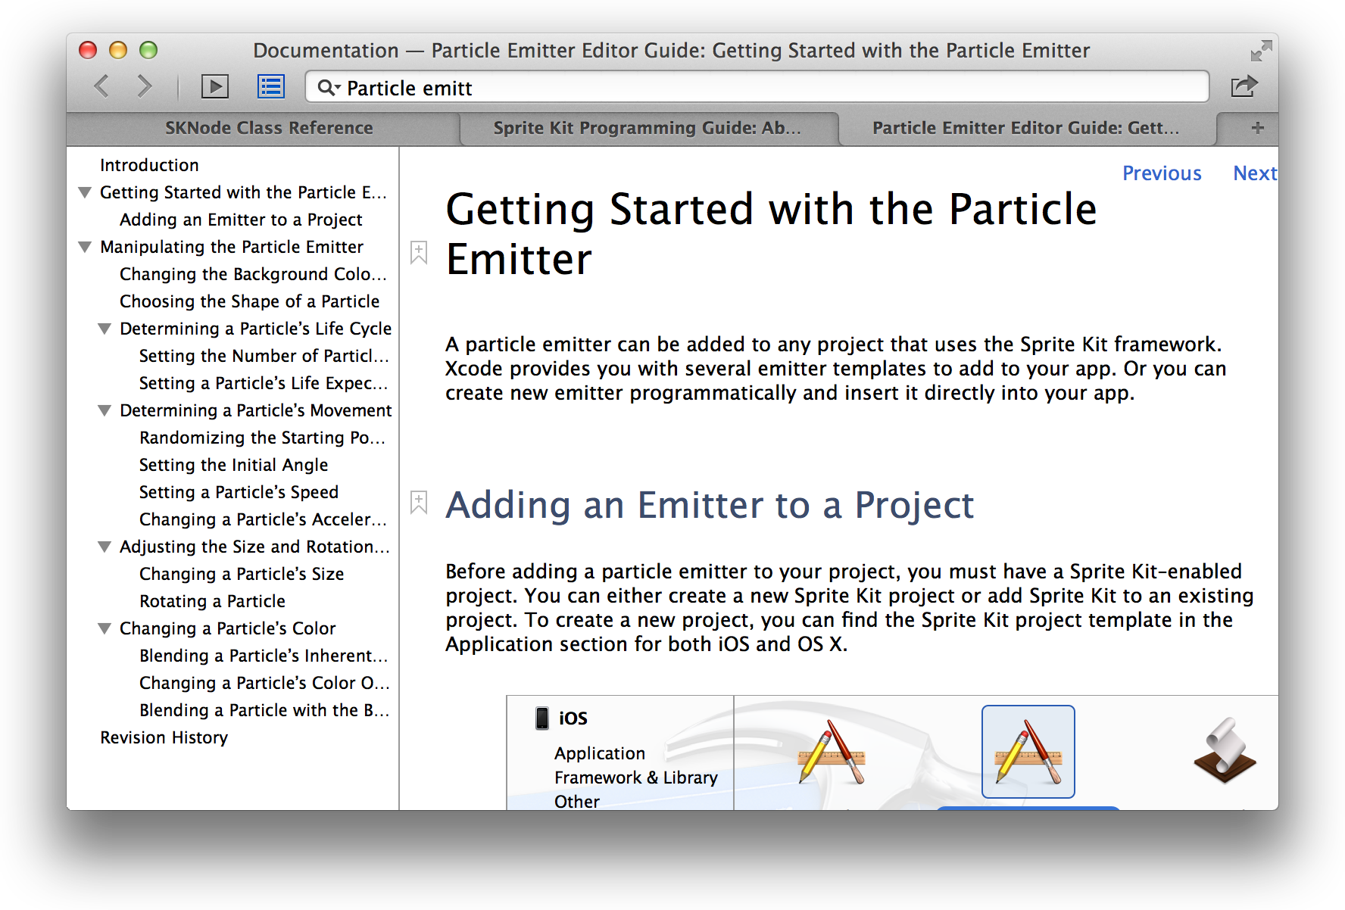

Stay Up to Date

To have quicker access to documents that you’ll return to, click the bookmark icon ( ) next to a chapter or section title. To display all of your bookmarks, click the documentation navigator button ( ) to display the navigation sidebar, then click the bookmark button ( ) at the top of the sidebar.



Stay Up to Date

Apple continually produces new and updated help articles, user guides, programming guides, and API reference. As updated documentation becomes available, it downloads to Xcode in the background. Be sure to keep your documentation up to date by leaving the default download behavior intact or by manually checking for documentation updates on a regular basis.

Stay Up to Date

Documentation is installed in the form of documentation sets, also called *doc sets*. Apple doc sets associated with your projects’ SDKs are installed with Xcode, and access to updates for them is controlled by subscription. For your convenience, Xcode can keep these subscriptions up to date. This feature is controlled by the option “Check for and install updates automatically,” which you can select in the Downloads pane (available by choosing Xcode > Preferences).

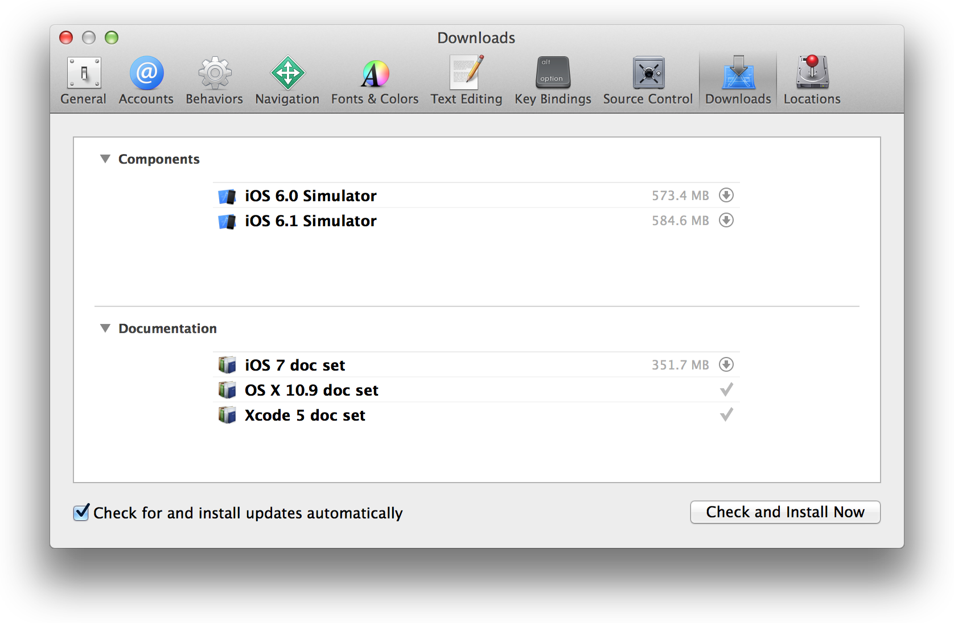

To check for updates manually, click “Check and Install Now.” If no new updates are available, Xcode displays a message to that effect. When an update for a doc set is available but not yet installed on your system, Xcode displays a Download button on the subscription line for that doc set. Click the Download button ( ) to download and install the updated doc set on your system.

Document Revision History

This table describes the changes to *Xcode Overview*.

|  |  |
| --- | --- |
| **Date** | **Notes** |
| 2013-10-22 | Updated the information about documentation viewing to reflect product improvements. |
| 2013-09-18 | Changed the title from "Xcode User Guide" and updated for Xcode 5. |
| 2011-03-02 | New document that explains how to use Xcode 4 to develop software for iOS and OS X. |

**you specific legal rights, and you may also have other rights which vary from state to state.** Apple Inc.

Copyright © 2013 Apple Inc. All rights reserved.

No part of this publication may be reproduced, stored in a retrieval system, or transmitted, in any form or by any means, mechanical, electronic, photocopying, recording, or otherwise, without prior written permission of Apple Inc., with the following exceptions: Any person is hereby authorized to store documentation on a single computer for personal use only and to print copies of documentation for personal use provided that the documentation contains Apple’s copyright notice.

No licenses, express or implied, are granted with respect to any of the technology described in this document. Apple retains all intellectual property rights associated with the technology described in this document. This document is intended to assist application developers to develop applications only for Apple-labeled computers.

Apple Inc.

1 Infinite Loop

Cupertino, CA 95014 408-996-1010

Apple, the Apple logo, Cocoa, Cocoa Touch,

Finder, Instruments, iPad, iPhone, iPhoto, iPod, iPod touch, iTunes, Logic, Mac, Objective-C, OS X, Passbook, Safari, and Xcode are trademarks of Apple Inc., registered in the U.S. and other countries.

Launchpad, Multi-Touch, and Retina are trademarks of Apple Inc.

iCloud is a service mark of Apple Inc., registered in the U.S. and other countries.

App Store and Mac App Store are service marks of Apple Inc.

OpenGL is a registered trademark of Silicon Graphics, Inc.

iOS is a trademark or registered trademark of Cisco in the U.S. and other countries and is used under license.

**Even though Apple has reviewed this document,**

**APPLE MAKES NO WARRANTY OR REPRESENTATION,**

**EITHER EXPRESS OR IMPLIED, WITH RESPECT TO THIS**

**DOCUMENT, ITS QUALITY, ACCURACY,**

**MERCHANTABILITY, OR FITNESS FOR A PARTICULAR**

**PURPOSE.ASARESULT,THISDOCUMENTISPROVIDED “AS IS,” AND YOU, THE READER, ARE ASSUMING THE ENTIRE RISK AS TO ITS QUALITY AND ACCURACY.**

**IN NO EVENT WILL APPLE BE LIABLE FOR DIRECT,**

**INDIRECT,SPECIAL,INCIDENTAL,ORCONSEQUENTIAL**

**DAMAGES RESULTING FROM ANY DEFECT OR INACCURACY IN THIS DOCUMENT, even if advised of the possibility of such damages.**

**THE WARRANTY AND REMEDIES SET FORTH ABOVE ARE EXCLUSIVE AND IN LIEU OF ALL OTHERS, ORAL OR WRITTEN, EXPRESS OR IMPLIED. No Apple dealer, agent, or employee is authorized to make any modification, extension, or addition to this warranty.**

**Some states do not allow the exclusion or limitation of implied warranties or liability for incidental or consequential damages, so the above limitation or exclusion may not apply to you. This warranty gives**